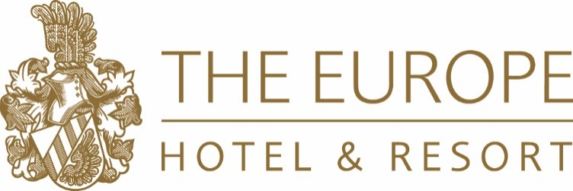

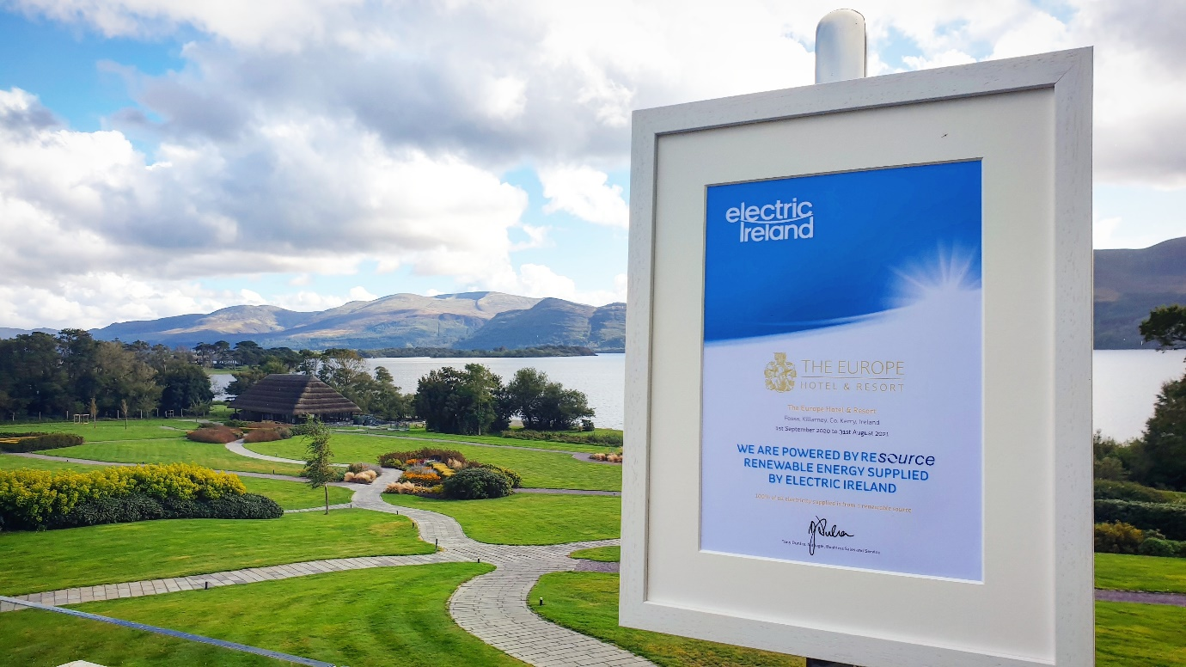
The Europe Hotel & Resort Goes Green with 100% Renewable Electricity

We are delighted to announce that the hotel now operates entirely on 100% Green Renewable Electricity.

For almost 60 years, The Europe Hotel & Resort has been setting the benchmark for innovation, technology, quality standards and customer service within the hospitality industry in Ireland. We have always challenged ourselves to lead by example and operate with pride. Now more than ever, it is of vital importance for not only the hospitality industry, but also society as a whole to take significant action and account for our responsibility for the environment.

We are acutely aware of how precious our planet is and count ourselves incredibly fortunate to be situated in one of Ireland’s most treasured locations, – a UNESCO World Biosphere no less. We challenged ourselves to make a significant, positive and immediate change to how we operate our business, while still maintaining the incredible facilities and level of service that we are renowned for.
Additionally, The Europe Hotel & Resort is part of the Killarney Hotels Sustainability Group, which is committed to continuously strive and reduce the environmental impact of our services and activities. For 2020, our focus and commitment is to reduce our Carbon Emissions by 25% and changing our electricity to 100% Green Renewable was an important step in this commitment.

One of our Company Core Values is “We Accept Responsibility” and aim at all times to fulfil our responsibility to society in general and the environment.

Taking in to account the scale of the resort and especially the energy consumption of facilities such as ESPA at The Europe, we needed a solution that would allow us to maintain our highly regarded amenities for our guests, while upholding our responsibilities to the environment.

Operating on 100% Renewable Electricity has enabled us to make a change that will have a direct positive impact. Switching to 100% Green Electricity proved a simple and highly effective way to cut our carbon emissions and reduce our impact on the environment. As a family owned company, integrity has a high status and one principle is continually “thinking of tomorrow today”.

“The Europe Hotel & Resort’s location overlooking some of Ireland’s most precious & inspiring landscapes ensures that our duty and respect to our environment is at the forefront of our minds. We are proud to now operate on 100% Green Renewable Electricity and hope that our action will inspire other companies to take further steps towards a greener, brighter future.”
- Michael Brennan, Managing Director of Killarney Hotels Ltd.

This step is one of many changes The Europe Hotel & Resort has made in their commitment to sustainability. Some of our other key measures include:

- Sourcing Responsibly & Locally: The Liebherr Family (hotel owners) own and operate one of the largest farms in Co. Kerry, which is between The Europe Hotel & Resort and The Dunloe Hotel & Gardens. Our farmers rear livestock to produce our own beef and lamb for the hotel menu, thus reducing the ‘food miles’ and ensuring our guests enjoy trustworthy, higher welfare and locally produced produce. The land stretches over 400 acres in the shadow of MacGillycuddy’s Reeks by Lough Lein from The Europe Hotel & Resort to The Dunloe Hotel & Gardens, and the farm is home to sheep and to over 350 head cattle, a combination of Aberdeen Angus, Charolais and Limousin. Historically, sheep and cattle that were reared at the farm were sold at a market or directly to factory, however in the last couple of years it has produced beef and lamb, which proudly features on the hotels’ menus. Seán Moriarty has been managing the farm for over 30 years and meets with the Chefs on a weekly basis to discuss the needs of their dishes. He also works closely with a local butcher to ensure the perfect treatment and aging of the meats. Having a close relationship results in a product of exceptional quality and of higher welfare, which supports the local community.

- In delivering our commitment, we comply with relevant environment legislation and take a proactive approach to future requirements and obligations.
- We seek to conserve natural resources through the responsible use of energy, water and materials.
- Monitoring and improving our recycling in areas such as energy consumption, reduction of waste materials and water consumption.
- Work with our suppliers to reduce carbon footprint and reduce the waste generated.
- Promoting efficient energy management and utilization.
- Monitoring water usage and encouraging water conservation.
- Managing waste and developing recycling initiatives.
- Communicating this policy and relevant environmental control to employees, suppliers and guests.
- All of the hotel’s ‘to go’ coffee cups and lids are recyclable.
- The hotel’s ‘to go’ picnic bags are reusable and the containers within are recyclable.
- The hotel is replacing single use plastic straws with biodegradable alternatives.
- The hotel also has 4 x electric vehicle charging points onsite
- The hotel is heavily focused on food sustainability and seasonality.

If you have any questions, please contact our Sales & Marketing Office on hotelsales@liebherr.com
The Europe Hotel & Resort, Fossa, Killarney, Co. Kerry, V93 KHN6, Ireland.
Tel: +353 64 6671340 | www.theeurope.com

