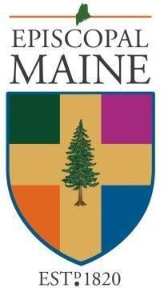

Loring Fund Grant Application for Clergy Conference 2026
Please print clearly or type
The Grants Committee prefers electronic application submissions.

Date of Application
Date of Program/Event | May 3-5, 2026
Name of Program/Event | 2026 Clergy Conference with Rev. Shaneequa Brokenleg at Schoodic Institute
Type of Request | Continuing Education
Applicant’s Name
Address
City, State, ZIP
Email Address
Primary Phone #
Cell Phone #
Congregation
Congo City / Town
Number of Years Canonically-Resident in Maine
Have you received prior support from the Loring Fund within the past five years? If so, please list the date and amount received.

Financial Information and Signature

Category | Notes / Description/Explanation | Amount
Registration Fee | $100.00 | 100.00
Rooming Fee | $213.64 | 213.64
Travel: Mileage | Total Miles x 75% of IRS rate  which in 2026 is 72.5 cents per mile
Total Expenses

Sources of Support | Description | Amount
Self
Congregation
Gifts from Others
Total Support

Total Grant Request | Expenses minus Support
Funds Needed By | April 20, 2026, if possible
Signature of
Applicant

 I have read and understand the Loring Fund Guidelines and will submit a written report (short) of my experiences within thirty days after the conclusion of this program/event/seminar.

Due to tax law, it is the diocesan policy to pay the institution directly in all possible cases.

Check Payable To: | Mailed To:
 | Institution/Congo Name
 | Addy 1
 | Addy 2
 | City
 | State
 | ZIP
 | Memo Line:

Please send this completed application to:

grants@episcopalmaine.org

