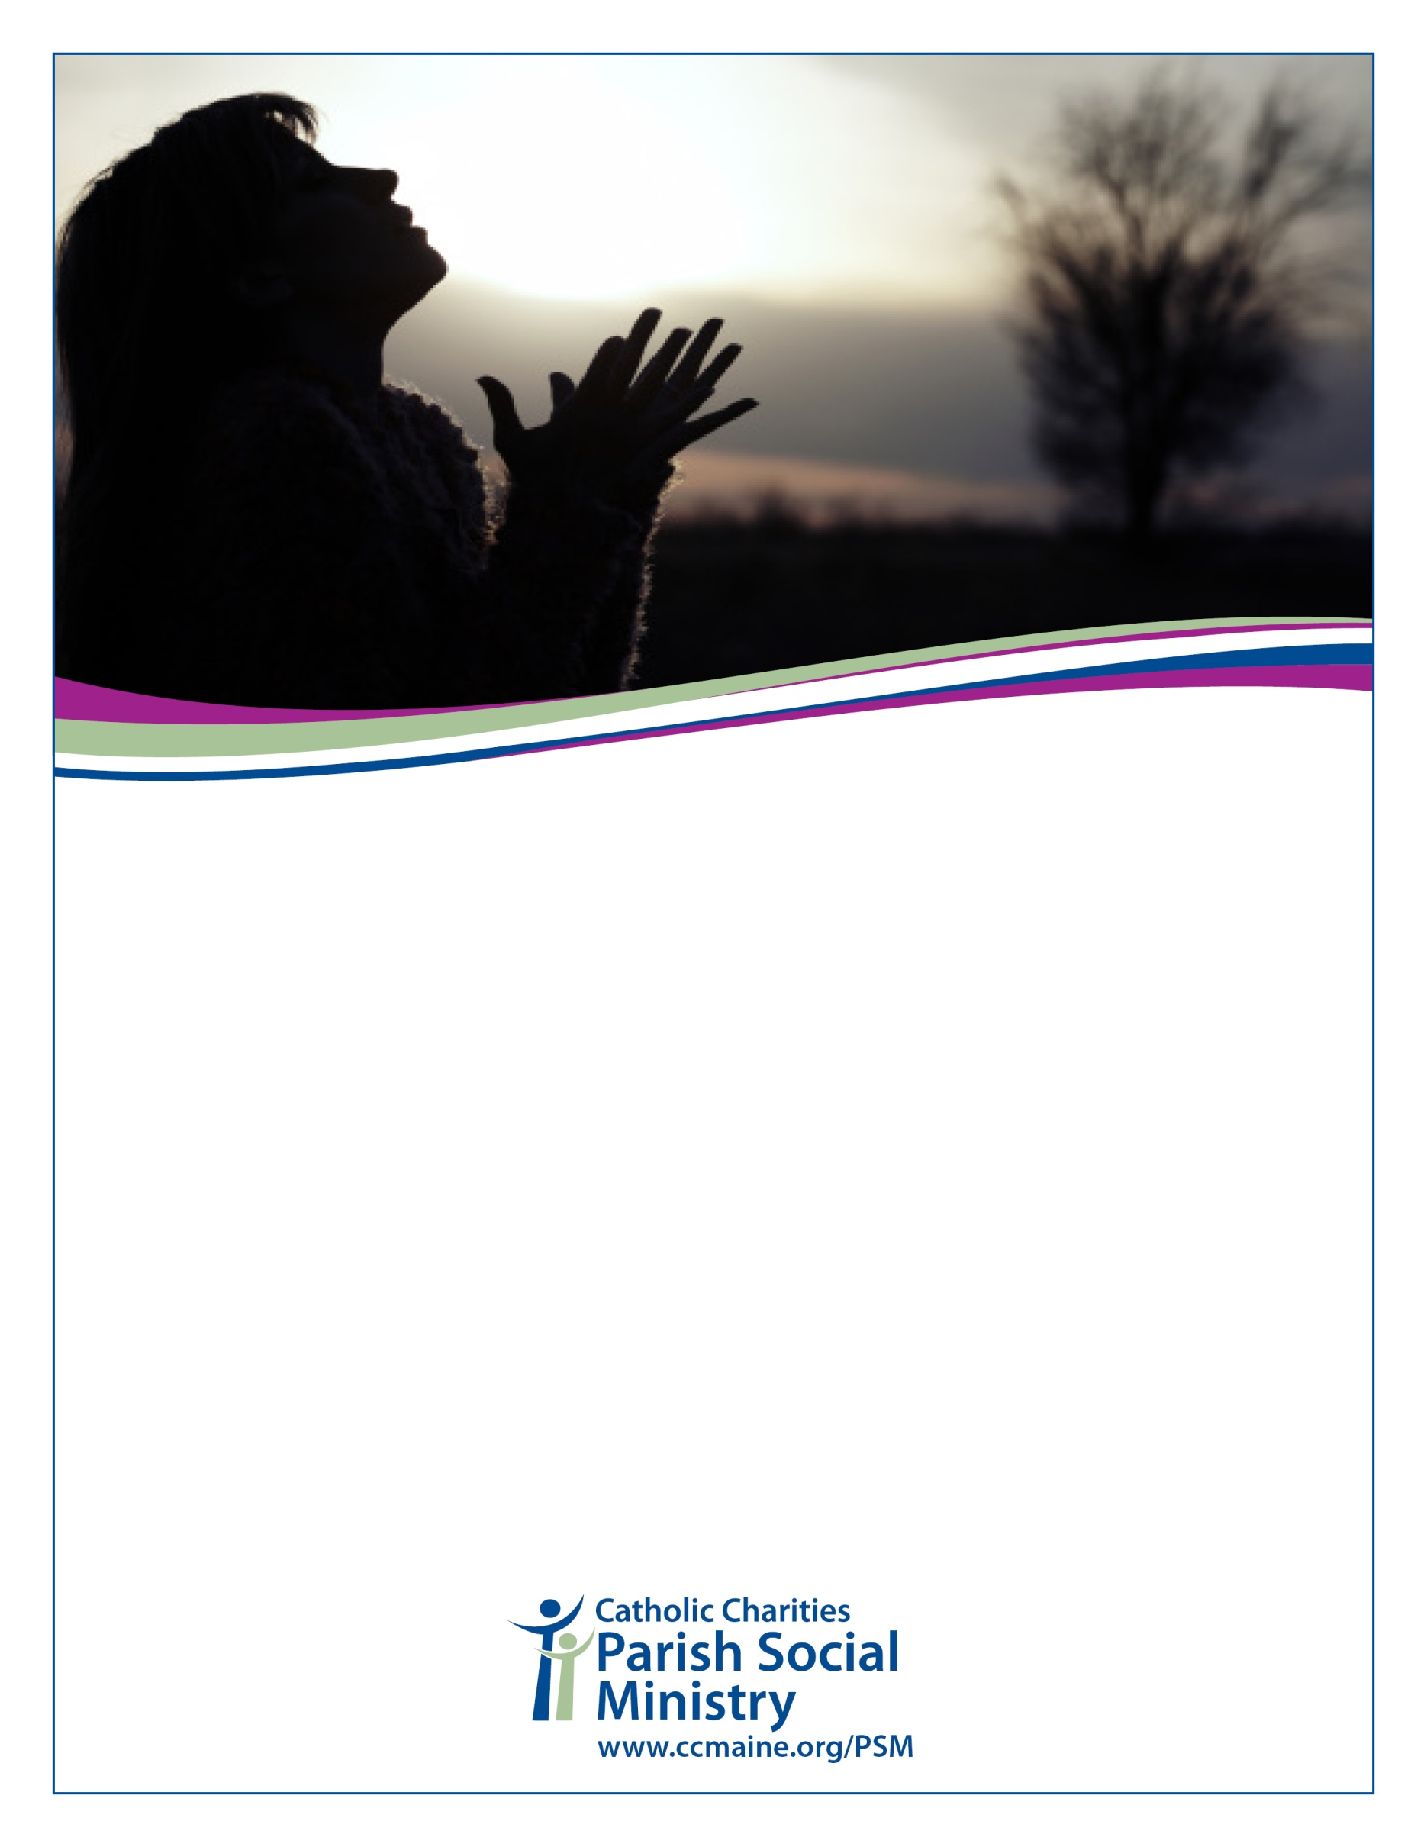

*Sponsored by*

**Our Lady of Hope Parish, the Portland Interfaith Clergy Association and**

and

**Opiate Addiction Crisis***Pray in solidarity with community for this crisis that overwhelms us. God is Hope.*

**Monday, June 11, 7pm**

**St. Pius X Church**

492 Ocean Ave., Portland

*Featuring Dan Mahoney speaking on addiction here in Maine*

**Ecumenical Prayer Service**