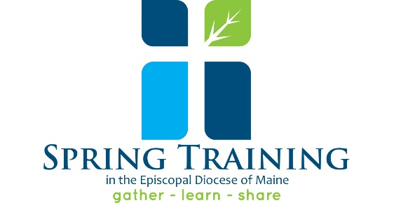
Diocesan Spring Training 2020
March 21st
9:30 am to 3:30 pm
South Parish Congregational Church
9 Church Street, Augusta, Maine

“You are the light of the world.”

We are excited to announce that the Rev. Jay Sidebotham, founder of RenewalWorks, will start us off with a presentation about his own experience as a parish priest, and how RenewalWorks can shift the focus of parishes so that we center our common life on discipleship with Jesus and spiritual growth. Then breakout discussion groups will give you insights and ideas to bring back to your parish. After lunch, there will be an opportunity to attend a workshop of your choice. We will close with Eucharist with Bishop Brown. This is a great opportunity to see old friends and make new connections with folks from all around the diocese. Space is limited. Registration required by March 16.
For workshop descriptions and registration, visit: episcopalmaine.org/spring-training

Diocesan Spring Training 2020
March 21st
9:30 am to 3:30 pm
South Parish Congregational Church
9 Church Street, Augusta, Maine

“You are the light of the world.”

We are excited to announce that the Rev. Jay Sidebotham, founder of RenewalWorks, will start us off with a presentation about his own experience as a parish priest, and how RenewalWorks can shift the focus of parishes so that we center our common life on discipleship with Jesus and spiritual growth. Then breakout discussion groups will give you insights and ideas to bring back to your parish. After lunch, there will be an opportunity to attend a workshop of your choice. We will close with Eucharist with Bishop Brown. This is a great opportunity to see old friends and make new connections with folks from all around the diocese. Space is limited. Registration required by March 16.
For workshop descriptions and registration, visit: episcopalmaine.org/spring-training

Schedule

Gather: Doors Open, Registration, Coffee Ready: 8:30 am

Presentation by Jay Sidebotham of RenewalWorks: 9:30 am

Break-Out Sessions: We are the light of the world: 11:00 am

Lunch – Youth Ministry Mission Exchange fundraiser: 12:00 pm

Workshop Session: 1:00 – 2:00 pm
Artful Prayer
Building Beloved Community with All Ages
Congregational Transitions
Liturgical Renewal in the Episcopal Church
Parables and Metaphors: Jesus teaches in Matthew’s Gospel
Social Justice and Advocacy Engagement
Year-round Stewardship -- A Model Program

Closing Worship with Bishop Brown: 2:15 pm

Schedule

Gather: Doors Open, Registration, Coffee Ready: 8:30 am

Presentation by Jay Sidebotham of RenewalWorks: 9:30 am

Break-Out Sessions: We are the light of the world: 11:00 am

Lunch – Youth Ministry Mission Exchange fundraiser: 12:00 pm

Workshop Session: 1:00 – 2:00 pm
Artful Prayer
Building Beloved Community with All Ages
Congregational Transitions
Liturgical Renewal in the Episcopal Church
Parables and Metaphors: Jesus teaches in Matthew’s Gospel
Social Justice and Advocacy Engagement
Year-round Stewardship -- A Model Program

Closing Worship with Bishop Brown: 2:15 pm

