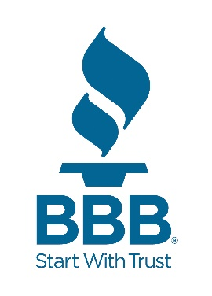
Better Business Bureau Northwest & Pacific
Contact: Roseann Freitas Phone 808-260-0643 Email: Roseann.freitas@thebbb.org

BBB Tips: How to Build Customer Relationships that Increase Repeat Business
When it comes to long-term success, building customer relationships may matter more than bringing in new business.

Numbers show that the likelihood of making a sale to an existing customer is as high as 70 percent, while the probability of selling to a new client could dip as low as five percent. Those existing customers are also 50 percent more likely to try your new products.
Positive customer relations directly influence your business’s bottom line. The better your business is at making its customers feel appreciated, the more likely it is that customers will return to your products and services. You become their first destination.

Those relationships don’t just happen, though. Businesses must establish a foundation of trust with their customers in order to keep them coming back. Better Business Bureau offers the following tips for building long-lasting connections with customers.

Keep in Touch

Like any close relationship, authentic communication is the secret to staying together. Your connection with your customers is no different. They want to hear from you, but when you chime in, the conversation needs to be about more than just the latest deals your company is pushing.

Some of the best ways to speak on a deeper level are to leverage tools such email marketing and social media platforms. For example, sending newsletters that deliver insights related to products your business offers. Social media also allows you to proactively provide updates on upcoming or ongoing issues related to your services.

Keep Responding
Responding to reviews and complaints should be an essential part of your business’s approach to customer relationships. Show appreciation following a great review and exhibit sincerity when provided criticisms. Those follow-ups add to the attachment customers have with your brand.

A recent BrightLocal survey stated that “89 percent of consumers are 'highly' or 'fairly' likely to use a business that responds to all of its online reviews.” Don’t lose business by failing to acknowledge what your customers are saying.

Keep Your Word
It may seem like a no-brainer to honor your promises to customers, but it’s not always that easy. Mistakes happen, and when they do, reputations and relationships take a hit.

It’s important to do the best thing you can in those situations: Make things right. If your customers’ expectations are at risk of going unmet, let them know immediately about your plan to fulfill your end of the transaction. Identifying and then correcting an issue may even bring you and your customer closer together.

Keep Thanking

Don’t take your customer relationships for granted. Your business relies on those connections to succeed. Take the time to let your most loyal customers know how grateful you are for their devotion.

Those expressions of appreciation can arrive in several forms. Depending on the size of your team, literal thank you notes serve as nice, personalized touchpoints. Providing free items or installing customer loyalty programs are effective ways to show thanks as well.

Keep Collecting Feedback

A lot of what was shared earlier regarding responsiveness applies here, too. Customers want to know you care about their experiences with your company. What’s different about collecting and acting on customer feedback, though, is that it can proactively alert you of their expectations.

How you gather that feedback – and how often it’s collected – depends on what works best for your business (online surveys seem to be the go-to route for many companies). The important thing is that you activate the feedback you receive. Use it to improve processes, interactions, and outcomes that ultimately grow your relationships with customers.

For more business tips, visit Trust-bbb.org.

