Continue Providing Healthcare Benefits during COVID-19

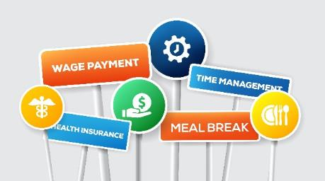
Hawaii employers can continue to provide company-paid healthcare benefits for eligible employees under certain circumstances. For qualified BIA-Hawaii members throughout the state, HMAA’s preferred pricing through our Association Health Plan may reduce the cost of continuing coverage for your employees and their families. Eligible employers can enroll in the BIA-Hawaii Association Health Plan with HMAA at any time rather than waiting for your health plan’s renewal period.

HMAA’s medical plans cover traditional and comprehensive alternative care including chiropractic, naturopathic, acupuncture, and massage therapy. Additional benefits include dental, prescription, vision, and life insurance. Because HMAA is passionate about your health, they also offer a variety of wellness services and discounts such as their innovative Baby & Me maternity program and free colorectal cancer screening. Their extensive provider network includes nationwide access to physicians and a free 24/7 telemedicine service.

You may have heard about loans available through the Small Business Administration’s Paycheck Protection Program (PPP), which businesses can use to keep employees paid and insured, and may be fully forgiven if certain requirements are met. Due to the complexity of, and potential changes to, the requirements, please consult with your legal or other advisor for further guidance.

HMAA understands that this is a difficult time for businesses and continues to have your best interest at heart. To learn more, contact HMAA at (808) 791-7616 or sales@hmaa.com.

