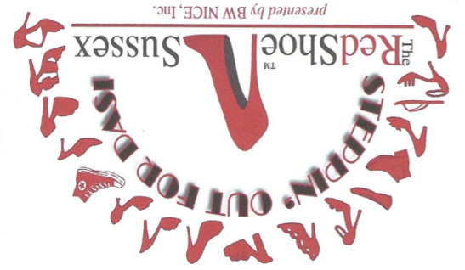 | October 14, 2021 6:00 PM  Lake Mohawk Country Club  21 The Boardwalk  Sparta, NJ 07871
 |  | Benefiting
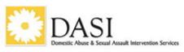
& BW NICE, Inc.

Sponsorship Opportunities
☐ | The Ruby Glass Slipper - $10,000 Presenting Sponsor
 | Reserved seating for 12, your company featured on welcome banner as presenting sponsor, featured recognition on the BW NICE website and social media, press release announcing sponsorship, radio spot featuring sponsorship, video (30-60 second video to share on social media) five minute video interview for sharing on social media, three photo social media post on all social media, five minutes to speak at the event to welcome guests, 3 minute video featured on chapter Facebook page and on our event website, thank you signage on each table.
☐ | The Scarlet Stiletto - $5,000 Sponsor
 | Reserved seating for 10, your company logo prominently displayed at event, video (30-60 second video to share on social media), three photo social media post on all social media, recognition on the BW NICE website and social media, thank you signage on each table.
☐ | The Sassy Slingback - $3,000 Sponsor
 | Reserved seating for 8, three photo social media post on all social media, signage prominently displayed, thank you signage on each table, recognition on the BW NICE website and social media.
☐ | The Darling D’Orsay - $1,500 Sponsor
 | Reserved seating for 6, photo social media post on all social media, thank you signage on each table.
☐ | The Plumy Platform - $1000 Sponsor
 | Reserved seating for 4, photo social media post on all social media, thank you signage on each table.
☐ | The Whimsical Wedge - $500 Sponsor
 | Reserved seating for 2, thank you signage on each table, logo on included in social media recognition.
☐ | The Covid Crocs- $150 Sponsor
 | Logo included in social media recognition and day of event program recognition.
Deadline for Sponsorship: September 1, 2021
Business: | Click or tap here to enter text.
Business Address: | Click or tap here to enter text.
Contact Person: | Click or tap here to enter text.
Phone: | Click or tap here to enter text. | Email: | Click or tap here to enter text.
Check #: | Click or tap here to enter text. | Amount | Click or tap here to enter text.

(Payable to BW NICE, Inc. – Note: “for sponsorship” on check)
Pay Online Available: RedShoeSusssex.com/paynow
Thank you for considering being a part of this incredible event. Your contribution is truly appreciated.
BW NICE is a 501 (c) (3) Organization, Registered with the IRS. Your contribution is tax-deductible to the extent allowed by law.
Red Shoe Committee: bwnicesussex@gmail.com
Return form and payment to: BW NICE Sussex | PO Box 650, Sparta, NJ 07871 (DO NOT MAIL CASH)
RedShoeSusssex.com

