March 2023
WHEREAS multiple myeloma, also known as myeloma, is a type of cancer that develops in plasma cells found in bone marrow and is the second most common blood cancer¹ diagnosis;
AND WHEREAS a growing number of Canadians are diagnosed with myeloma every day, yet myeloma is relatively unknown, and remains incurable²:
AND WHEREAS great strides have been made in the development of new innovative treatments for myeloma^{3a}, but there remains a critical need to raise awareness and support for Canadians’ access to these treatments, and clinical research to find a cure for this deadly disease^{3.b};
AND WHEREAS the city of XXX and the Canadian myeloma community are committed to supporting the range of diverse communities impacted by the disease, especially those disproportionately experiencing its effects^{3b} and regardless of race, ethnicity, culture, gender, socio-economic background or language;
AND WHEREAS the local Multiple Myeloma Support Group and a national patient organization, Myeloma Canada, work in tandem offering resources like information, advocacy, a sense of community⁴, and showing people living with myeloma they are not alone.
AND WHEREAS Multiple Myeloma Awareness Month is an important opportunity to further educate the public, and medical community in recognizing myeloma’s signs and symptoms, which is crucial for achieving earlier diagnoses and thus better outcomes for people suffering from this difficult, lifelong disease;

His Worship XXX, Mayor of XXX proclaims that the month of March 2023, shall be known as “Multiple Myeloma Awareness Month” in our city.

- Sources included on the following page

Data Sources

  - Myeloma is frequently cited in multiple publications as the 2nd most common blood cancer diagnosis
    - Tsang, M., Le, M., Ghazawi, F.M., Cyr, J., Alakel, A., Rahme, E., Lagacé, F., Netchiporouk, E., Moreau, L., Zubarev, A., Roshdy, O., Glassman, S.J., Sasseville, D., Popradi, G. and Litvinov, I.V. (2019), Multiple myeloma epidemiology and patient geographic distribution in Canada: A population study. Cancer, 125: 2435-2444. https://doi.org/10.1002/cncr.32128
    - Blood Cancer in Canada Facts & Stats (2016) https://www.llscanada.org/sites/default/files/National/CANADA/Pdf/InfoBooklets/Blood_Cancer_in_Canada_Facts_%26_Stats_2016.pdf
  - Further explanation of myeloma & disease mechanisms are widely available
    - Tsang, M. et al (2019) – 1 a
    - Canadian Cancer Society (website). “What is myeloma?” https://www.cancer.ca/en/cancer-information/cancer-type/multiple-myeloma/multiple-myeloma/?region=mb

  - Incidence and prevalence rates are growing by a statistically significant proportion, which has been the case since the late 80’s / early 90’s
    - Demers AA, Sainte-Jacques N, Ellison J, Brenner D, Fitzgerald N, Aziz S, Turner D. Update on cancer incidence trends in Canada, 1984 to 2017. (2022) Health Promot Chronic Dis Prev Can. 2022;42(7):301-5. https://doi.org/10.24095/hpcdp.42.7.04
    - Canadian trends in cancer prevalence (1992 - 2017). Canadian Cancer Tool https://health-infobase.canada.ca/ccdt?index=4241
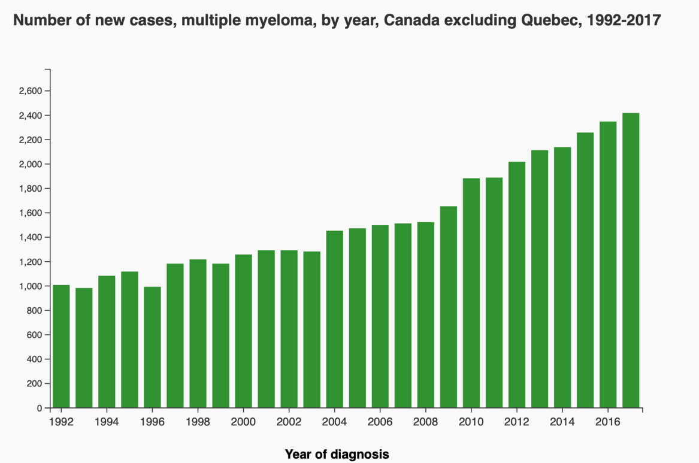

  - Vast improvement to myeloma’s 5-year survival rate since the early 90’s, due to new treatment development & better understanding of the disease has given myeloma patients a nearly 50% chance of surviving at least 5 years past their diagnosis
    - Cancer survival statistics, 2020 update & Brenner, D. et al (2020)
    - Canadian trends in cancer prevalence Statistics Canada, Catalogue no. 82-003-XPE • Health Reports, Vol. 23, no. 1, March 2012 https://www150.statcan.gc.ca/n1/pub/82-003-x/2012001/article/11616-eng.htm

  - Myeloma awareness is of timely importance for two key reasons:
    - Myeloma and its treatment both significantly compromise patients’ immune systems, and preliminary research has also demonstrated the mRNA vaccines for COVID-19 are also less effective for blood cancer patients, leaving them extremely vulnerable to the SARS-COV2 virus, and any others. Increased awareness of myeloma can help the public understand who bears the consequences of noncompliance with safety measures.
      - Tzarfati, K.H., Gutwein, O., Apel, A., Rahimi-Levene, N., Sadovnik, M., Harel, L., Benveniste-Levkovitz, P., Chaim, A.B. and Koren-Michowitz, M. (2021), BNT162b2 COVID-19 Vaccine is significantly less effective in patients with hematologic malignancies. American Journal of Haematology. https://doi.org/10.1002/ajh.26284
    - A significant body of international research has shown myeloma to be notably more prevalent amongst people of African descent (and more so in men); and Canadian academics have also demonstrated myeloma to be notably more prevalent in First Nations populations, especially First Nations women. The global movement towards racial justice and equality must be echoed by every corner of society and raising awareness for diseases which have had their national burden overlooked due to the (marginalized) populations they impact, is a step in the right direction.
      - Mazereeuw, M. V., Withrow, D. R., Diane Nishri, E., Tjepkema, M., & Marrett, L. D. (2018). Cancer incidence among First Nations adults in Canada: follow-up of the 1991 Census Mortality Cohort (1992-2009). Canadian journal of public health = Revue canadienne de sante publique, 109(5-6), 700–709. https://doi.org/10.17269/s41997-018-0091-0
      - Cancer in First Nations people in Ontario, Canada: Incidence and mortality, 1991 to 2010 Sehar Jamal, Carmen Jones, Jennifer Walker, Maegan Mazereeuw, Amanda J. Sheppard, David Henry, and Loraine D. Marrett Health Reports, Vol. 32, no. 6, June 2021
      - Ailawadhi, S., Bhatia, K., Aulakh, S., Meghji, Z., & Chanan-Khan, A. (2017). Equal Treatment and Outcomes for Everyone with Multiple Myeloma: Are We There Yet? Current Hematologic Malignancy Reports, 12(4), 309–316. doi:10.1007/s11899-017-0393-y
      - Tsang, M. et al (2019) – 1b
- a.
    - As a patient organization. Myeloma Canada remains deeply committed to ensuring our services and programs are accessible to, and beneficial for, all Canadians impacted by myeloma, regardless of their race, ethnicity, religion, gender, or sexual orientation.
    - https://www.myelomacanada.ca

