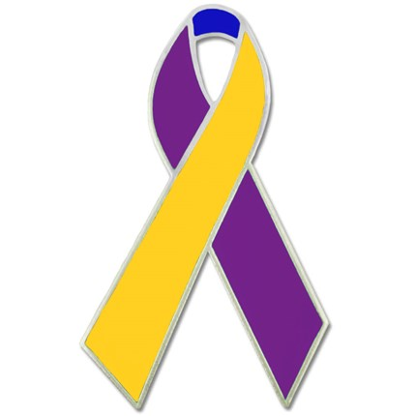
Dear Members and Friends of the Chatham United Methodist Church (CUMC),

First and foremost, I hope you and your families are doing OK during this very challenging time. And, thank you all for your prayers of support during my bladder cancer journey. It has involved a series of treatments, then major surgery (neobladder), and now ongoing testing to make sure I’m OK. So far, so good.

After I shared the fact of having this disease and my offer to help fellow patients and their families, during events at CUMC, some of you came to me to let me know of family members or friends with bladder cancer – or you helped me get in touch with other CUMC members and friends about this. I certainly hope that all of those fellow patients are continuing to progress through their journeys OK, as well. And for those of you who are fellow patients yourselves, thank you for the time spent on the phone, as we shared stories, exchanged info, and discussed advice and guidance.

Now, regarding the Subject of this letter: Knowing the background that we share involving bladder cancer, this letter is an invitation for you to forward the following information regarding participation in the annual Walk to End Bladder Cancer to the bladder cancer patients you know, and also to consider participating yourself.

This year, because of COVID-19 restrictions, the Walk is happening in 2 parts.

The first part is a virtual walk, scheduled for Saturday May 2nd at 10 AM ET. The virtual walk is the main subject of this letter.

The second part for us here in New England (and selected other locations, including the Jersey Shore) is a real walk later in the year. My wife, Jan, is the New England Walk organizer (as she also did last year). You can find out about the NJ version at www.bcan.org.

It’s important for those intending to participate to respond soon, because of deadlines indicated below (highlighted in bold).

The overall coordinator of the Walks is the Bladder Cancer Advocacy Network (BCAN, pronounced “beacon”). As I mentioned above, the nationwide virtual walk has been scheduled for Saturday, 5/2/2020 at 10 am ET. The idea is that people will walk on their own, listening to a broadcast on BCAN’s social media channels; the broadcast will go for approximately an hour. The full message from BCAN is below, but here is some of the key info:

- Registration is at www.bcanwalk.org.
- People can either register directly for the virtual walk, or they can register for any of the planned “real” walks, and this will automatically include them in the virtual walk as well.
- We’re trying to get people to register by Thursday, 4/23, so that we will have time to ship them a t-shirt prior to the virtual walk.
- There’s also a special promotion: if you raise $100 by Monday, April 20, 2020 using the BCAN web site or Walk with BCAN mobile app, you will receive a free BCAN Bundle, which includes a cap, tumbler, and bladder cancer awareness bracelets.

If you have any questions, please let me know. And please feel free to forward this message to anyone else – we appreciate any and all efforts to raise awareness for the Walks – to help generate much-needed funding for R&D. Bladder cancer is the 4th most prevalent cancer for men and 6th or 7th overall (men are 4 times more likely to get it than women), yet R&D funding for bladder cancer ranks way down at #23.
Thanks!

Best wishes,

Bob Schreiber
schreiberrp@alum.mit.edu (forwards to work schreiberrp@cdmsmith.com and home schreiber@rcn.com

The Bladder Cancer Advocacy Network (BCAN) Is hosting a special virtual walk event
Saturday, May 2, 2020 at 10am ET.

The Virtual Walk to End Bladder Cancer will be an interactive nationwide event which will involve participants walking from a place of their choosing. This event will broadcast on BCAN’s social media channels (Facebook, Twitter and YouTube).
1. It’s easy. Register at www.bcanwalk.org and recruit your friends, family, and colleagues to join the cause from wherever they are. Be sure to register by Thursday, April 23, 2020 to receive your walk t-shirt prior to the event!
2. It’s fun. Joining with others or forming your own virtual walk team is a great way to stay connected in a time of social distancing.
3. It matters. In 2020, more than 81,000 people will hear the words “You have bladder cancer.” More than 17,000 of them will not survive their disease. Bladder cancer is among the most commonly diagnosed cancers in the U.S., but one of the least known and understood. The money raised from the Walks will help the Bladder Cancer Advocacy Network (BCAN) continue its mission of advocating for bladder cancer research and supporting those impacted by the disease.

You can help end this disease by participating in the Virtual Walk to End Bladder Cancer to raise awareness, raise funds, and raise spirits in a time of social distancing.

We hope you will join us!

2020 National Walk Sponsors include: Astellas/Seattle Genetics, AstraZeneca, FerGene, Genentech, Janssen Oncology, EMD Serono/Pfizer, and Photocure.

Please visit www.bcan.org for more information about the Bladder Cancer Advocacy Network.

