What is Zoom?
Zoom is a cloud-based platform for video and audio conferencing and chat. Zoom works on mobile devices, desktops, and telephones and will enable the community to connect safely during COVID-19.

Before reading further, we suggest you familiarize yourself with Zoom and watch this short video on how to join a meeting. The video page also offers short, thorough tutorials for accessing Zoom by phone and accessing Zoom via desktop/laptop computer.

How do I use Zoom?
You have several options for utilizing Zoom! Zoom meetings can be accessed via the web, a free computer program, a mobile app, cell phones and landline telephones.

- To learn more about Zoom, please visit the FAQ page and the Getting Started guide.

- To learn the basics of joining a Zoom meeting, please see here.

- For more information on downloading the Zoom mobile app, please see here.

- For more information on accessing Zoom via laptop or desktop computer, please see here.

- For more information on accessing Zoom from a landline phone, please see here.

Try a test meeting!
Before Sunday morning, we encourage everyone to join a test meeting to see how the process works for you and to address any confusion. You may join a test meeting here.

How does it work?
Each week, Chatham UMC will offer a virtual Coffee Hour. A Zoom meeting is a live video and audio feed that will enable anyone with the invitation to access conversation and fellowship! Small groups and Bible studies will also be moving forward with Zoom.

If you access Zoom via the web, computer program, or mobile app, you will be able to view the video feed and will have the option of also being seen on video (you have the option of not appearing on video, which each individual participant can control for themselves).

If you access Zoom via a cell phone or landline telephone, you will be able to listen to the audio from the Zoom meeting, but will not have the option of being on video or viewing video.

What to expect!
Here is a guide that can be tailored to your own comfort level with technology:

1. A clickable link to join the Zoom meeting from a computer. If you will be accessing Zoom via a computer, please read the RED section below.

2. A one tap mobile number. If you are accessing Zoom via a smartphone or mobile phone, please read the BLUE section below.

3. A dial-in number for use on a landline phone. If you are accessing Zoom via a landline phone, please read the GREEN section below.

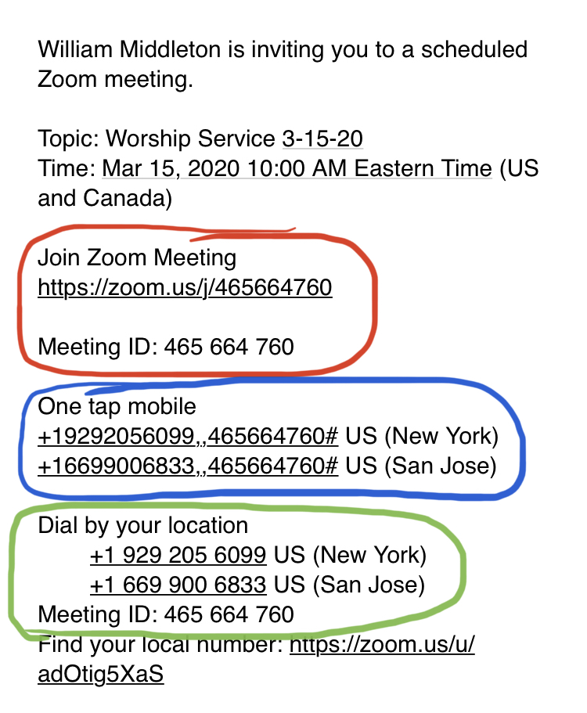

- Join Zoom Meeting from a computer (a clickable link to join the Zoom meeting)
If you will be attending worship or a meeting via Zoom and are accessing the meeting invitation on the same computer you’re planning to use for the meeting, you can click the “Join Zoom Meeting” link. This will open a Zoom webpage, pictured below.

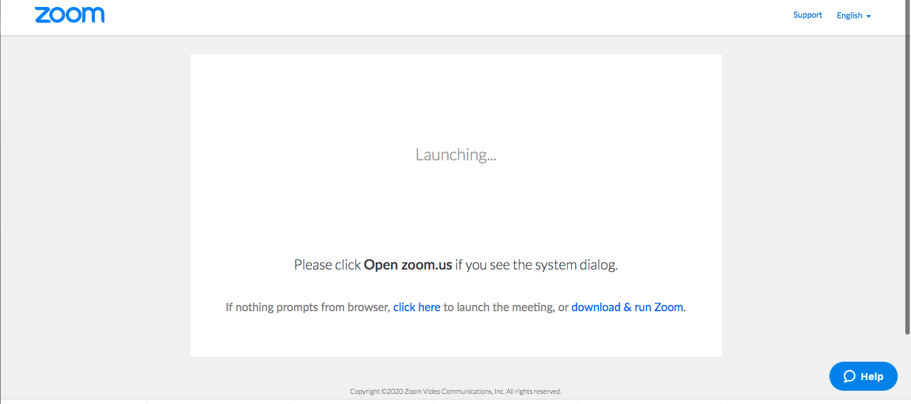

This webpage will give you the following options:

a) open the Zoom program on your computer (if you already have it installed);
b) download and run the Zoom program on your computer;
c) launch the meeting from your browser, without downloading or using the Zoom computer program.

If you choose to use Zoom on the web or are otherwise prompted to enter a Meeting ID number, the Meeting ID number listed below the “Join Zoom Meeting” link in the invitation email is the number you will enter.

For information on how to navigate Zoom once you are in the meeting, please see this guide!

- One tap mobile
If you choose to call into the meeting/worship service from your smart phone, you can click this option to dial in from your mobile phone. The benefit of this option is that the Meeting ID will be entered automatically for you when prompted (hence “one tap”).

- Dial by location (A dial-in number for use on a landline phone)
If you choose to call into the meeting/worship service from a landline phone, you will need to dial the New York number listed in the invitation email. Landline callers should be prepared to enter the Meeting ID on your phone’s keypad.

What if I need help?

That’s okay! You can access the Zoom Help Center online or contact them by phone at 888-799-9666, extension 2.

Thank you!
Thank you all for your flexibility and patience as we work to lower our community’s risk of exposure while maintaining our commitment to our faith, our church and each other!

