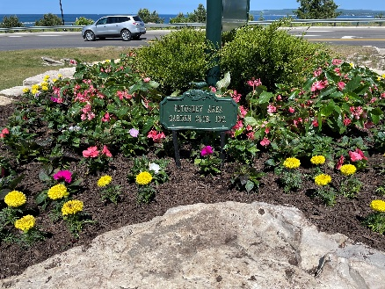
In 1934, a group of residents formed the Petoskey Garden Club (later adding the more inclusive “Area”), with their mission to restore Petoskey’s beauty. They encouraged home owners to plant trees, flowers, and gardens, and urged businesses to install and plant flower boxes in front of their stores.

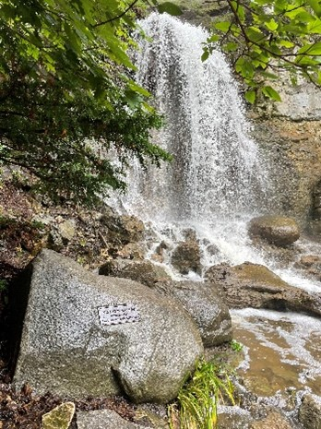
Gradually, the landscapes improved. The limestone quarry became a park, the beautiful Waterfall Area, and in 1990, PAGC bought landscape boulders, installed, and planted two large beds, complete with irrigation. The floral beds are planted largely with perennials, with annuals added for splashes of color, as many graduation, engagement, and wedding photos are taken there. Memorial in the Waterfall Area to the founder of the Petoskey Area Garden Club, Dorothy Loveless. PAGC has two large beds in this area.

The old railway depot at the waterfront is now the Little Traverse Historical Museum, and we have a large, beautiful bed there. The bulk of it has flowering perennials with borders of bulbs blooming in spring and annuals planted in June.

Moving in from the marina area, one comes to the Downtown area and Pennsylvania Park. This park is the gathering place of our city where concerts, art fairs, picnics, and dog walking are constant. It is a social and aesthetic center with green lawns and towering trees to shade in the summer heat. In 1973, the City Council proposed removing the historical railroad tracks and turning Penn Park into a parking lot! The members of PAGC vigorously objected to the idea.

In April of that year, PAGC headed a petition drive for a City Charter amendment banning the use, sale, or lease of parks without a vote of the citizens. On June 8, 1973, PAGC member Barbara Waters filed the petition which allowed the issue to be put on the ballot. Throughout the summer and fall PAGC and other like-minded organizations informed voters of the importance of the issue. In November, the amendment was voted in, and Ms. Waters was elected mayor of Petoskey, the first female mayor. Pennsylvania Park was saved as well as the other parks in Petoskey.

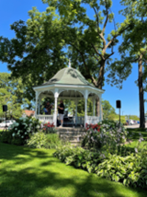
Pennsylvania Park has several floral beds planted and maintained by PAGC. The club constructed the lovely white Gazebo with a copper roof and planted the beds surrounding it for their 50th Anniversary in 1984. The Gazebo is a focal point of the park and is often used for concerts and city celebrations. For their 80th Anniversary, the Gazebo was restored and got a fresh coat of paint and new plantings around it. The club also installed a Blue Star Memorial that year (2014).This anniversary in 1984 must have put the PAGC members to thinking about their future projects as well as their past accomplishments. They began a huge fund-raising endeavor that raised $100,000. In 1986, those funds were placed in the Petoskey/ Harbor Springs Area Community Foundation, where they have grown each year. All expenses needed for PAGC projects and plantings come from the interest generated by the Foundation funds.

PAGC also plants and maintains beds at the North and South entrances to the city, and a large, diverse City Center bed at the corner of Mitchell and Howard Streets, adjacent to Pennsylvania Park. On the walkway of the Bear River Recreational Park, we have a Monarch Way Station, planted in 2008. We also pay for 24 baskets each summer for the Mitchell Street Bridge. Automatic watering and feeding were added two years ago.

For the past seven years, PAGC has been developing ideas and plans for a children’s garden. We were advised early on by Deborah Kinney, designer of MSU’s Children’s Garden, to focus our garden on what makes our community unique. We thought of the lakes, dunes, forests, native plants, and the indigenous people who first lived and still here. Partnering with the landscape architectural firm of Beckett & Raeder, the Little Traverse Bay Band of Odawa, and the City of Petoskey Department of Parks & Recreation, this project is now part of the city’s Master Plan.

It will be called Kitigaan Children’s Garden (“Kitigaan" meaning “children” in the Odawa language), focusing on the native plants and the culture of the Odawa. It will be a place where children can play, climb, explore, plant, and learn. It will be in Arlington Park (2.5 acres), one block north of Pennsylvania Park, overlooking Little Traverse Bay, and adjacent to the ancient path that the Odawa and other tribes traveled between Mackinaw City and Grand Rapids.

Petoskey Area Garden Club is beginning to raise matching funds to augment what the city can obtain through municipal grants for this new project.

2024 is the 90th Anniversary year of PAGC. This Kitigaan Garden will express the same commitment to the community that the Garden Club founders and members though the years have made: “To provide leadership in education resources and networking opportunities for its members to promote love of gardening, floral and landscape design, and civic and environmental responsibility.”

