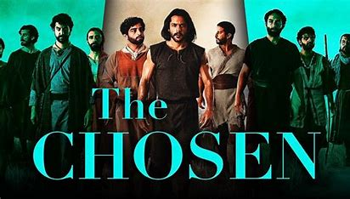

The Chosen is an American Christian historical drama television series. It has been released in theaters and is available for streaming on several online services. Created, directed, and co-written by filmmaker Dallas Jenkins, it is the first multi-season series about the life and ministry of Jesus of Nazareth. Primarily set in Judaea and Galilee in the 1st century, the series centers on Jesus and the people who met and followed him. The series stars Jonathan Roumie as Jesus as well as Shahar Isaac, Elizabeth Tabish, Paras Patel, Noah James, and George H. Xanthis.
Season One
Set in 1st century Galilee, the first season chronicles Jesus starting to build a group of disciples and his ministry,^{[5]} inviting people with different backgrounds to study under him. As he performs his first miracles, including turning water into wine in Cana, Jesus calls the redeemed woman Mary Magdalene; the stonemason Thaddeus; the choir member Little James; the fishermen Simon, Andrew, Big James, and John; the caterer Thomas and vintner Ramah; and the tax collector Matthew to follow him. Following Jesus's meeting with the Pharisee Nicodemus, the season culminates with the group traveling through Samaria, where Jesus launches his public ministry after revealing himself to Photina, a Samaritan woman.
Season Two
Beginning in Samaria, the second season moves into nearby regions such as Syria and Judea, where Jesus continues to build his group of students. As he continues to perform miracles, including healing the paralytic at the Pool of Bethesda, while preparing for a significant sermon, Jesus additionally calls John the Baptizer's disciple Philip, the architect Nathanael, and the Zealot Simon Z. As the word of Jesus spreads throughout the region,^{[5]} he encounters both opportunities and difficulties.^{[6]} The season ends on the preparations for Jesus's Sermon on the Mount with the help of the business apprentice Judas Iscariot.
Season Three
Returning to Capernaum, the third season portrays the increasing popularity of Jesus, which troubles different societal and political groups, including the Romans and the Pharisees.^{[7]} Following the Sermon on the Mount, Jesus sends his twelve apostles, two by two, to preach and perform miracles without him, leading to the disciples facing their biggest challenge yet. Jesus then returns to his hometown, Nazareth, which results in a shift to his ministry in the year of his popularity. After multiple miraculous occurrences, the season closes in the Decapolis and at the Sea of Galilee, where Jesus feeds thousands with loaves and fishes and then walks on the water.

