Ready Pinellas Emergency Planning Mobile App
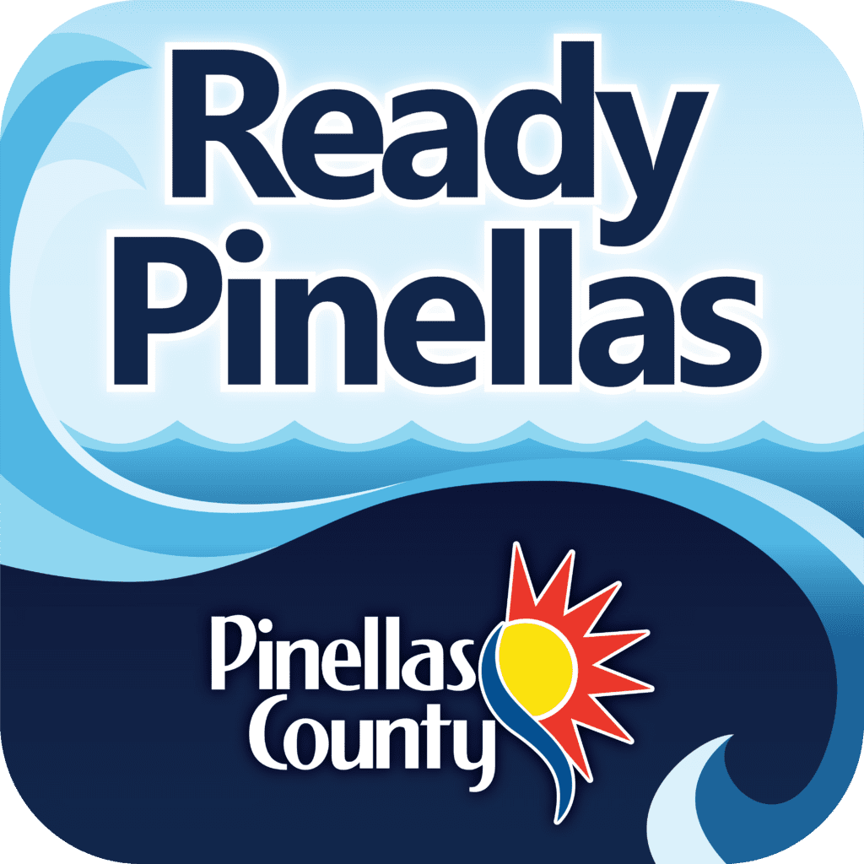
Ready Pinellas is designed to help you prepare yourself and your family before, during and after a storm. It is available for free download on the Apple App Store and Google Play store.
With the Ready Pinellas app, you can personalize your emergency plan, use handy checklists, find preparedness tips and save important information all in one place.
As a storm approaches, the app will provide real-time updates to help keep you safe. It will provide resources to contact us year-round and during a disaster and give you tips to stay informed.


Ready Pinellas App Features
- Know Your Zone: You can use the app to look up your hurricane evacuation zone.
- Make a Plan: Use our emergency supply checklist, home inventory and emergency contacts tools to build a personal emergency plan that you can share. You can take pictures of items for your home inventory.
- Push Notifications: Through the app, you will receive emergency notifications from Pinellas County Emergency Management, the National Weather Service and Alert Pinellas.
- Special Needs: You can learn more about special needs assistance, which is intended for those who need transportation or require minimal medical assistance while seeking public shelter. You can register from the app.
- Preparedness Tips: Learn how to prepare your family, pets, home, condo, mobile home, boat and more.
- Safety Tips: Find information on What to Do Now before, during, and after an event. Learn about year-round preparedness, how to clean up after a flood or food safety if power has been out.
- Report Damages after a storm has hit Pinellas County.
For more information on all-hazard preparation, visit disaster.pinellas.gov.

