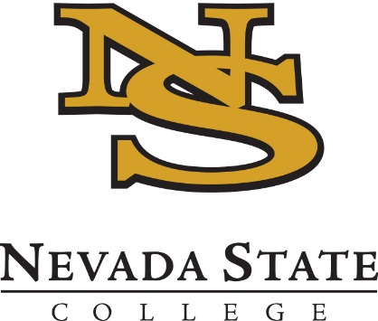
2018 No-Cost Textbook Summer Institute
Application Deadline – February 23rd
Applicant Notifications – February 27th

OVERVIEW
The No-Cost Textbook Summer Institute seeks to support projects that help NSC faculty (1) reduce textbook costs for NSC students taking classes in the core curriculum (2) maximize student savings by converting a course with high frequency and/or enrolment.

Eligibility
Participation is invited from all full-time tenured, tenure-track, or lecturer faculty on a recurring contract, as well as staff who possess relevant expertise. We welcome applications from groups of faculty who will convert several sections of a course.

NO-COST TEXTBOOK PROGRAM
Faculty who are in the early stages of converting a course to a no-cost textbook are encouraged to apply. There will be a combination of weekly group meetings and work days, one-on-one check-ins with the program coordinators, and an expectation to complete some work independently. Participants will be expected to employ or pilot a course with a no-cost textbook in the 2018-19 school year. A stipend of $3000 will be provided for participation in the six-week institute.

Examples of Potential PROPOSALS
- Adoption of the OpenStax Chemistry textbook
- Adoption of a multi-user library ebook.
- Building a course using a combination of open content, journal articles, and content created by the instructor.

Program dates
Applicants must be able to attend all (or nearly all) of the No-Cost Textbook Institute sessions taking place during Summer Session I—May 14 through June 20, 2018. All sections occur from 9:00 a.m. – 12:00 p.m.

Monday | Wednesday
Monday, May 14th | Wednesday, May 16th
Monday, May 21st | Wednesday, May 23rd
Monday, May 28th – HOLIDAY | Wednesday, May 30th
Monday, June 4th | Wednesday, June 6th
Monday, June 11th | Wednesday, June 13th
Monday, June 18th | Wednesday, June 20th – final progress reports

Application
Complete the application below and submit to tiffany.lemaistre@nsc.edu by 5 p.m. on Friday, February 23rd.
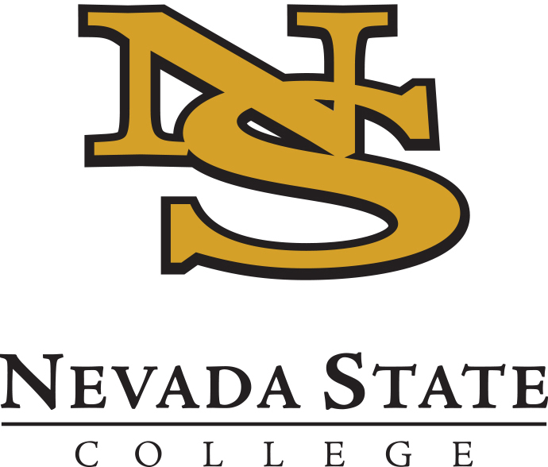
2018 No-Cost Textbook Summer Institute
APPLICATION

Submission Instructions: Please delete the program information listed above and then save this application (.doc, .docx, or .pdf) using the file name “2018_NCT_LastName.doc”. Submit your application to tiffany.lemaistre@nsc.edu by 5 p.m. on Friday, February 23rd.

Name:
Email:
School/Department:
Project Title:

Is this a joint application with other faculty? ☐ Yes ☐ No

Course Details

- What course (including code and number) would you convert during the Institute?

- How many sections of this course will you teach in fall 2018 and spring 2019?

- What is the title and price of the current required textbook/s for this course?

- If you are interested in adopting an open textbook or a library ebook, what is the title of your proposed text?

Project Details

- Please describe why your proposed course is a good candidate for conversion – please include any details about student feedback or relevant data to support your description.

- Please describe your proposed plan to execute your conversion. Identify which tasks have been completed (if any) and which tasks you hope to make progress on during the No-Cost Textbook Institute.

- How do you think the No-Cost Textbook Institute can benefit you in achieving your project goals or objectives? For example, what types of support are you specifically interested in?

