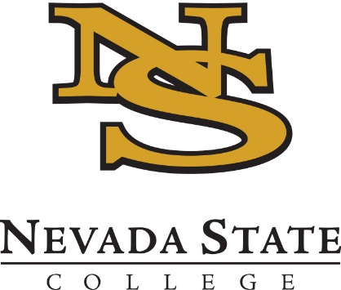
2021 No-Cost Textbook Grants
Application Deadline – March 1st, early submission is strongly encouraged
Applicant Notifications – Ongoing, with final notifications on March 5th

OVERVIEW
The No-Cost Textbook Grant program seeks to support projects that help NSC faculty (1) reduce textbook costs for NSC students (2) maximize student savings by converting a course with high frequency and/or enrollment.

Eligibility
Participation is invited from all full-time tenured, tenure-track, or lecturer faculty on a recurring contract, as well as staff who possess relevant expertise. We welcome applications from groups of faculty who will convert several sections of a course.

NO-COST TEXTBOOK GRANT PROGRAM
Faculty who are in the early stages of converting a course to a no-cost textbook are encouraged to apply. There will be a combination of regular one-on-one check-ins with the program coordinators, and an expectation that most work will be completed independently. Participants will be expected to have a converted course that is ready to teach and to present the results of their conversion to campus by June 30th, 2021. A stipend of $3000 will be provided for the conversion. An initial $1,000 stipend will be provided on acceptance into the program. The remaining $2,000 stipend will be provided upon completion of the conversion process.

Examples of Potential PROPOSALS
- Adoption of the OpenStax Chemistry textbook
- Adoption of a multi-user library ebook.
- Building a course using a combination of open content, journal articles, and content created by the instructor.

Application
Complete the application below and submit to nathaniel.king@nsc.edu by 5 p.m. on Monday, March 1st.

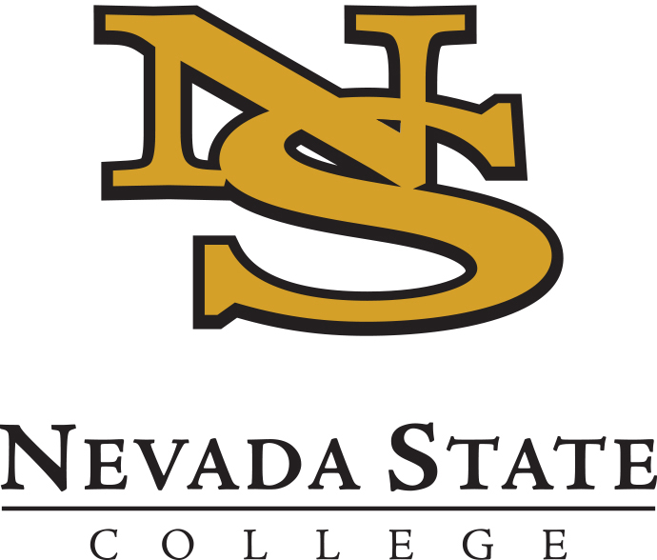
2020 No-Cost Textbook Grant
APPLICATION

Submit your application to nathaniel.king@nsc.edu by 5 p.m. on Thursday, January 9th.

Name:
Email:
School/Department:
Project Title:

Is this a joint application with other faculty? ☐ Yes ☐ No
Does my supervisor support this application? ☐ Yes ☐ No

Course Details

- What course (including code and number) would you convert during the Institute?

- How many sections of this course will you teach in spring 2020 and fall 2020?

- What is the title and price of the current required textbook/s for this course?

- If you are interested in adopting an open textbook or a library ebook, what is the title of your proposed text?

Project Details

- Please describe why your proposed course is a good candidate for conversion – please include any details about student feedback or relevant data to support your description.

- Please describe your proposed plan to execute your conversion. Identify which tasks have been completed (if any) and which tasks you hope to make progress on during this time.

- How do you think the No-Cost Textbook Grant Program can benefit you in achieving your project goals or objectives? For example, what types of support are you specifically interested in?

