Beverages (regular and sugar free welcomed)
- Apple Juice
- Orange Juice
- Milk (the kind that doesn’t need to be refrigerated)

Canned Goods (easy open tops/low sodium and vegetarian items welcomed)
- Fruit
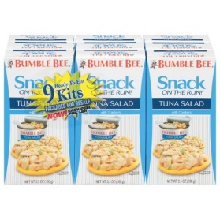
- Soups
- Chili Beans
- Ravioli
- Tuna

Microwaveable Items
- Cup of Noodles
- Cup of Rice
- Cup of Oatmeal
