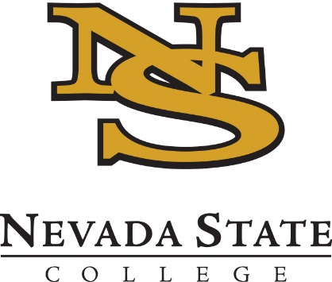
2019 No-Cost Textbook Summer Institute
Application Deadline – March 15th
Applicant Notifications – March 22nd

OVERVIEW
The No-Cost Textbook Summer Institute seeks to support projects that help NSC faculty (1) reduce textbook costs for NSC students (2) maximize student savings by converting a course with high frequency and/or enrollment.

Eligibility
Participation is invited from all full-time tenured, tenure-track, or lecturer faculty on a recurring contract, as well as staff who possess relevant expertise. We welcome applications from groups of faculty who will convert several sections of a course.

NO-COST TEXTBOOK PROGRAM
Faculty who are in the early stages of converting a course to a no-cost textbook are encouraged to apply. There will be a combination of weekly group meetings and work days, one-on-one check-ins with the program coordinators, and an expectation to complete some work independently. Participants will be expected to employ or pilot a course with a no-cost textbook in the 2019-20 school year. A stipend of $3000 will be provided for participation in the six-week Institute.

Examples of Potential PROPOSALS
- Adoption of the OpenStax Chemistry textbook
- Adoption of a multi-user library ebook.
- Building a course using a combination of open content, journal articles, and content created by the instructor.

Program dates
Applicants must be able to attend all (or nearly all) of the No-Cost Textbook Institute sessions taking place during Summer Session II—July 1 through August 7, 2019. All sections occur from 9:00 a.m. – 12:00 p.m.

Monday | Wednesday
Monday, July 1st | Wednesday, July 3rd
Monday, July 8th | Wednesday, July 10th
Monday, July 15th | Wednesday, July 17th
Monday, July 22nd | Wednesday, July 24th
Monday, July 29th | Wednesday, July 31st
Monday, August 5th | Wednesday, August 7th – final progress reports

Application
Complete the application below and submit to nathaniel.king@nsc.edu by 5 p.m. on Friday, March 15th.
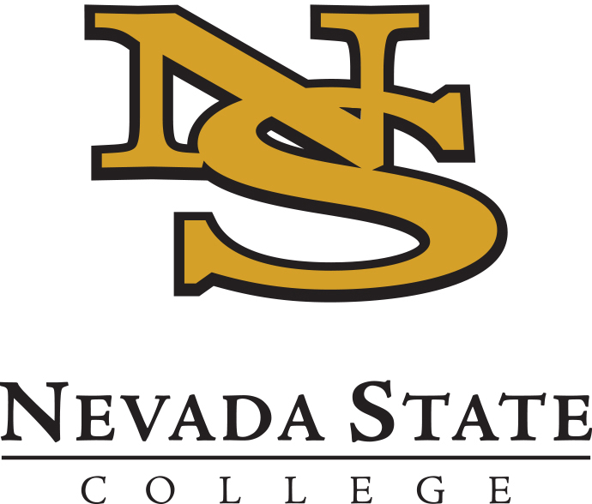
2019 No-Cost Textbook Summer Institute
APPLICATION

Submit your application to nathaniel.king@nsc.edu by 5 p.m. on Friday, March 15th.

Name:
Email:
School/Department:
Project Title:

Is this a joint application with other faculty? ☐ Yes ☐ No

Course Details

- What course (including code and number) would you convert during the Institute?

- How many sections of this course will you teach in fall 2019 and spring 2020?

- What is the title and price of the current required textbook/s for this course?

- If you are interested in adopting an open textbook or a library ebook, what is the title of your proposed text?

Project Details

- Please describe why your proposed course is a good candidate for conversion – please include any details about student feedback or relevant data to support your description.

- Please describe your proposed plan to execute your conversion. Identify which tasks have been completed (if any) and which tasks you hope to make progress on during the No-Cost Textbook Institute.

- How do you think the No-Cost Textbook Institute can benefit you in achieving your project goals or objectives? For example, what types of support are you specifically interested in?

