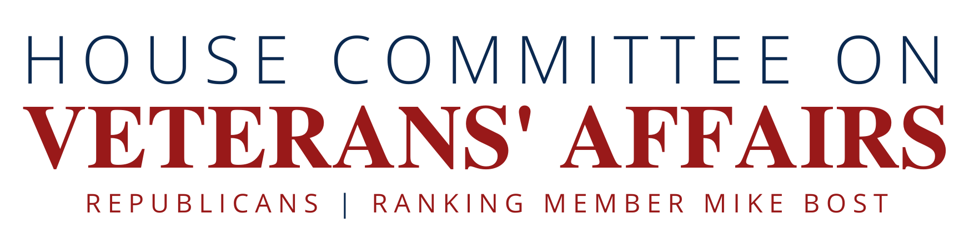

The Veterans’ Cyber Risk Awareness Act

Background:

Veterans – like all Americans – increasingly use social media and online platforms to connect with one another, engage with news, and share information. Certain risks are inherent online, including identify theft, fraud, scams, and disinformation campaigns. A number of government agencies like the Department of Homeland Security and the Federal Bureau of Investigation are taking action to address those risks on a national scale. However, as the government agency responsible for caring for the nation’s veterans, the Department of Veterans Affairs (VA) should proactively provide veterans with information about how to protect themselves online and assess whether veterans are uniquely vulnerable to cyber risks.

The Veterans’ Cyber Risk Awareness Act would direct VA’s Office of Public and Intergovernmental Affairs to conduct a communications and outreach campaign to educate veterans about cyber risks. In conducting the campaign, VA would be required to coordinate with expert entities in government and the private sector. The bill would also require VA to enter into an agreement with a Federally funded research and development corporation to study veteran vulnerability to cyber risks, the availability of resources for combatting cyber risks among veterans, and the effectiveness of VA’s communications and outreach campaign. This study will provide needed information to inform any further actions that may be needed to protect veterans from online threats.

The Message:

- Certain cyber risks are inherent in our increasingly online lives.
- VA should be proactive about informing veterans of cyber risks and sharing best practices from across government and the private sector to help veterans keep themselves and their families safe.
- The Veterans’ Cyber Risk Awareness Act would help veterans protect themselves online and provide valuable information about the potential dangers they may face there.

