OSHA Training Toolbox Talk:
Portable Ladders – Performing Pre-use Inspections
OSHA safety standards require that we inspect our portable ladders before we first use them on any work-shift. This is so we can identify visible defects that could cause a ladder to fail and the user to possibly be injured. An inspection must also be conducted after any event that occurs during the shift that may cause damage to a ladder; for example, if a portable ladder were accidentally knocked over, dropped, or struck by moving equipment.
So here are some common safety hazards and defects you should look for when you first set up your portable ladder. Keep in mind that some of these inspection points are only applicable to specific types of ladders (like extension, step, or mobile ladders) or to ladders made of specific materials (like wood or metal), while other inspection points apply to all portable ladders:
- Side rails that are split, bent, dented, splintered, cracked, or broken;
- Rungs, cleats, braces, or steps that have been bent, dented, cracked, splintered, or broken;
- Screws, rivets, or other fasteners that are loose or missing;
- Ladder components such as spreaders, hinges, and braces that are loose or damaged;
- Spreaders that do not lock into place when the ladder is set up;
- Ladder components that are rusted or corroded;
- Damage such as burns or blisters caused by excessive heat or flames;
- Non-skid safety feet or pads that are missing or damaged;
- Wheels, casters, or stoppers on mobile ladders that are malfunctioning or damaged;
- Pull ropes and pulleys that are worn, frayed, malfunctioning, or broken;
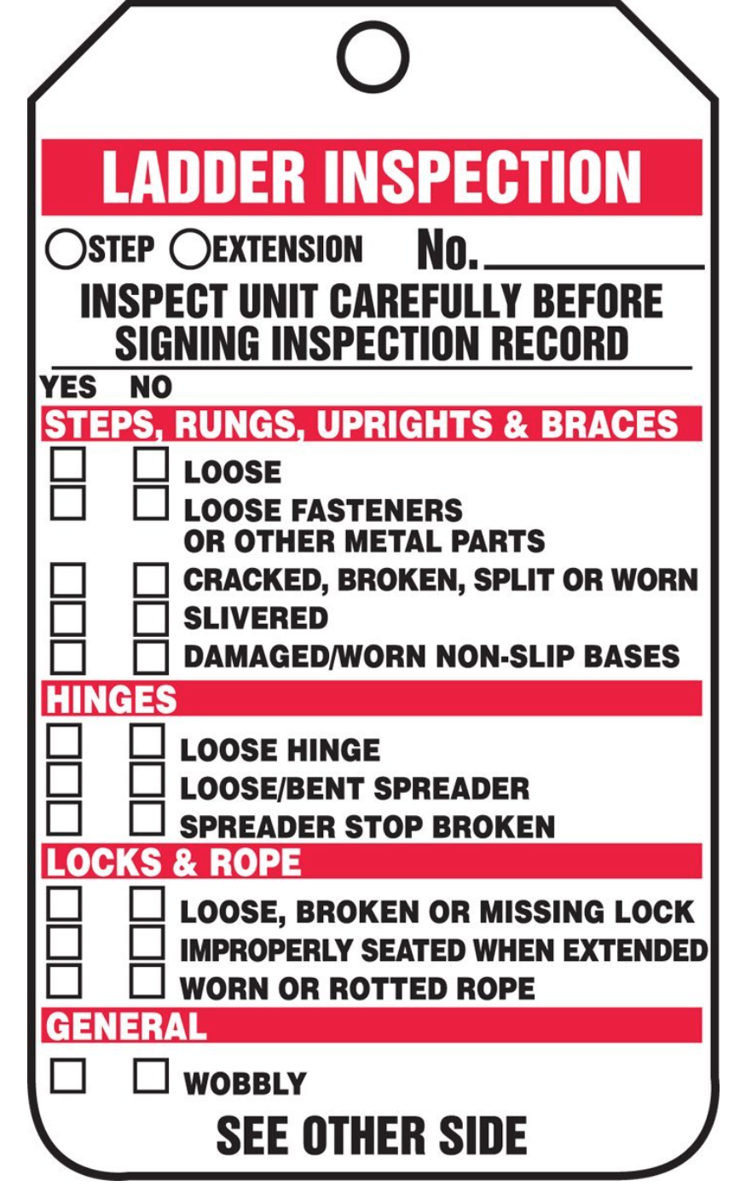
- Steps, rungs, or side-rails which are oily, greasy, or otherwise slippery;
- Make-shift repairs or modifications.
When we do find structural or other defects on any portable ladder during our inspections, OSHA safety standards require that we immediately attach a tag stating “Dangerous: Do Not Use” or with similar language to the ladder. The damaged ladder must then be removed from service until it has been repaired by a qualified person to its original condition. Ladders that cannot be satisfactorily repaired by a qualified person must be destroyed and replaced.
Of course, most ladder damage can be avoided by making sure ladders are stored in a safe area and in a secure manner so they do not fall over or get struck by moving equipment or materials. And we should also take extra care when transporting portable ladders to avoid causing damage.

