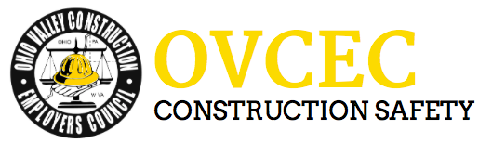

Toolbox Talks – Heat Stress

Heat stress occurs when body temperature increases faster than heat can be removed.

Body temperature can increase due to two sources: heat from activity and heat from the environment. Heat from activity is the amount of heat generated by the worker due to the amount of physical exertion he is extending due to his workload. Heat from the environment is the amount of heat gained due to radiant heat or lack of air movement.

Factors that may increase the chance of a worker developing heat stress include:
Poor physical fitness, obesity, increased age, pre-existing medical conditions, short term illnesses (e.g. flu), chronic skin disorders, use of medication, alcohol and drug use or a previous heat stroke.

Early signs include:
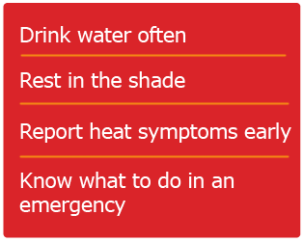
1. Feeling not well, headaches or nausea.
2. Decreased efficiency, coordination and
alertness.
3. Increased irritability.
4. Light-headedness or dizziness.
5. Fainting.

If a worker exhibits or reports early signs and symptoms of heat stress:

1. Remove the worker from the hot environment to rest in a cool place and to drink cool water.
2. If a worker has fainted, have the worker rest with his or her legs and feet elevated.
3. Have the worker assessed by the first aid attendant or a physician (if necessary).
4. Keep the worker under observation until he or she is fully recovered from the effects of heat. If
there is any doubt about the worker’s condition, obtain medical advice.
5. Change the work schedule or reduce the work pace before he or she returns to work.

Keys to preventing heat stress include:

1. Drinking plenty of water and avoid caffeine (Have a water cooler on-site).
2. Wearing clothing made out of a breathable fabric.
3. Scheduling work to minimize heat exposure. Do the hardest physical work during the coolest
part of the day.

Remind crewmembers that they are required to wear long pants and over-the-shoulder shirts at all times.

