

OSHA Training Toolbox Talk:

**Avoiding Electrical Hazards When Using Portable Ladders**

You would never hold a metal rod in your bare hand and purposely touch it to an energized power line, would you? Of course you wouldn’t. And for the same exact reasons, you shouldn’t ever use a portable ladder with side rails made from aluminum or other conductive material near energized power lines. And the same goes for when you are performing work on or near electrically energized equipment. Making contact with an energized line or equipment while standing on or touching a metal ladder gives electricity a path to ground, and that can lead to your being electrocuted. So today we will discuss some things to keep in mind to avoid electrocutions when using a portable ladder.

•  Only use a ladder manufactured with non-conductive side rails when working anywhere near overhead electrical lines. This helps prevent you from being electrocuted if your ladder (or you) makes accidental contact with an energized power line.

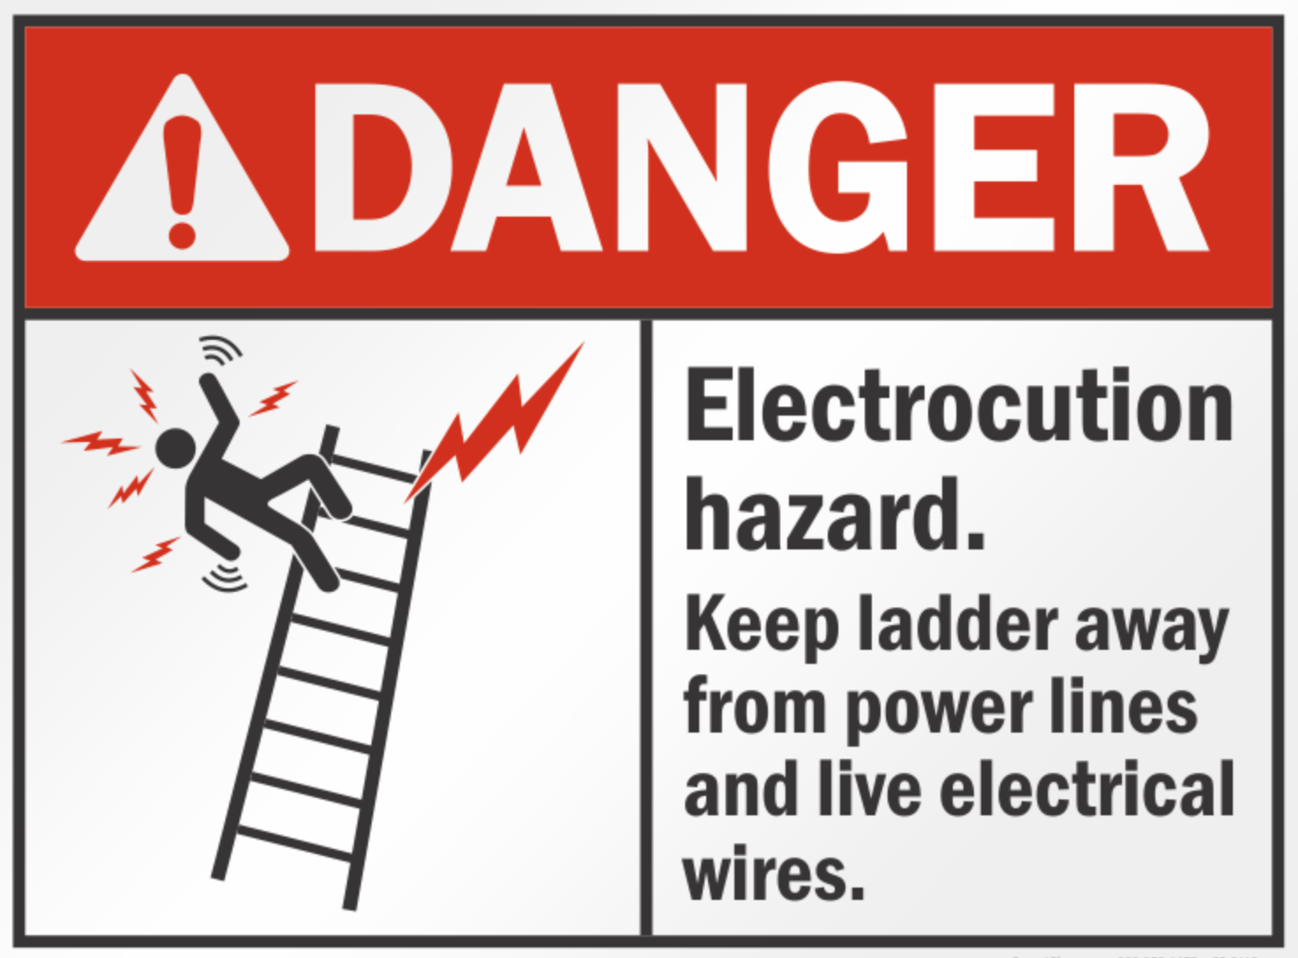•  You should also use a ladder with non-conductive side rails any time you are performing work on or near potentially energized electrical equipment; for example, wiring a fixture, drilling a hole in a wall that contains electrical wiring, or even changing a light bulb.

•  Your best choice is a ladder made with fiberglass or fiber-reinforced plastic side rails; these materials do not normally conduct electricity.

•  Wood ladders that are dry and well maintained are also considered to have non-conductive side rails. However, a wooden ladder could actually conduct electricity if it gets wet or lies in water for an extended period of time and becomes waterlogged.

•  Make sure when setting up your metal ladder that it is set up far enough away from electrical lines so that contact between the ladder (or you) and the line is not possible if the ladder unintentionally falls to the side, towards the electrical line.

•  Also be mindful of the length of any materials you are handling when working from a ladder located near energized lines or exposed conductors. If the material is long enough to make accidental contact with them (such as a long piece of metal trim or gutter, or a semi-rigid metal cable), you should reposition the ladder farther away to avoid unintentional contact.

•  Last but not least, keep in mind that you do not have to make actual contact with an electrical line to be electrocuted. The electrical current from an electrical line can actually arc, or jump, several feet. So just avoiding contact with a line when working on a metal ladder is not good enough; you must also maintain a safe distance away for the electrical line. Since the safe clearance distance depends on the voltage of the line, check with your safety rep regarding what a safe working distance would be – in some cases it could be 10 feet or more!

Keep in mind that some situations may require the implementation of formal lock-out/tag-out procedures. Or we might even have to get the power company to install insulators on overhead lines.