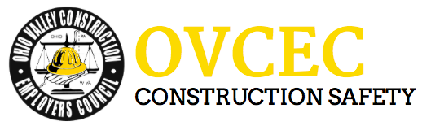

Toolbox Talks - Frigid Temperature Safety Tips

This week has already brought frigid temperatures, fierce winds and chilling snow. It has also brought a steady stream of patients into hospital emergency rooms with cold-weather injuries ranging from slip-and-falls to frostbite. Here are some tips during this time.

Dress Warmly and Stay Dry
Adults and children should wear:
- a hat
- a scarf or knit mask to cover face and mouth
- sleeves that are snug at the wrist
- mittens (they are warmer than gloves) water-resistant coat and boots
- several layers of loose-fitting clothing
Be sure the outer layer of your clothing is tightly woven, preferably wind resistant, to reduce body-heat loss caused by wind. Wool, silk, or polypropylene inner layers of clothing will hold more body heat than cotton. Stay dry-wet clothing chills the body rapidly. Excess perspiration will increase heat loss, so remove extra layers of clothing whenever you feel too warm. Do not ignore shivering. It's an important first sign that the body is losing heat. Persistent shivering is a signal to return indoors.
Avoid Exertion
Cold weather puts an extra strain on the heart. If you have heart disease or high blood pressure, follow your doctor's advice about shoveling snow or performing other hard work in the cold. Otherwise, if you have to do heavy outdoor chores, dress warmly and work slowly. Remember, your body is already working hard just to stay warm, so don't overdo it.

