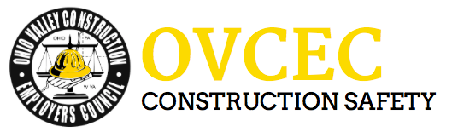

Toolbox Talks

Emergency Preparation – The Importance of Sticking with the Plan
Should a fire break out, a chemical spill occur, or any other type of emergency happen that requires us to evacuate our work areas, it is of upmost importance that we stick with our pre- arranged emergency action plans. And that means we must all evacuate our work areas right away and assemble at our designated meeting areas.
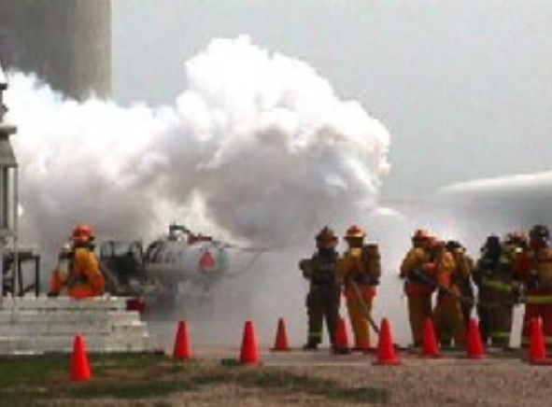
Sometimes it is tempting to ignore an alarm signal, dismissing it as either a false alarm or maybe a fire drill. Or you may decide to stick around and try to figure out what is going on when an alarm is sounded instead of evacuating to your assigned meeting area. But you must avoid these temptations for your own good, as well as for the safe-being of others. That is because when somebody does not report to their assigned meeting place, their supervisor cannot confirm that the person has safely escaped from the danger area. And that means that one or more emergency responders are going to have to risk their life to go back into the workplace to look for that person.
Since we are discussing the topic of emergency evacuations, this would be a good time to review our emergency evacuation procedures; more specifically, where our designated meeting areas are located when we must evacuate the workplace:
[Take a moment to recap where your primary meeting places are for the group of trainees. Pass out an evacuation route map if you have one available. Also cover any secondary (back-up) meeting place you may have designated for the group to assemble in case of unusual events, such as when the wind is blowing smoke or chemical vapors towards your regular meeting place. Last but not least, remind trainees of the types of alarms or signals (e.g.; bells, sirens, P.A. announcements . . .) that will be used to alert workers of any event requiring evacuation of the workplace].
So please, for the sake of emergency responders and yourself, always report to your designated meeting area right away when an evacuation alarm is sounded. While the odds of you or someone else being hurt may be relatively small if you don’t follow our procedures, the potential for a serious injury or death occurring will definitely increase. And no one wants to be responsible for someone else being hurt or killed!

