****OSHA Training Toolbox Talk:

Working Safely with Chainsaws

Chainsaws can make quick work of cutting a limb off a tree . . . or a part off of your body. Here is

an overview of a few steps we can take to help avoid some hazards of working with chainsaws.

•  Always remain a safe distance away from sparks, flames, and any other potential sources of ignition when adding gasoline to a chainsaw. Also make certain the engine, muffler, and all other components of the saw are cooled down before refueling. And, of course, smoking is NEVER allowed during refueling, either!

•  Always inspect your chainsaw before use to make sure of the following, where applicable:

* All screws and bolts must be tight and secure, and all covers are secured in place;
* Insure there are no leaks on any fluid reservoirs, caps, hoses or connections (such as for fuel, oil, and chain lube);
* Check that the chain is set and maintained at the correct tension, per manufacturer’s recommendations;
* Make sure there is adequate chain lube in the reservoir;
* Make certain the muffler is in place and free of damage or deterioration; and,
* Insure the tip guard is in place on the saw, and that the chain brake is functioning properly (where equipped).

•  Wear all personal protective equipment (PPE) needed to protect yourself when using the saw. PPE requirements may vary depending on operations being conducted, but could include safety glasses or goggles, tight-fitting gloves, ear plugs or muffs, a hard hat, safety boots, and arm and leg protection.

•  Always set the chainsaw on the ground or other stable surface when pulling the starter rope; and NEVER “drop start” a chainsaw.

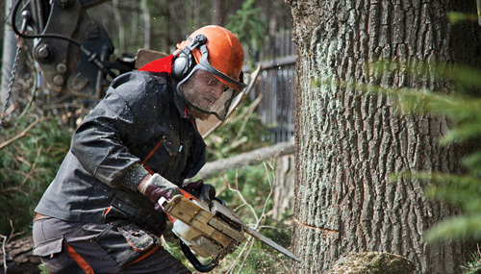•  Position your body so that you are stable to lessen the chance of a slip or fall while cutting with the saw; and always remain alert to the possibility of “kickback”. Always use both hands to hold the chainsaw securely during use. And be sure to release the throttle switch when you are not cutting.

•  Never cut an object directly over your head or any other position where the material could fall and strike you or another person.