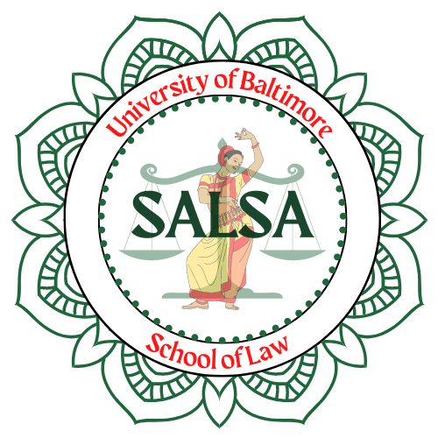
2023 – 2024 E-Board APPLICATION
South Asian Law Students Association
University of Baltimore Chapter

Name:

Position(s) desired:

You may list or rank more than one position.
Please provide a short statement telling us a little about yourself and why you think you are a good candidate for this position.
Please send your completed application form and statement of interest to nirali.patel@ubalt.edu by 6:00 PM on Friday, February 24, 2023.
If you have any questions or problems please reach out.

