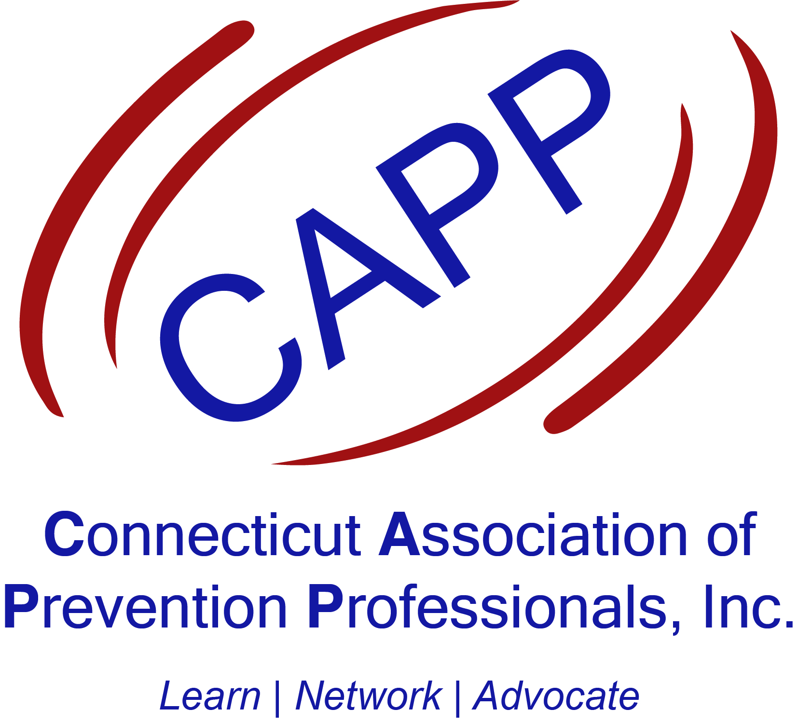

Photo Release Form for Minors (under 18)

The CT Association of Prevention Professionals has my permission to use my child’s photograph publicly. I understand that the images may be used in print publications, online publications, presentations, websites, and social media. I also understand that no royalty, fee or other compensation shall become payable to me by reason of such use.

Parent/Guardian signature: ________________________________Date________

Parent/Guardian Name: ______________________________________________

Child’s Name: ______________________________________________________

