2025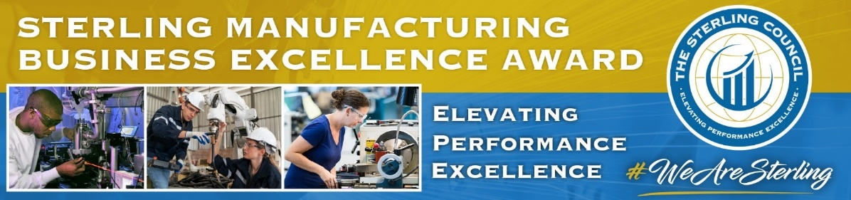

The Sterling Manufacturing Business Excellence (SMBE) Award process brings focus to manufacturing performance excellence. Manufacturers are interviewed and evaluated by expert teams of individuals from the manufacturing and Sterling communities who contribute time, expertise, and diverse perspectives in company evaluations.

The purposes of this award process are to:
- Recognize high-performing regional manufacturing companies.
- Provide opportunities for organizational learning and development.
- Promote and elevate participating manufacturers and the entire sector.

- The process begins with nominations of manufacturers. Eligibility: All manufacturers with production facilities in Florida or Georgia, not having won the SMBE Gold Level award in 2023 or 2024, are eligible to participate. It is not necessary for the nominee to be a member of any association. A nomination may be made by any individual or organization including any industry group, supplier, customer, workforce or economic development organization, University/College/School, or government agency. Self-nominations are acceptable.
- Company commitment: A nominal fee investment for this award process with other promotional benefits is based on number of employees (FTEs) according to this schedule:
* $ 975 – fewer than 21
* $ 2075 – 21 to 50
* $ 3175 – 51 to 100
* $ 4275 – 101 to 150
* $ 5475 – More than 150
Time investment by the nominated manufacturing company is about
six to eight hours over several
weeks from January to April 2025.

Benefits include thorough feedback in terms of strengths and opportunities for business improvement, as well as company exposure and promotion in the community.

- To nominate, use the online Nomination Form or SMBEA@TheSterlingCouncil.org. Simply, please include your contact information as well as a name and contact information for the nominee company. No nomination write-ups are required.
- Following nomination, the Nominee will be notified and asked to complete and submit the Application Profile and Overview (one to two hours), forwarding with attachments to SMBEA@TheSterlingCouncil.org. The writing style and the content of the Profile are not evaluated. The Profile provides context for evaluation, detailed information of the company, and describes internal and external pressures and influences which affect operations.

The final day for nominations is December 20, 2024. The Application Profile and Overview should be submitted by the Nominated company by Tuesday, January 7, 2025.

- Once the Profile is submitted, an initial web meeting (about 90 minutes) is scheduled with the Nominee and a team of Examiners for an overview of the nominated company business. Discussion will include review of basic elements of high performance based on the 2025 Evaluation Criteria. Then the Examiner team will schedule and conduct a more in-depth interview/site visit (about three hours) with managers and employees to discuss detailed aspects of the manufacturer to evaluate company systems and practices. The site visit may be virtual, in-person, or hybrid.

- Upon completion of all company interviews, Examiners confer to review the evaluations, and determine Finalists. A team of Judges will review the Finalist evaluations to decide the recipients. Awards will be made based on scoring against the 2025 Evaluation Criteria for high performance. Recipients will be recognized May 30, 2025, at the Sterling 33rd Annual Awards Banquet at the Hyatt Regency Orlando.

- All participating manufacturers will be provided with a highly value-added evaluation feedback discussion and written report offering specific identified company strengths and opportunities for improvement. Discussion will include recommended improvement actions and examples of role model practices. Participants should also expect to be invited to participate in knowledge sharing, developmental, and promotional activities in the Florida manufacturing and Sterling communities.

