Search Medium

Write

2


Member-only story

The Best Somatic Patterns

The study of the self from the perspective of one’s lived experience, encompassing the dimensions of body, psyche, and spirit.



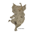

Lewiscoaches
·
Following
Published in

Dancing Elephants Press

·
4 min read
·
1 day ago
138
3
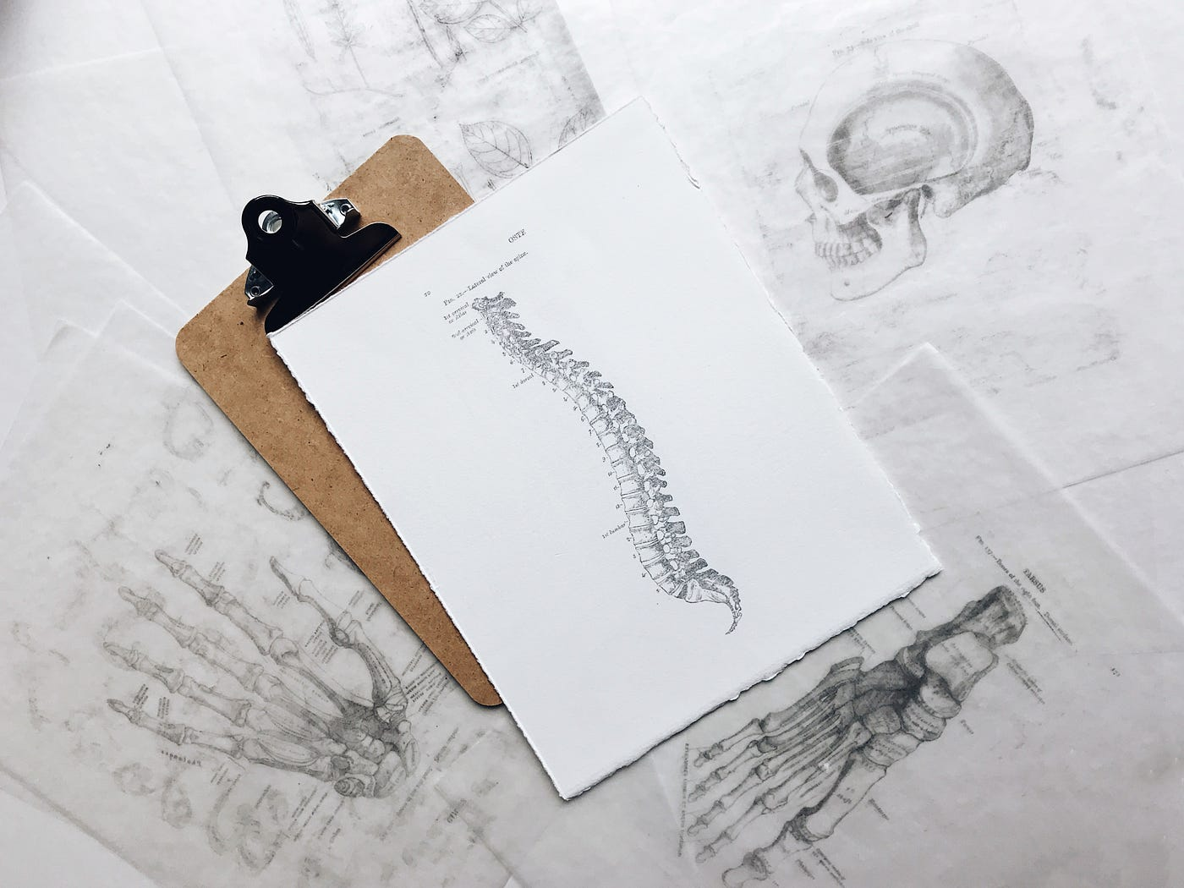
Photo by Joyce Hankins on Unsplash
Somatics is the study of the self from the perspective of one’s lived experience, encompassing the dimensions of body, psyche, and spirit.
Somatic Movement Education and Therapy “supports homeostasis, co-regulation and neuro-plasticity in our students and clients.” Thomas Hanna who coined the term Somatics defines it this way
Body-Mind Centering® “is an integrated and embodied approach to movement, the body and consciousness. Developed by Bonnie Bainbridge Cohen, it is an experiential study based on the embodiment and application of anatomical, physiological, psychophysical and developmental principles, utilizing movement, touch, voice and mind. Its uniqueness lies in the specificity with which each of the body systems can be personally embodied and integrated, the fundamental groundwork of developmental re-patterning, and the utilization of a body-based language to describe movement and body-mind relationships.”
See https://www.bodymindcentering.com/about/
As you learn more about Somatics and Body-Mind Centering® You may also discover that as a young child you stood too early. You may also discover that you stood before you could push your body up from rolling into sitting, that bypassed certain connections in your brain that coordinate movement. Eventually that inefficient pattern might cause low back pain, a pattern that you see in children walking “bow-legged.” If your knees fall out of the plumb line either in a “bow-legged” or “knock-kneed” position, that will put undue pressure on your knees, ankles, and feet. It helps to review how you learned to crawl on your stomach, how you learned to push from your toes, and later how you learned to stand. It helps to “re-connect the dots” of each pattern, layer by layer.
I began studying with Bonnie in 1973 — every year filled with invaluable experiences and explorations of these patterns, the systems (muscular, skeletal, glands, organs, fluids, cardiovascular and more), the anatomy, the psychological aspects, and the consciousness associated with each system. These experiences enhanced my motor skills which allowed me to discover new ways of thinking that applied to many areas of life — emotionally as well as intellectually. Learning to push helps in defining your boundaries. Learning to reach helps in asking for help or opening to the outer world. Learning to pull empowers you to help yourself up or bring something or someone closer to you.
Here’s the sequence of development from conception to adulthood which you can repeat in this order to repattern yourself. It’s best to work with a BMC practitioner or teacher who knows these patterns, if possible, who can guide you. Or you can go to seminars offered in your area, look on the BMCAssoc.org website for classes, watch videos of Bonnie teaching on youtube.com, or go to her website:
https://www.bonniebainbridgecohen.com/

The 7 Pre-vertebrate Patterns that carry the internal movements of our bodies through space, develop our central vertical axis, and our longitudinal axis — the foundation for balanced movement:
- Vibration — energetic condensing and expanding
- Cellular Breathing — the first pattern of life as fluids within our cells
- Sponging — transitional fluid passing through the membranes
- Pulsation — ebb and flow of the fluid surrounding our cells
- Navel Radiation — first pattern of moving through space around the navel
- Mouthing — a wavelike movement connecting the mouth with the gut
- Pre-spinal — a turgid central axis in the center of our bodies

The 4 Vertebrate Patterns that carry on from the pre-vertebrate patterns:
- Spinal (wriggling)
- Homologous (moving the upper body, then the lower body)
- Homolateral (side to side)
- Contralateral (moving the right arm with the left leg, vice versa, and integrating all of the previous patterns)
There are many fascinating elements in each of these patterns. If you are a mover (and a shaker), you should definitely explore Body-Mind Centering® for all the beautiful innuendos that knowing and feeling how to move from conception to adulthood bring.
A child who has experienced this work has a strong lift of her head, a strong support from her right hand, and a beautiful reaching of her left arm as she sees something — what is it? It’s someone she loves! She shows us the integration of the pre-vertebrate patterns with the vertebrate patterns — specifically, her push patterns that lead to a homolateral reach pattern of her left arm led by her desire to be close to someone she sees!

The senses spark our desire to explore and move into space:
— moving towards the breast
— smelling and tasting mother’s milk
— hearing sounds and voices
— seeing contrasts and faces
— learning where one is in space (through balance and proprioception)
— and touching other people, objects, the floor, hard and soft toys
The Takeaway
You can return to pain-free living using these early patterns to “re-member” the natural curves of your spine and seek the right help for your body from other health professionals who have been working with these patterns for many years.
The Author: Sara K. Vogeler, BMC, RSMT, MSMT/E, LMT, AOMT, MFLCI,
ACE-cert. is an Orthopedic Exercise Specialist, Author, and Speaker. She is the Founder and Director of The NeuroMuscular Center, Inc.
https://www.TheNeuroMuscularCenter.com
Sara is both a NeuroMuscular Therapist and, a Registered Somatic Movement Therapist who served previously as president of ISMETA (the International Somatic Movement Education and Therapy Association) and is a past- president of the Body-Mind Centering® Association.

Neuromuscular

Psychology

Early Childhood Education

Somatic Experiencing

Emotional Health

138
3



