Present: Sandy Cabelis, Terri Fiori, Chris Farra, Linda Kitson, Charles Sacks, Virginia Liberato,
Susan Barbieri, Karen Topjian and Theresa Parker Duane
Absent: Annaiz Morale,
Guest: Diane Gote, FY 2021 Parliamentarian, Shannon Landestoy SRB FY 2021
Sandy Cabelis called the meeting to order at 4:04 PM
Presidents Report Sandy Cabelis
Last meeting of the fiscal year.
Steve Levi, past president 2002-2003 passed from natural causes. We will post on social media and in the Blueprint Magazine. Karen will review files to find photograph of Chapter Montclair Iris Garden. Rona will work on copy for article. His obituary lists donations should be sent to ASID NJ Chapter. In lieu of the Board sending flowers the Chapter will donate a ASID Chapter membership to a Berkley student in Interior Design in Steve’s name.
An electronic survey will be sent to approve August and September Minutes. Please send edits directly to Theresa at terry@riversorg.com
All Board Members need to send Sandy and Theresa the list of their Committee members with contact information for Presidential Citations and for Theresa to post in Associations Anywhere, so volunteers are recorded for succession planning with national.
The State of the Society will take place on September 23, 2020 at 5:30 PM and Lead directly into the Design Excellence Awards. All Board Members are asked to be on Zoom link at 5:20 PM as panelists for State of the Society.
Program will be from 5:30 PM – 6:00 PM, at 6:00 PM the DEA will begin from the same Zoom link.
Welcome
Thank our volunteers
Presidential citations
Pass the Gavel – Terri
Terri will introduce new Board members and touch on her 2021 Strategic Plan.
Financial Report Chris Farra
The fiscal year 2021 Budget has been approved by the Board. To finish August and September of 2020 the finance reports will be posted to QuickBooks as soon as National Posts the information.

Chris and Sandy will review full budget in QuickBooks to make sure all funds are properly allocated for the year’s actuals. The current bookkeeper is reviewing all entries: journal, bank statements and PayPal to make sure they match.

Due to our current issue of not being able to access Chapter Cell phone, the PayPal account sends verification code to Theresa Parker Duane’s personal cell phone (585-576-****). If you need activation code text Theresa and she will forward to you.
Motion: to approve the FY 2021 budget was carried via electronic vote. APPROVED Unanimously
Membership Report Charles Sacks
As of Aug 2020, the chapter has 454 Members. 2 new (Allied & Associate), 1 returning members and zero suspended members.
Count of Current Suspended*** Members: 26 – most are Emerging Professionals

Charles spoke with Jonathon Baron he has enthusiastically agreed to be the new Membership Chair.
Board Members are asked to please send dates you think the student day event should be since it will be virtual. Please use Shared Calendar developed by Linda named 2020-2021 Industry Calendar, we need to be sure we don’t conflict with other events and that our target audience doesn’t have to choose between events.

Business Conference Terri Fiori
The Chapter Business Conference will be held on September 22, 2020. The program has been announced, our social media and the evite is scheduled to go out tomorrow. For the Free National Panel discussion Terri will work with Sal (908 Enterprises) to stream Zoom to Facebook Live.
Panelist: 12:00 PM – 1:00 PM – Free Program
Kerrie Kelly, Kia Weatherspoon, John Cialone and Jennifer Kolstad
Key Notes: 2:00 PM – 5:00 PM - Paid Program
Mike Michalewitz, Michelle Williams, Alan Siegel, LuAnn Nigera
Two Program speakers and graphics that have been shared
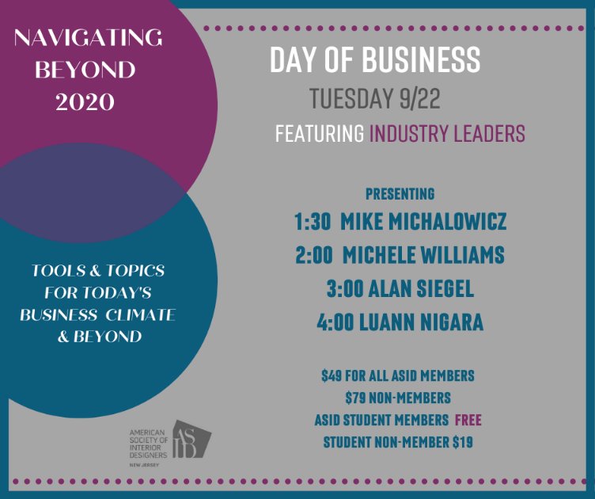
All Board Members are asked to share these social media posts through their personal social media accounts. Terri will reach out to National to post these graphics on the national social media platforms.
DEA Susan Barbieri
…Board Members are asked to review the DEA/Board Emergency Meeting Minutes.

Admin Report Theresa Parker Duane
We are having issues connecting PayPal to Constant Contact. The PayPal was attached to someone named Annette. I will be meeting via phone with Constant contact tomorrow to get this fixed for Day of Business. If we cannot remedy in timely matter, we will use Eventbrite for events and Constant Contact for emails for these two events.

Social Media/Public Relations Terri Fiori
Committee is currently comparing three quotes for social media public relations; WingNuts, 908 Enterprise, and one additional company. The contracts are not offering same services, so comparison is taking time, but all three companies are requiring that we provide content for them to post. A copy of each contract and voting survey will be sent to all Board Members. Theresa will add an option to abstain for those who know individuals personally.
Board Workflow Chart Sandy Cabelis
The Board reviewed edits from previously shared meeting. Community Service has been added since this morning. Theresa will Flip position of Chris and Charles, so Charles will be next to SRB since they work together.
Note this is a living document it should be on the agenda for the first Board Meeting.
A Motion was made to not make edits suggested above and to accept document as it is of Board Meetings with the understanding it will be on the first agenda of the new physical year.
Motion: Virginia Liberato Second: Susan Barbieri APPROVED Unanimously
New Business Terri Fiori
CLC has been rescheduled for September 15 – 17, 2020. Terri has sent everyone link to register for conference. Please plan to attend the Keynotes and program specifically targeted to FY2021 Boards. Note National has opened this to public. Please attend those events highlighted as FY2021 Members. Note FY2021 Board Members have video to watch from nation prior to attending CLC Sessions.
Leadership Virtual Training will be on October 14, 2020 from 2:00 PM – 5:00 PM, details to follow.
Nancy Mikulich, ASID Associate will be unable to accept the position of Programs Director for FY 2021 Board. She will not be able to take role because of Associate status. We have spoken with national and they will not grant us dispensation for Nancy to accept position. The Board is asked to send Terri names of other possible candidates that are not Ip or associate members. Nancy will let us know if she is able to stay on as Chair.
Board Members are encouraged to ask Chairs of Committee to join Board Meeting at 4:30 PM after private Board votes. This option to attend will be made to those who attend Leadership Training for the chapter.

Linda will download the calendar she created in word to the ASID Outlook email box and invite Board to join calendar and add events as they become known to our chapter

The storage unit needs to be transferred from Freehold to North NJ Parsippany. Susan & Linda are willing to volunteer on a weekday, but Virginia and Sandy need to do on a weekend. Sandy will send out dates and we may do this in shifts and arrange handing off the key to unit.
Please keep the 1st Thursday 3:50 PM of the month available for FY 2020 – 2021 for Board meetings.
Sandy needs to be removed as bank signatory and Terri needs to be added.
A Motion was made to adjourn the meeting at 5:53 PM
MOTION: Virginia Liberato SECOND: Terri Fiori APPROVED Unanimously
NOTE: The next meeting of the NJ ASID Board will be held on Thursday, October 1 at 3:50 PM via Zoom Meeting. Board Meetings going forward will be the first Thursday of the month for the FY2021.

Respectfully submitted,

Theresa Parker Duane
The Rivers Organization

