LITTLE EGBERT TRACT
Multi-Benefit Tidal Restoration

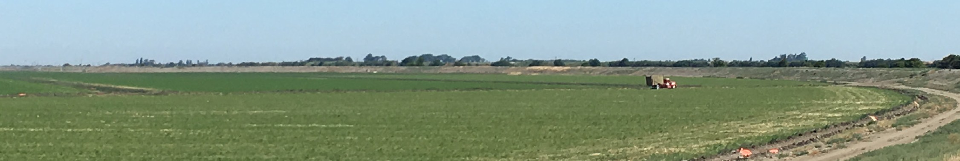

OVERVIEW
The Little Egbert Tract (Property) Multi-Benefit Tidal Restoration Project (Project) analysis is located on a 3,096-acre property located in the legal Sacramento and San Joaquin Rivers Delta, and just upstream of the confluence of Cache Slough, Steamboat Slough and the Sacramento River. The Project is located at the downstream (southern) end of the Yolo Bypass in Solano County, California and north of the city of Rio Vista, California. The property is currently under agricultural cultivation and has a restricted-height levee (road and farm berm are at roughly EL +11) easements on the north and east to allow high flows to flood and pass through the site.

The Property is rare in the Delta as the land is mineral soils (clays to silt clay loams) and not subsided. The site topography varies from roughly -8 feet to +9 feet (North American Vertical Datum 1988), with roughly 75% at or below the -1 foot elevation. Historically, the site was mostly shallow tidal waters transitioning to perennial marsh, wet meadow and native grassland when moving up to the higher elevations.

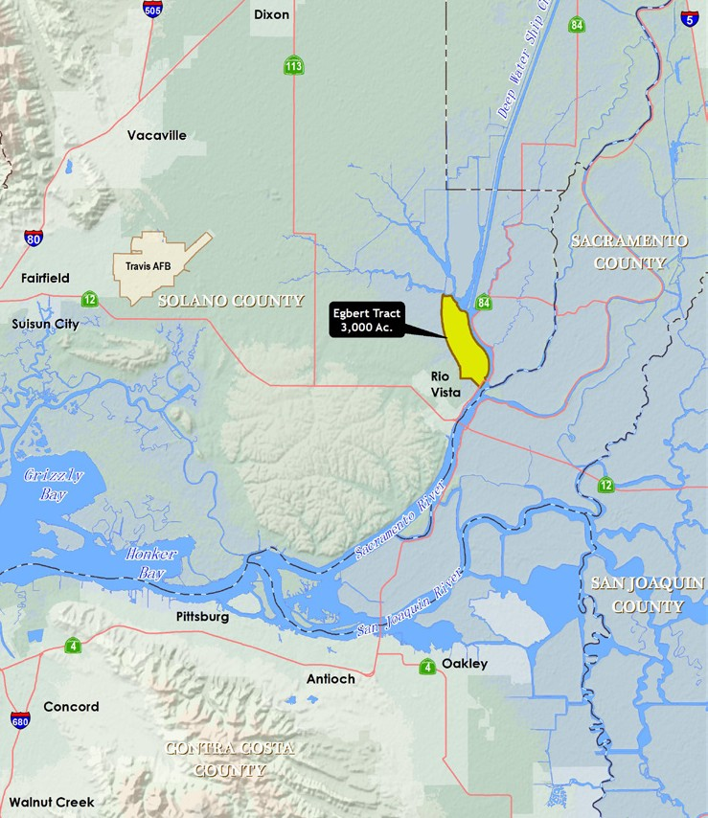
CONFLUENCE OF INTERESTS
Flood Conveyance
The Property has been identified as an important component of the Yolo Bypass Improvements in the Central Valley Flood Protection Plan Basin-Wide Feasibility Study Sacramento River (Draft, July 2017), which is intended to better accommodate flood flows through the bypass in order to decrease surface water elevations through the Sacramento Metropolitan area, and reduce flood heights on the western portion of the Yolo Bypass, affecting Yolo and Solano counties.
Regional Agricultural Sustainability
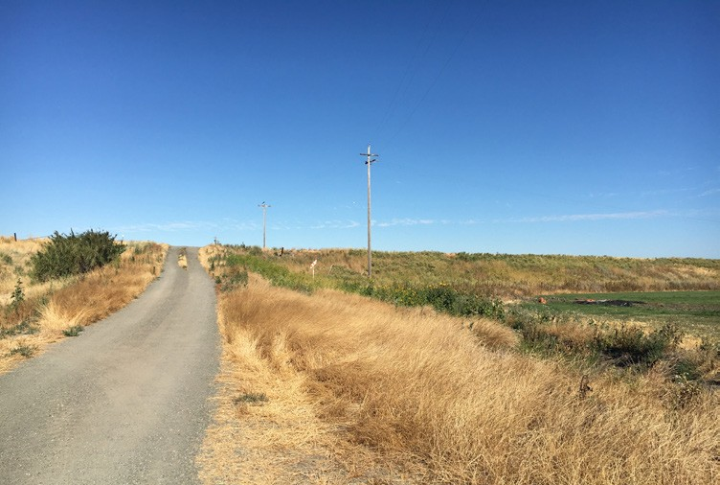
The Property is currently being farmed in alfalfa and wheat, and irrigated by nine lift pumps out of Lindsay, Cache and Willow sloughs. The limited-height levee (farm berm) along Lindsay and Cache sloughs allows flooding at high water events, which places the agricultural operation at risk. This occurred during the both the 1986 and 1997 floods and damaged significant portions of the farm berm. Such floods have roughly a 4% chance to recur during any flood season (i.e., 25-year event). As a result of this flood recurrence and the cost to restore agricultural function, the long term viability of the site remaining in cultivation is at issue. A regional review of agricultural sustainability will be done as part of the project feasibility to determine ways to off-set potential impacts to farming if flooding were to be more frequent.
Floodplain Habitat Restoration
While the site is not inundated during the low to moderate flow events floodplain, the Property has been identified as potential or capable of supporting Critical Habitat for green sturgeon, Delta and longfin smelt, Chinook salmon, and steelhead. The Project will examine ways to improve the floodplain habitat, including reduction of fish stranding during high (peak) flood events, increased riparian corridors and providing legal, financial and environmental assurances for long-term stewardship to meet regulatory mitigation requirements.

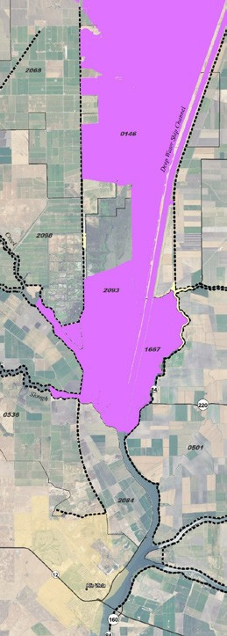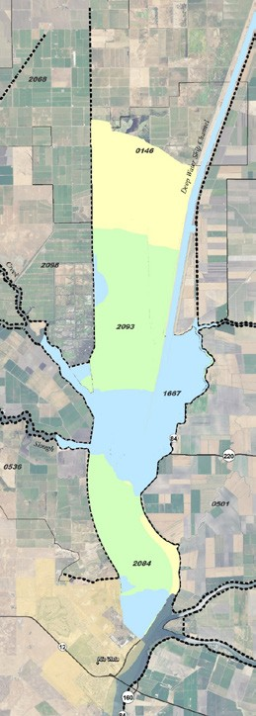

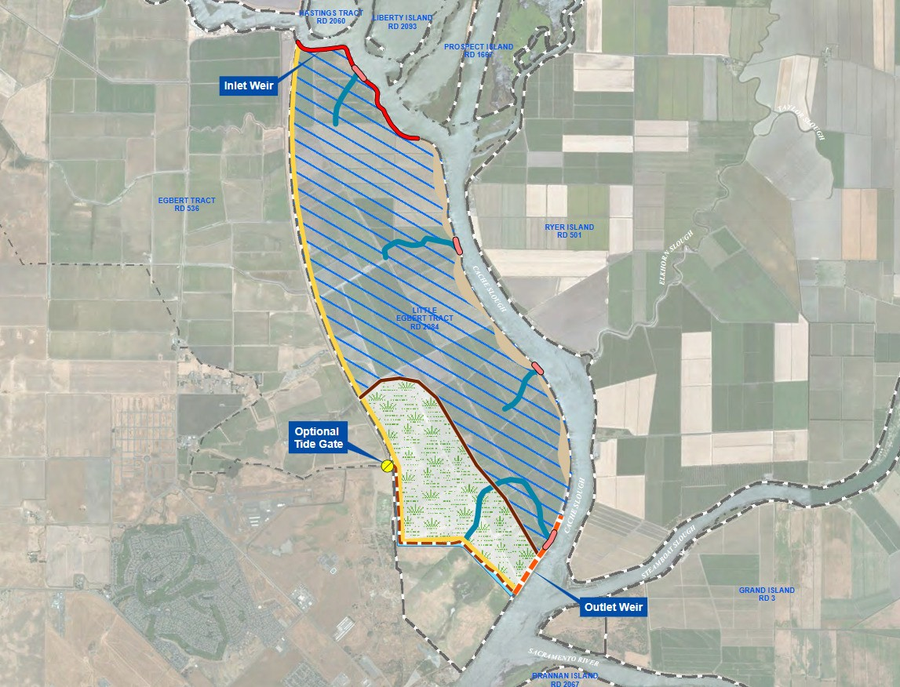
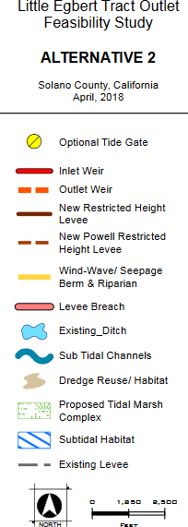CONCEPT
BENEFITS
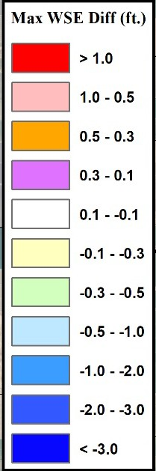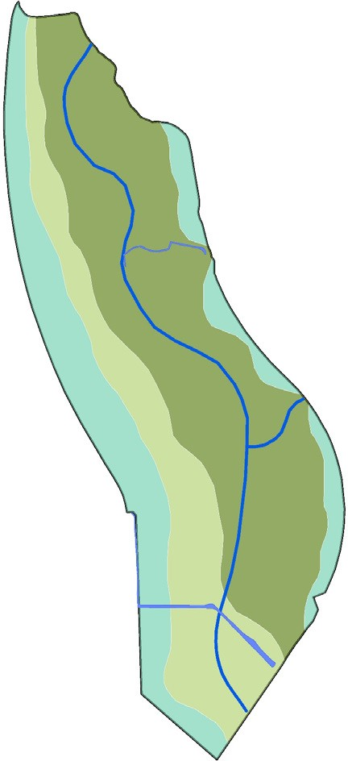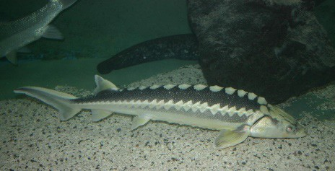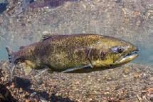
REGIONAL BENEFITS:
DWR Feasibility Study Results
Without Little Egbert Tract: With Little Egbert Tract: Water Surface Elevation goes Up Water Surface Elevation goes Down

4
Future + Alt. 1
Future
Green Sturgeon
Delta Smelt
Chinook Salmon
FISH HABITAT NEEDS

-Spawning
-Flood Refuge
-Rearing
-Food Web Support
-Migration / Spooling

