<<Month, Day Year>>

Dear << First Name>>:
Prior to participating on a team from << High School X>>, athletes must provide the Athletic Department with current address, emergency contact, insurance, medical alert and health history information. To expedite this process << High School X>> uses an online data entry system.
To enter your information, visit www.swol123.net. The first time you visit the website you will need to enter your <<College X or personal for High School parents>> email address and click Get Password.

Joining SportsWareOnLine
Instruction | Example
Go to www.swol123.net.
Scroll to the middle of the screen and click the Join SportsWare button. | 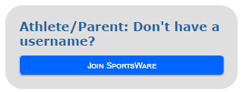
Enter your School ID  You should have received a School ID from the athletic trainer. This is required to join the correct school. | 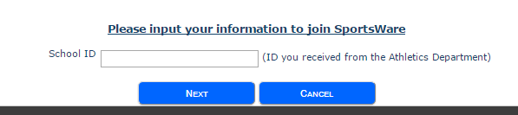
Enter your First Name, Last Name, Email address and click the Send button. | 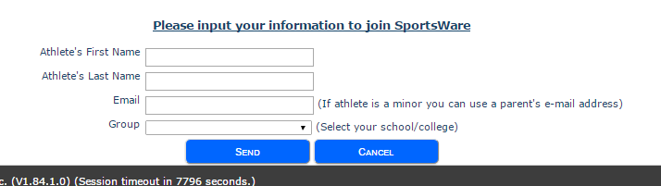
Your request to join SportsWare will then be sent to the Athletic Trainer for review. | 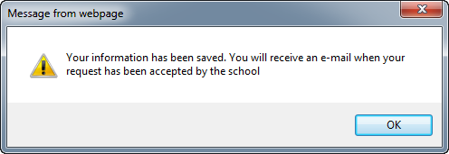
Once your request is accepted you will receive an e-mail with the Subject “SportsWare request accepted”.

Open the e-mail and click the www.swol123.net link to continue to SportsWareOnLine.

Setting Your Password
Instruction | Example
Go to www.swol123.net
Enter your Email Address and click the Reset Password button. | 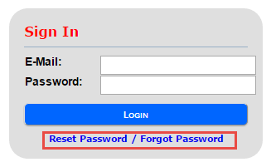
You will receive and e-mail with the Subject “SportsWareOnLine Password Request”.  Open the e-mail and click on the link to reset your password. Enter your e-mail address, new password and click the Save button. | 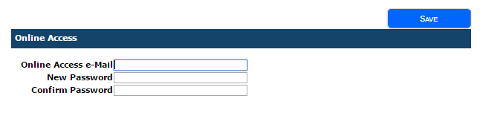

Updating Your Information
Instruction | Example
Go to www.swol123.net.
Enter your Email Address and click the Login button. | 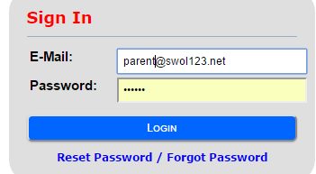
Select My Info: Update your address, emergency contact and insurance information.
school.
Start entering Athlete’s information. Complete the Athlete Online Access section by updating it with the Athlete’s email address (defaults with Parents initially). Then Update The Parent Online Access section with email and password. Continue to complete the remaining tabs. | 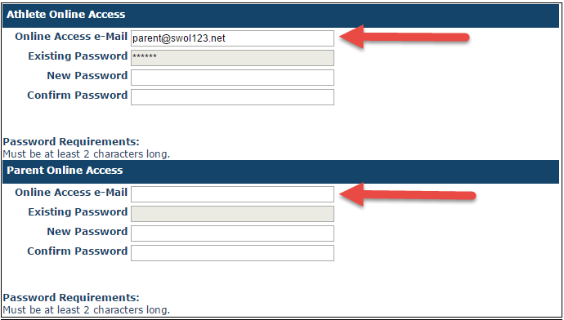
Once done with My Info go to:

Med History: Complete a Medical History questionnaire.

Forms: View/complete required paperwork. Note: SportsWare will also display “You have ? forms to complete/download”.

Print: Print My Info and Medical History data.

Thank you for your prompt help. If you have any questions, please contact the athletic office at <<xxx-xxx-xxxx>> for assistance.

Sincerely,
<<Athletic Trainer>>

