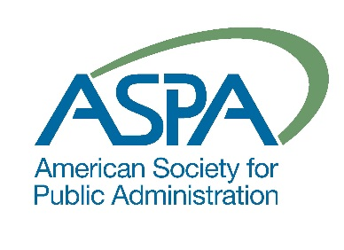
American Society for Public Administration
Southern California Chapter

71st Awards Nomination Form (2019)

Individual or Group Nominated

Name of Individual or Group:
Title/Organization:

Nominated for the following award (See attached page for Award Descriptions):

Will Baughman Chapter Development Award
Tom Bradley Equal Opportunity Award
Winston Crouch Award for Innovation in Government
Clarence A. Dykstra Award for Excellence in Government
Henry Reining Outstanding Organization Award
Harry Scoville Award for Academic Excellence

Earl Warren Outstanding Public Service Award

NOTICE:
Please provide a brief description of the Nominee’s qualifications for this award on page three of this application, giving particular attention to distinctive achievements or contributions.

Name of Nominator:
Title/Organization:
Organization Address:
Organization Phone:
Email Address:

Please submit by Thursday, May 9th, 2019 to:

Akiko Yamagami, ayamagami@hotmail.com

AWARD DESCRIPTIONS:

Will Baughman Chapter Development Award:
This award is presented to a member who has made a significant or sustained contribution to the Los Angeles Metropolitan Chapter of the American Society for Public Administration.

Tom Bradley Equal Opportunity Award:
This award is presented to an individual or organization, which has successfully promoted equal opportunity in the workplace or the community.

Winston Crouch Award for Innovation in Government:
This award is presented to an individual or organization, which has developed new and creative approaches to providing public services.

Clarence A. Dykstra Award for Excellence in Government:
This award is presented to an individual who has made a significant contribution to the practice of public administration (emphasis on a singular significant accomplishment).

Harry Scoville Award for Academic Excellence:
This award is presented to an individual who has made a significant contribution to public administration through teaching, research, writing and related activities.

Henry Reining Outstanding Organization Award:
This award is presented to an organization whose accomplishments have significantly contributed to good government or improved quality of life in the Los Angeles Metropolitan area.

Earl Warren Outstanding Public Service Award:
This award is presented to a civic leader who has made an outstanding, sustained contribution to good government in the Los Angeles Metropolitan area.

SUMMARY OF ACHIEVEMENT

Please include specific accomplishments (e.g. impact on the field, workplace or community) and provide background information on the person, organization or program being nominated. Please explain in the space provided below:

Are you willing to provide additional information at the request of the Awards Committee?
Yes No (The Awards Committee will retain all nomination materials).

