EVENT CALENDAR

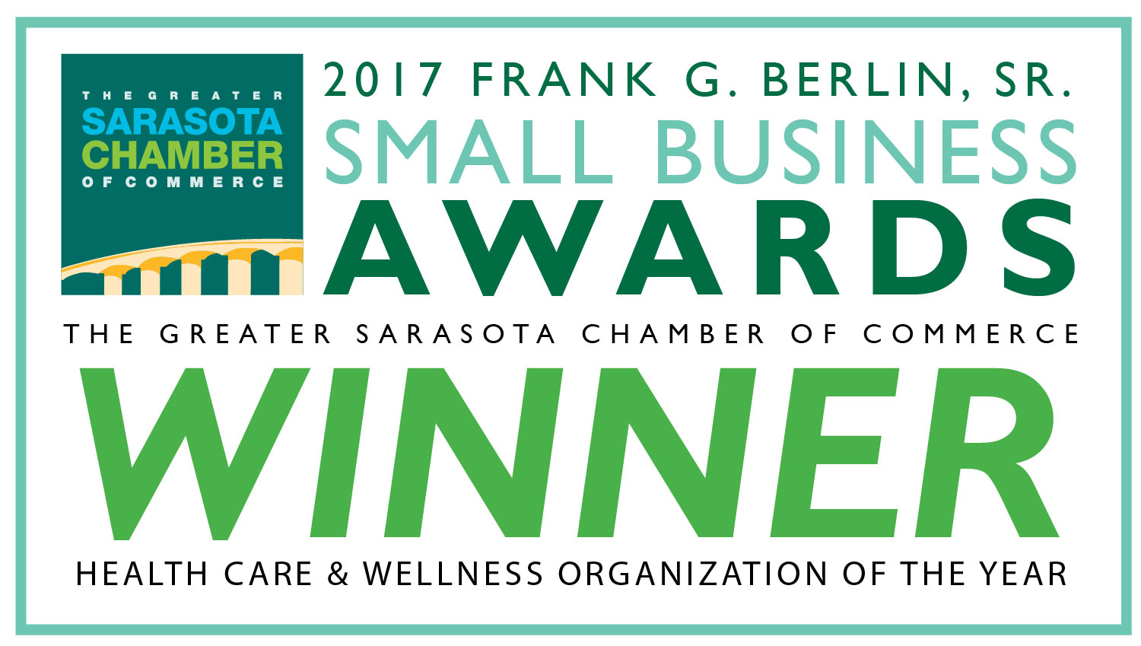

JANUARY and FEBRUARY 2020

JANUARY EVENTS

Wednesday, January 8, 2020
Chapter Meeting - Noon to 1:30 PM
"Accessibility at the Ringling Museum"--Erin Carter
11:45 AM - $5 lunch or bring your own
North Sarasota Library Meeting Room, 2801 Newtown Blvd., Sarasota

Monday, January 13, 2020
HLAA Sarasota/Manatee Board Meeting - 6:00 to 7:30 PM
Center for Arts and Humanities
1226 N. Tamiami Trail, Sarasota

Tuesday, January 14, 2020
Curtain Time Theatre Club - 7:30 PM
"Sister Act"
Players Theatre
838 N. Tamiami Trail, Sarasota

Friday, January 17, 2020
"Happy Hour" - 6:00 to 8:00 PM
New Location- Mattison’s 41
7275 S. Tamiami Trail, Sarasota

Saturday, January 25, 2020
Downtown Sarasota Farmers Market - 7:00 AM to 1:00 PM
FREE Hearing Screenings
Main and Lemon Streets, Sarasota

Tuesday, January 28, 2020
Private Eyes Movie Club - Around 4:00 PM
Hollywood Theatres
1993 Main Street, Sarasota

FEBRUARY EVENTS

Wednesday, February 12, 2020
Chapter Meeting - Noon to 1:30 PM
"Update on Implantables"-Cristina Costas
11:45 AM - $5 lunch or bring your own
North Sarasota Library Meeting Room
2801 Newtown Blvd., Sarasota

Thursday, February 13, 2020
“After Hours” Chapter Meeting
5:30 PM Meet & Greet
6:00 PM Meeting "Hearing Loops: Key to Audience
Satisfaction for 160.000 Locals with Hearing Loss"
Dr. Juliette Sterkens, AuD
Mattison’s 41
7275 S. Tamiami Trail, Sarasota

Saturday, February 15, 2020
2020 Hearing Tech Expo
The Eighth Hearing Tech Expo - 9:00 AM to 3:00 PM
Manatee Technical Institute
6305 State Route 70, Bradenton

Tuesday, February 18, 2020
Curtain Time Theatre Club - 7:30 PM
"Head Over Heels"
Players Theatre
838 N. Tamiami Trail, Sarasota

Friday, February 21, 2020
"Happy Hour" - 6:00 to 8:00 PM
Mattison’s 41
7275 S. Tamiami Trail, Sarasota

Saturday, February 22, 2020
Downtown Sarasota Farmers Market - 7:00 AM to 1:00 PM
FREE Hearing Screenings
Main and Lemon Streets, Sarasota

Tuesday, February 25, 2020
Private Eyes Movie Club - Around 4:00 PM
Hollywood Theatres
1993 Main Street, Sarasota

FOR THE CURRENT EDITION OF LISTEN!UP
Go to -- hlas.org/News/listen-up/

