Program Director Focus Group Application
Application Deadline: March 24, 2023

CoAEMSP is seeking applicants to serve on the CoAEMSP Program Directors Focus Group (PDFG). The PDFG is a consultative group offering expertise and valuable input to the CoAEMSP Board of Directors. In doing so, the group offers feedback and perspective to the CoAEMSP Board, Committees, and staff, especially relating to day-to-day operational aspects of CAAHEP accredited and CoAEMSP Letter of Review paramedic programs. Members of the group are volunteers. The PDFG is not a governing body, does not set policy, and does not participate in accreditation decisions.

The PDFG is the equivalent of a standing focus group providing a conduit of information flow from program directors responsible for operationalizing accreditation processes. Furthermore, members of the PDFG may have specific items of interest they wish to discuss and forward for consideration to the board.

For consideration, complete and return the application packet no later than March 24, 2023, to the CoAEMSP via email to mike@coaemsp.org. Incomplete packets or late submissions will not be considered. The complete application includes:

This application – must be typed
A current resume or CV
A letter from your employer supporting your participation
Acknowledgement of the expectations (found at the end of this application)

In addition, an applicant’s program affiliation must be in good standing. Good standing is defined as a program holding active status as a CoAEMSP Letter of Review program (LOR), or active initial or continuing CAAHEP accreditation, with no adverse accreditation action in the past 3 years, including suspension, revocation, or probation.

APPLICANT PROFILE

First Name: MI: Last Name: Suffix:
Degrees & Credentials: (list the degrees and credentials as you would when professionally listing your name):
Title:
Employer:

Mailing Address:

City: State: Zip Code:

Work Phone:

Cell Phone:

Home Phone:

Preferred Phone (CoAEMSP Use):

Primary Email:

Secondary Email:

AREAS OF EXPERTISE

Distance Education
Teaching/Administrative Experience with Distance Education:

Describe your experience with Distance Education:

Satellite/Alternate Locations
Teaching/Administrative Experience with Satellite/Alternate Locations:
Describe your experience with Satellite/Alternate Locations:

Consortium
Teaching/Administrative Experience with Consortium:
Describe your experience with Consortium:

PROGRAM INFORMATION

- CoAEMSP Program Number: 600
Sponsor/Institution Name, City & State:
Sponsor Institution Type [consortium, university, community/technical college, hospital, fire department, or EMS agency-based program]

- List your experience in EMS education (education, education programs, dates of experience):

- Describe why do you wish to serve on the Program Directors Focus Group?

- Check which option below best describes your experience with self-study report development.
  - I have been the primary author of the self study document at least once.
  - I have assisted someone else in the development of the self study.
  - I reviewed our self study document prior to submission.
  - I have not been involved with the self study document.

- Check which option below best describes your experience with annual report preparations.
  - I have been the primary individual to collect and collate data for the annual report and have written the report at least once.
  - I have been the primary individual to collect and collate date for the annual report at least once but someone else has written the report.
  - I have assisted with the collection of data for the annual report and assisted with writing the report at least once.
  - I have not participated in the collection of data or writing the annual report.
  - I have reviewed the data and annual report prior to submission.

- Check which option below best describes your experience with a site visit by the CAAHEP/CoAEMSP:
  - I have been the primary individual responsible for planning and implementing the site visit at least once.
  - I have assisted in the planning and coordination for the site visit at least once.
  - I was present for and participated in the site visit at least once.

For consideration for the CoAEMSP Program Directors Focus Group, return a completed application packet by March 24, 2023, to mike@coaemsp.org. Applications are accepted via email only.

QUESTIONS? Contact Mike Miller | mike@coaemsp.org | P: 214-703-8445, x120

Program Directors Focus Group

Mission/Definition:
The Program Directors Focus Group (PDFG) is a consultative group offering expertise and valuable input to the CoAEMSP Board of Directors. In doing so, the group offers feedback and perspective to the CoAEMSP Board, Committees, and staff, especially relating to day-to-day operational aspects of CAAHEP accredited and CoAEMSP Letter of Review paramedic programs. Members of the group are volunteers. The PDFG is not a governing body, does not set policy, and does not participate in accreditation decisions.
The PDFG is the equivalent of a standing focus group providing a conduit of information flow from program directors responsible for operationalizing accreditation processes. Furthermore, members of the PDFG may have specific items of interest they wish to discuss and forward for consideration to the board.
Selection Criteria:
- Current Program Director (PD) of a CAAHEP accredited or CoAEMSP Letter of Review paramedic program.
- A minimum of 1-year experience as a PD.
- PD of a program that is in good standing. Good standing is defined as a program holding active status as a CoAEMSP Letter of Review program (LOR), or active initial or continuing CAAHEP accreditation.
- Effective verbal and written communication skills.
- Demonstrated ability to work as an effective member of a team.
- Listens carefully and respectfully, seeking to understand each person’s perspective.
- Demonstrated ability to creatively problem solve.
- Ability to be candid and respectful.
- Ability to question assumptions and look for new insights.
- Committed to the time necessary to serve the PDFG. Anticipate quarterly web-conference meetings lasting 1-2 hours each.

Disqualifying Criteria:
- A PD from a suspended or revoked LOR program, or a program holding CAAHEP accreditation on probation for any reason in the past 3 years.
- Being a current site visitor, self-study report reviewer, or CoAEMSP Board member.

Membership:
- 24 members (4 members from each NASEMSO Region – East, South, Great Lakes, Western Plains, and West, and 4 members at large).
- A diverse membership that represents the many challenges PDs encounter. Such challenges may include, but are not limited to:
  - Specific student needs based on geography and demographics
  - Degree and certificate programs
  - Distance education including hybrid programs
  - Consortium, university, community college, hospital, fire department, or EMS agency-based programs
  - International experience
  - Programs with satellite and alternate locations
- Appointments will be for one (1) year. If an appointee is unable to fulfill their one (1) year term, a new appointment will be made based on region or member at large serving for one (1) year from the time of appointment.
- Appointees may not serve consecutive terms but may apply for future appointments. However, preference will be given to qualified applicants who have not served on the PDFG.

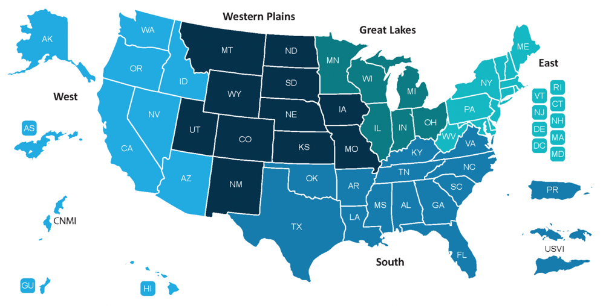

Note: all requirements are subject to the discretion of the CoAEMSP Board.

ACKNOWLEDGEMENT OF EXPECTATIONS

I, , acknowledge the expectations of serving on the CoAEMSP Program Directors Focus Group (PDFG) and agree to participate in a minimum of two (2) meetings annually. Furthermore, I recognize my participation is as a member of a team of program directors and requires me to listen carefully and respectfully, seeking to understand each person’s perspective; demonstrate the ability to creatively problem-solve; and, question my own assumptions looking for new insights. I understand that if the CAAHEP accredited or CoAEMSP Letter of Review Paramedic program with which I work for falls out of good standing with CoAEMSP or CAAHEP, that this may affect my status to serve as a member of the Program Directors Focus Group.

Name Date

