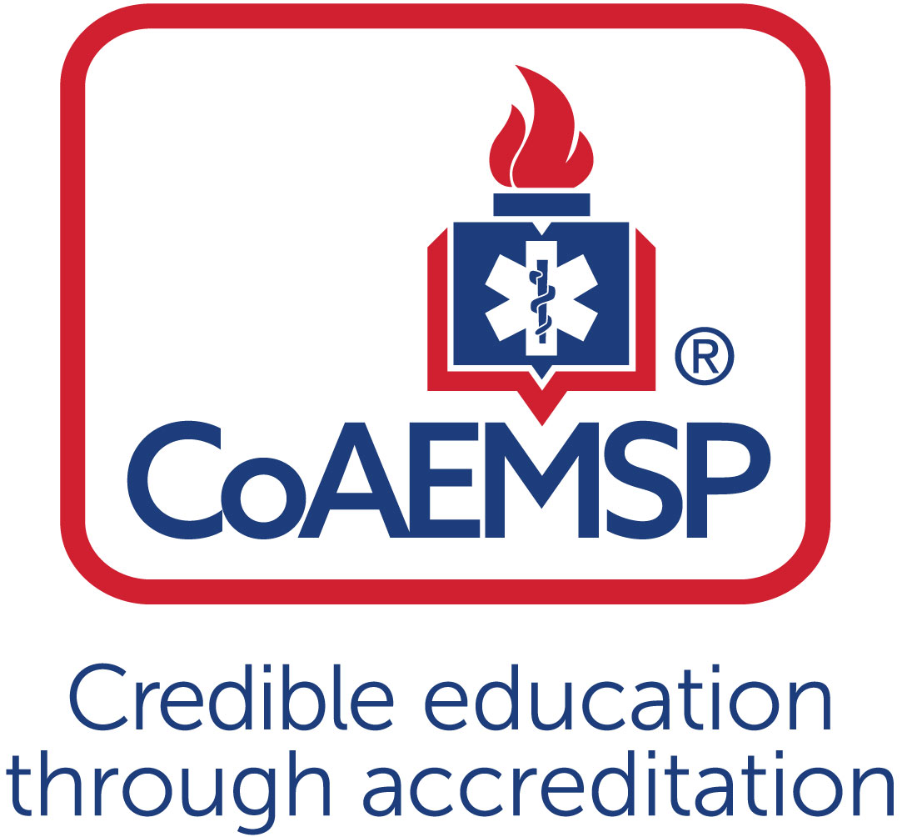
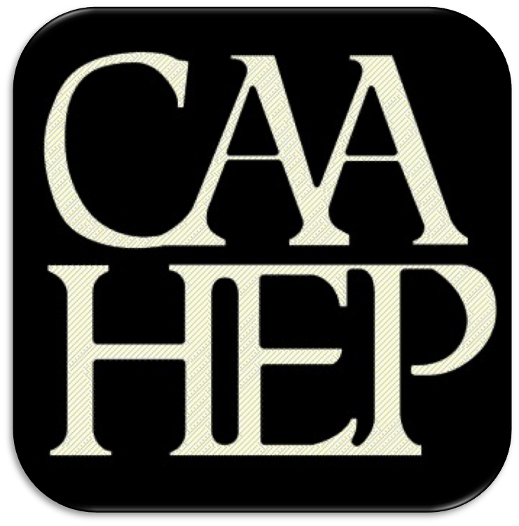

Advisory Committee Meeting Minutes

See last page for the purpose of the program’s Advisory Committee, including a description and list of responsibilities.

SPONSOR / INSTITUTION NAME:
CoAEMSP PROGRAM NUMBER: | 600xxx | DATE, TIME, + LOCATION OF MEETING:
CHAIR OF THE ADVISORY COMMITTEE:

ATTENDANCE

Community of Interest | Name(s) – List all members. Multiple members may be listed in the same category. | Present – Place an ‘x’ for each person present | Agency/Organization
Physician(s) (may be fulfilled by Medical Director)
Employer(s) of Graduates Representative
Key Governmental Official(s)
Police and Fire Services
Public Member(s)
Hospital / Clinical Representative(s)
Other
Faculty
Sponsor Administration²
Student (current)
Graduate
Program Director, ex officio, non-voting member
Medical Director, ex officio, non-voting member

Agenda Item |  | Discussion | Action Required | Lead | Goal Date
 | Call to order |  | Yes / No
 | Roll call |  | Yes / No
 | Review and approval of meeting minutes |  | Yes / No
 | Endorse the Program’s minimum expectation  [CAAHEP Standard II.C. Minimum Expectation]  - “To prepare competent entry-level Paramedics in the cognitive (knowledge), psychomotor (skills), and affective (behavior) learning domains with or without exit points at the Advanced Emergency Medical Technician and/or Emergency Medical Technician, and/or Emergency Medical Responder levels.”  - Establish / review additional program goals |  | Yes / No
 | Endorse the Program’s required minimum numbers of patient/skill contacts for each of the required patients and conditions  [CAAHEP Standard III.C.2. Curriculum]  - NEW Appendix G: Student Minimum Competency Matrix (effective July 1, 2019)  - Review summary graduate tracking reports |  | Yes / No
 | Review the program’s annual report and outcomes  [CAAHEP Standard IV.B. Outcomes]  - Annual Report data  - Thresholds/Outcome data results  - Graduate Survey results  - Employer Survey results  - Resources Assessment Matrix results  - Other |  | Yes / No
 | Review the program’s other assessment results  [CAAHEP Standard III.D. Resource Assessment]  - Long-range planning  - Student evaluations of instruction and program  - Faculty evaluations of program  - Course/Program final evaluations  - Other evaluation methods |  | Yes / No
 | Review program changes (possible changes)  - Course changes  (schedule, organization, staffing, other)  - Preceptor changes  - Clinical and field affiliation changes  - Curriculum changes  - Content  - Sequencing |  | Yes / No
 | Review substantive changes (possible changes)  [CAAHEP Standard V.E. Substantive Change]  - Program status  - Sponsorship  - Sponsor administrative personnel  - Program personnel: PD, Lead Instructor, other  - Addition of distance education component  - Addition of satellite program |  | Yes / No
 | Other identified strengths |  | Yes / No
 | Other identified weaknesses |  | Yes / No
 | Identify action plans for improvement |  | Yes / No
 | Other comments/recommendations |  | Yes / No
 | Staff/professional education |  | Yes / No
 | CoAEMSP/CAAHEP updates |  | Yes / No
 | Next accreditation process  (i.e., self-study report, site visit, progress report) |  | Yes / No
 | Other business |  | Yes / No
 | Next meeting(s) |  | Yes / No
 | Adjourn |  | Yes / No

Minutes prepared by Date
Minutes approved by Date
If item #5 above was acted on, then:
Medical Director’s signature Date
Attach Appendix G > Table 1 to verify which required minimum numbers were reviewed and endorsed (if item #4 above was acted on)

PURPOSE OF THE ADVISORY COMMITTEE
The Advisory Committee must be designated and charged with the responsibility of meeting at least annually to assist program and sponsor personnel in formulating and periodically revising appropriate goals and learning domains, monitoring needs and expectations, and ensuring program responsiveness to change, and to review and endorse the program required minimum numbers of patient contacts. [CAAHEP Standard II.B. Appropriate of Goals and Learning Domains]

Additionally, program-specific statements of goals and learning domains provide the basis for program planning, implementation, and evaluation. Such goals and learning domains must be compatible with the mission of the sponsoring institution(s), the expectations of the communities of interest, and nationally accepted standards of roles and functions. Goals and learning domains are based upon the substantiated needs of health care providers and employers, and the educational needs of the students served by the educational program. [CAAHEP Standard II.A.]

Responsibilities of the Advisory Committee
- Review and endorse the minimum program goal.
- Review and endorse the required minimum numbers of patient/skill contacts for each of the required patients and conditions.
- Verify that the Paramedic program is adhering to the National Emergency Medical Services Education Standards.
- Review Program performance based on outcomes thresholds and other metrics (at a minimum credentialing success, retention, and job placement).
- Provide feedback to the Program on the performance of graduates as competent entry level Paramedics (for employers).
- Provide feedback to the Program regarding clinical and field opportunities and feedback on students in those areas.
- Provide recommendations for curricula enhancements based on local needs and scope of practice.
- Assist with long range planning regarding workforce needs, scheduling options, cohort size, and other future needs.
- Complete an annual resource assessment of the program.

The best practice is that the chair is not the Program Director. The Advisory Committee is advising the program.
Additional faculty and administration are ex-officio members.
Add rows for multiple members of the same community of interest If the program has additional named communities of interest, list the community of interest and the name(s) that represent each.
Additional program goals are not required by the CAAHEP Standards. If additional program goals are established, then the program must measure them.

