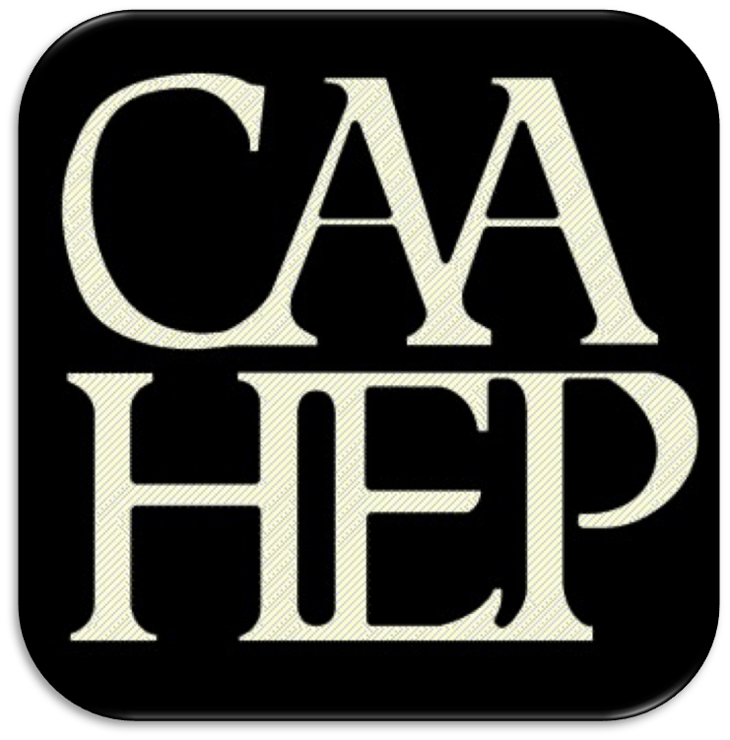
Advisory Committee Roster

effective enter date here

COMMUNITIES OF INTEREST: The communities of interest that are served by the program must include, but are not limited to: students, graduates, faculty, sponsor administration, hospital/clinic representatives, employers, police and/or fire services with a role in EMS services, key governmental officials, physicians, and the public. [Standard II.A. Program Goals and Outcomes]

CoAEMSP PROGRAM NUMBER: | 600xxx
SPONSOR / INSTITUTION NAME:
CHAIR OF THE ADVISORY COMMITTEE:
Community of Interest | Name(s) | Agency/Organization | Contact Information
Physician(s)
(may be fulfilled by Medical Director)
Employer(s) of Graduates Representative
Key Governmental Official(s)
Police and Fire Services
Public Member(s)
Hospital / Clinical Representative(s)
Other
Faculty
Sponsor Administration
Student (current)
Graduate
Program Director,
ex officio, non-voting member
Medical Director,
ex officio, non-voting member

The best practice is for the Chair to be one of the communities of interest and not the Program Director. The Advisory Committee is advising the program.
List all members. Multiple members may be listed in the same category.
Faculty and administration are ex-officio members.
Add rows for multiple members of the same community of interest If the program has additional named communities of interest, list the community of interest and the name(s) that represent each.

