Alexis James Waggoner is a theologian and educator working as the Marketing and Digital Education Director for the Westar Institute, an inter-faith organization dedicated to bridging the gap between religious scholarship and culture. She is also the Minister of Christian Formation at Broadway Presbyterian Church in New York City, ordained with the Christian Church (Disciples of Christ). She has served as a Chaplain in the Air Force Reserves for the past six years.

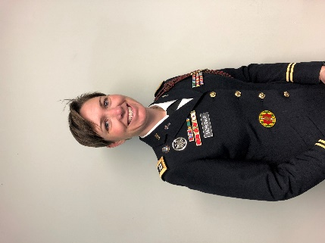
Chaplain (CPT) Tiann (T) Morgner has served over the past 12 years in the United States Army, first as an enlisted Chaplain Assistant, then Chaplain Candidate, and now Battalion Chaplain for the 1st Battalion 77th Armored Regiment, 3rd Armored Brigade Combat Team, 1st Armored Division, Fort Bliss Texas. Ordained as a minister in the Christian Church (Disciples of Christ), T’s greatest joys are still being present in all of life’s ups and downs for her Soldiers and Families, providing a word of hope in some of the darkest times, and reminding Soldiers that they are loved.
Chaplain Morgner’s deployments include a combat deployment in support of Operation Iraqi Freedom as a Chaplain Assistant Non-Comissioned Officer and most recently a rotation to the Republic of Korea as a Battalion Chaplain. She has served as a Battalion Chaplain Assistant Non Commissioned Officer for the 93rd Military Police Battalion and 4th Battalion 3rd Infantry Regiment “The Old Guard”. She then served in the reserves as a Chaplain Candidate for several different units while preparing herself for ministry. Her active duty chaplain assignments include a basic training battalion chaplain with 3rd Battalion, 10th Infantry Regiment, 3rd Chemical Brigade, Fort Leonard Wood, MO, and her current assignment as the 1st Battalion 77th Armored Regiment Chaplain.
Chaplain Morgner holds a Masters in Divinity and a Masters in Theological Studies from Wesley Theological Seminary as well as Graduate Certificates in Muslim Christian Studies and Ecumenism from the Washington Theological Consortium. Her undergraduate degree is from American University.
Chaplain Morgner’s awards and decorations include the Army Commendation Medal (3 Oak Leaf Clusters), the Army Achievement Medal (1 Oak Leaf Cluster), the Army Good Conduct Medal, as well as many others.
T is married to her husband Ryan and they have two beautiful daughters, Savannah and Tory, as well as two dogs.

