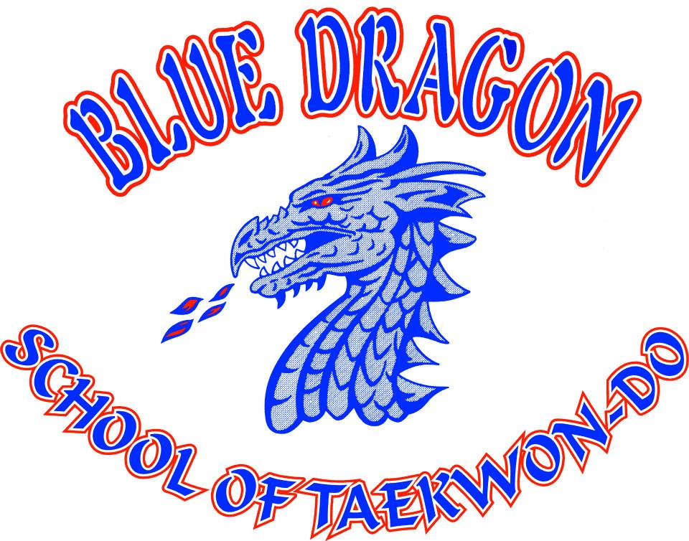

1553 N Old US Hwy 31, Rochester, IN 46975 | 574-223-6511 | www.tkdbluedragon.com
What inspired you to bring a martial arts school to Rochester?
I recognized a need in the community for students who wanted to learn authentic Taekwondo as originally taught by General Choi.
Can you describe the different types of classes and programs you offer?
We offer a variety of programs to accommodate all ages and skill levels, including:
- Children’s Classes (Ages 6-12)
- Adult Classes (Ages 12 and up)
- Private Lessons ($20 for a half-hour session, $40 for an hour)
- Ancient Ninja Flexibility & Balance Class (Designed for adults 60+)
- Special Needs Classes (Tailored to individual abilities)
- Self-Defense Workshops ($10 per person, minimum of 8 participants per class)
What are some of the key benefits of martial arts training beyond self-defense?
Martial arts instill confidence, proper breath control, balance, and discipline. Taekwondo, in particular, emphasizes core values such as courtesy, self-control, perseverance, and an honorable spirit. It’s not just about learning techniques, it’s about personal growth and developing a strong mindset.
Why are you invested in the Chamber?
I’ve always believed in the importance of giving back to the community. As a business owner and past Chamber board member, I see firsthand how local businesses and organizations support each other. Taekwondo is about much more than kicking and punching, it’s about fostering a sense of community and respect, which aligns with the Chamber’s mission.
How can Fulton County residents get ahold of you?
We can be reached by email (dptc56@yahoo.com), phone (574-223-6511), or by Facebook message

