 |  |  |  | 
2023 FALL RENEWAL CAMPAIGN

To: Current Chamber Members with Energy contracts ending thru December 2024

Subject: Chamber Energy Purchasing Cooperative Renewal Program

IT’S TIME TO RENEW!    Thank you for your continued support of the Energy Purchasing Cooperative Program. Members with current energy agreements which expire between now and December 2024 are up for renewal.  War, weather, and worry over the economy continue to charge utility prices. The upcoming Presidential campaign will further exacerbate the situation. Now is the time to lock in rates before your present contract ends. Waiting could cost you hundreds of dollars! Don’t miss out on continued price stability, budget control and peace-of-mind.  Since 2004, the Cooperative Electricity and Natural Gas rates have been lower than both market rates and the weighted annual utility standard offer service rates.  CQI’s 25-plus years of experience with proven results provides the best option for stabilizing your utility expenses.  TAKE ACTION REGISTER NOW!  (New contracts will start at the end of your current one.) |  |  | NO HASSLE PROCESS  - Obtain a Letter of Authorization from  your Chamber website or contact CQI Associates.  - Complete and Sign the Letter of Authorization.  - Provide a complete copy of your most recent Utility bill(s) for all accounts you plan to enroll, and include a copy of your current contract.  Scan and email full copies of all documents to sean@cqiassociates.com or fax to 410-630-5911  To refresh your knowledge about the purchasing cooperative simply watch this short video.  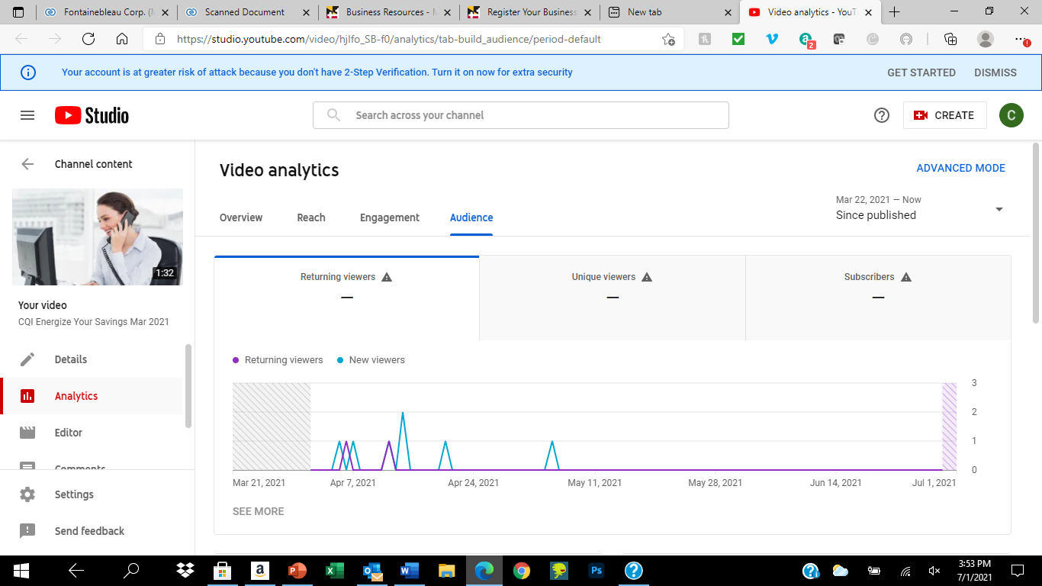  CQI - Energize Your Savings
The application deadline for the Chamber of Commerce Energy Purchasing Cooperative
program is Friday, September 29, 2023.
Questions? Please contact: Joe Tabeling - joe@cqiassociates.com (443)472-3870
"Serving Chamber Members as the Trusted Energy Advisor since 2004"

