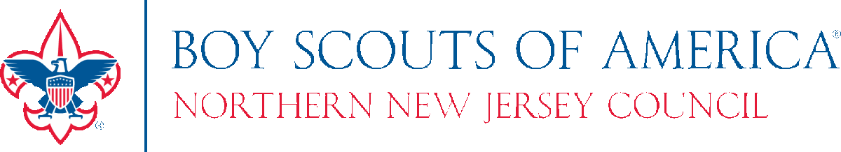

Details on Annual Health and Medical Record Exception for Summer 2020

To address several challenges presented by COVID-19, there will be a one-time exception in effect for portions of the Annual Health and Medical Record (AHMR) until August 31, 2020, to facilitate long-term camping.

Note: Participants that have a valid, completed AHMR Parts A, B & C within 12 months of camp need no exception.

Highlights of the exception include the following elements:
- Extended validity of Part C of the AHMR for 6 months if completed on or after February 1, 2019.

- Allows for use of alternate exams to assist new campers.
  - Attach a completed alternate exam (sports, school, annual well exam at pediatrician) completed on or after February 1, 2019. This will be accepted as a valid Part C until August 31, 2020.
  - Update Parts A and B of the AHMR within two weeks of your departure to camp.
  - There will be no other exceptions outside these parameters
- This does not apply to unit activities greater than 72 hours.

If a participant does not meet the criteria above, the following are options to consider to obtain an examination:

- Telephonic well appointment – Conducted with an individual’s existing health care provider (HCP) to complete the AHMR Part C exam and examiners signature virtually.

- Professional or Compliance well exams - Adult participants whose profession requires regular well or compliance exams (emergency responders, pilots, etc.) may also be able to complete the exam requirements by having the conducting HCP complete Part C either during those well checks or telephonically.

- Local Community clinic or alternative HCP - If primary HCP is unavailable, use alternatives / clinics in the local community such as alternate HCP, CVS, Rite Aid, Care Now, etc.

IN THE STATE OF NY, 12 MONTH MEDICAL EXAMS ARE REQUIRED. WE CAN MAKE NO EXCEPTIONS TO NEW YORK STATE LAW.
*This applies to anyone attending Camp Turrell and/or Floodwood Mountain Reservation

We also encourage anyone whose medical condition or history has significantly changed since their last physical exam to have approval from their health care provider prior to attending camp.

