
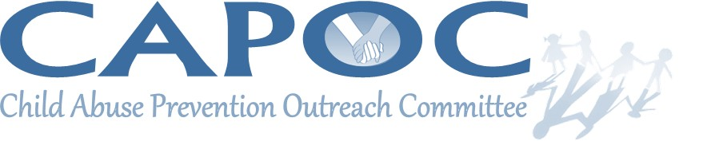

JOIN US FOR OUR 10TH ANNUAL WALK
SATURDAY, APRIL 7th from 10-1,
PENN PARK IN YORK CITY
Registration to start at 9:00 am

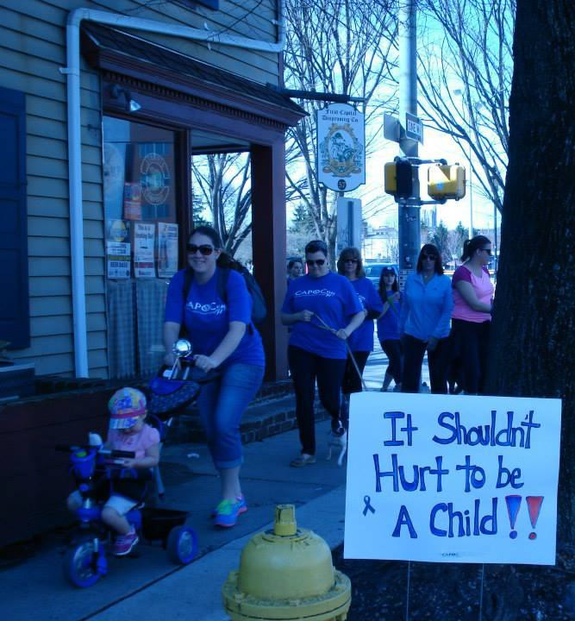

The blue ribbon represents child abuse awareness- wear blue during the month of April!

(Registration form attached at bottom)

Join us for a 1.3 mile walk to show your support for the prevention of child abuse.

What will be there?

Bounce house

Information on family services across York County

Leashed dogs and strollers are welcome!



REGISTRATION FORM

Submit to:

Wellspan Health, York Hospital

c/o Caroline Tyrrell, Case Mgt. Department

1001 S. George Street, PO Box 15198, York PA 17405

NAME:

ADULT CHILD NAME:
ADULT CHILD NAME:
ADULT CHILD

NAME:

ADULT CHILD

Registration fee: $10, free for children under 12 You will receive a re-usable tote bag with registration.

Blue adult t-shirts with CAPOC logo are $5

Checks can be made out to York County Human Services Fund, with CAPOC in the memo line.

All proceeds benefit parenting support materials and resources for children and families.

From the bottom of our hearts, we thank you for your support. Together we make York County a safer place for our children. 

