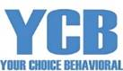

We provide quality service for those struggling with life problems. We service children, adolescent and adults. We have a unique way of bringing these services to underserved areas of Nevada.

Tele-therapy is a service that we provide to those with access to internet and a computer. It can be done in the home or any other private area.
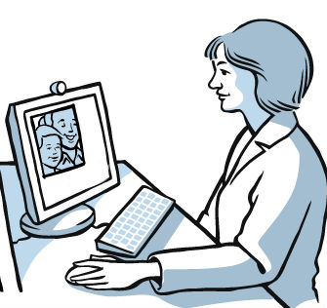
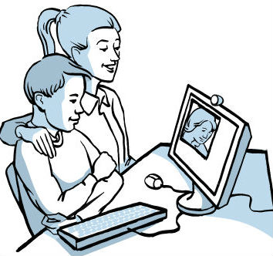

Our outpatient treatment services are designed to address a wide range of mental health issues, including anxiety, panic, depression, attention deficit disorder, obsessive-compulsive disorder, bi-polar disorder, trauma, personality, grief/loss, family, school performance, life adjustment challenges and more.

Services:
- Mental Health Assessments
- Individual and family therapy
- Tele-therapy
- Medication Management
- Psychiatric Evaluations
- Group therapy
- Anger Management Program

Services can be reimbursed by insurance carriers: NV Medicaid FFS, Silver Summit, Prominence, NV Preferred Healthcare, One Health, Multiplan, or cash pay.
To learn more, contact a representative:

YOUR CHOICE BEHAVIORAL SERVICES “YCB”
1140 Almond Tree Ln. #306
Las Vegas, NV 89104-3233
775-777-1099
www.yourchoicebehavioral.com

