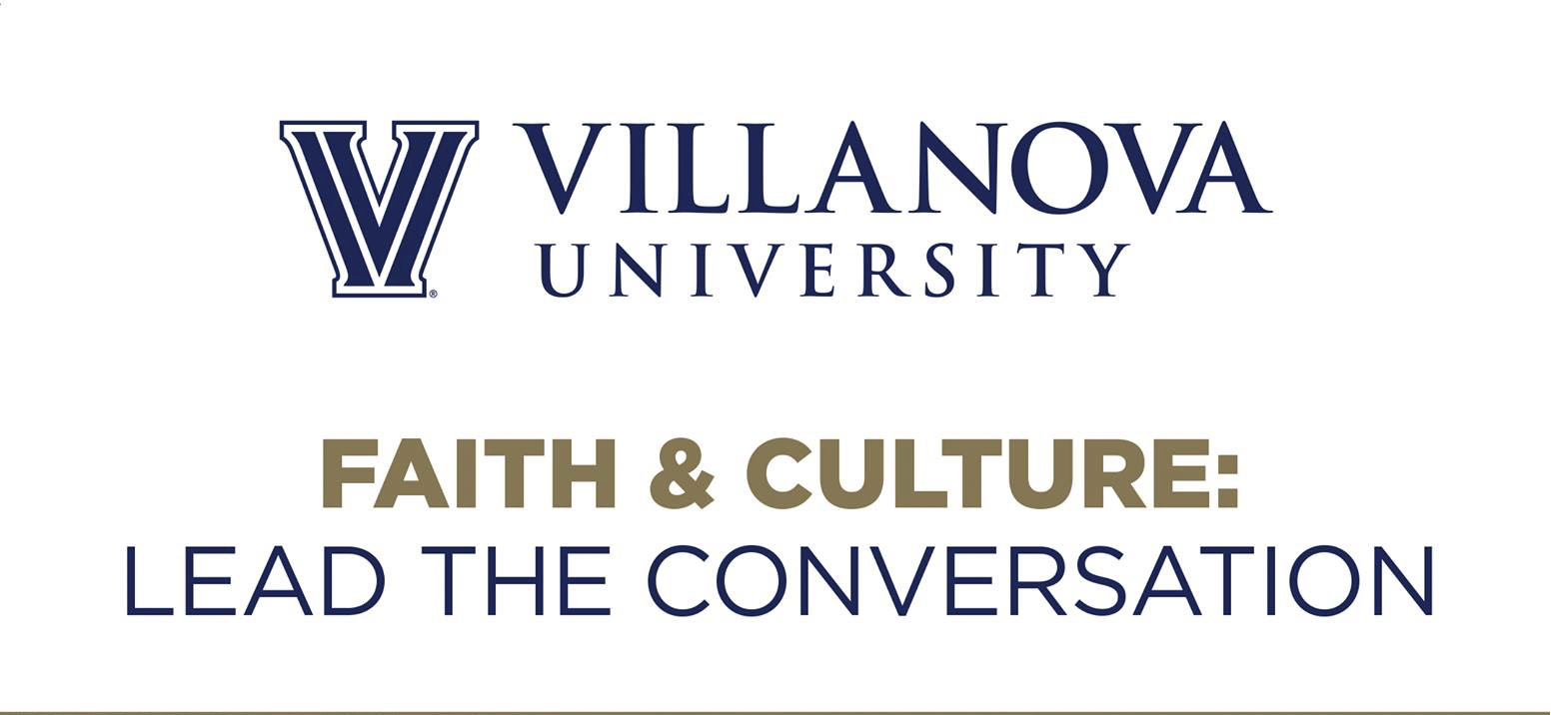

CONNELLY FELLOWSHIP IN RELIGION, SCIENCE AND HUMAN FLOURISHING

2020-2021 APPLICATION

About the Connelly Fellowship: This project gives students an opportunity to conduct academic research and participate in theological, ethical, and scientific reflection enriched by the experiences of their peers and their spiritual and religious traditions. It seeks to enable the development of students as reflective decision-makers who will seek solutions, enact change, and contribute to the flourishing of the human family. Although the research project is not for credit, the Fellowship provides an opportunity to explore questions “close to the heart” and engage with peers on these questions.

Responsibilities of a Connelly Fellow include:
- Produce a significant and meaningful (written) research project
- Work with a faculty mentor
- Accomplish this research in conjunction with theological (religious or spiritual) reflection on the project
- Participate in regular group discussions to share research ideas
- Form a community of scholars
- Meet project deadlines
- Fellow will receive a $500 stipend

Application Details: To apply for the fellowship, please assemble the requested contact information and fellowship proposal describing your principal question or area of interest, as well as a current resume/vitae and unofficial transcript. (Please see page two for specifics.) Once the materials are compiled, please e-mail them to Sr. Ilia Delio (ilia.delio@villanova.edu) by Sunday, December 20, 2020. Applications received after December 20 may not be considered.

~Page 1~
A. CONTACT INFORMATION
Name:
Major/Intended Major:
Year in College:
Email:
Campus Address:

B. STATEMENT DESCRIBING YOUR INTEREST IN THE FELLOWSHIP
In 500-750 words, briefly describe the research project you would like to explore as a Connelly Fellow. It will be helpful to consider the following questions: What critical question or research area do you wish to study? Why is this topic of importance today? What particular concerns motivate you to think about it more deeply? Why does it warrant theological reflection?
(Please submit as a double-spaced word-processing document (or PDF) with standard font and margins.)

C. RESUME/VITAE
Help us understand a little more about you and the things in which you invest your academic and extra-curricular energies.

D. UNOFFICIAL TRANSCRIPT
Your unofficial Villanova transcript can be obtained from https://mynova.villanova.edu
(Search for “View Academic Transcript.”)

DEADLINE: DECEMBER 20, 2020

