The Complete Combatant’s

Deliberate
Practice

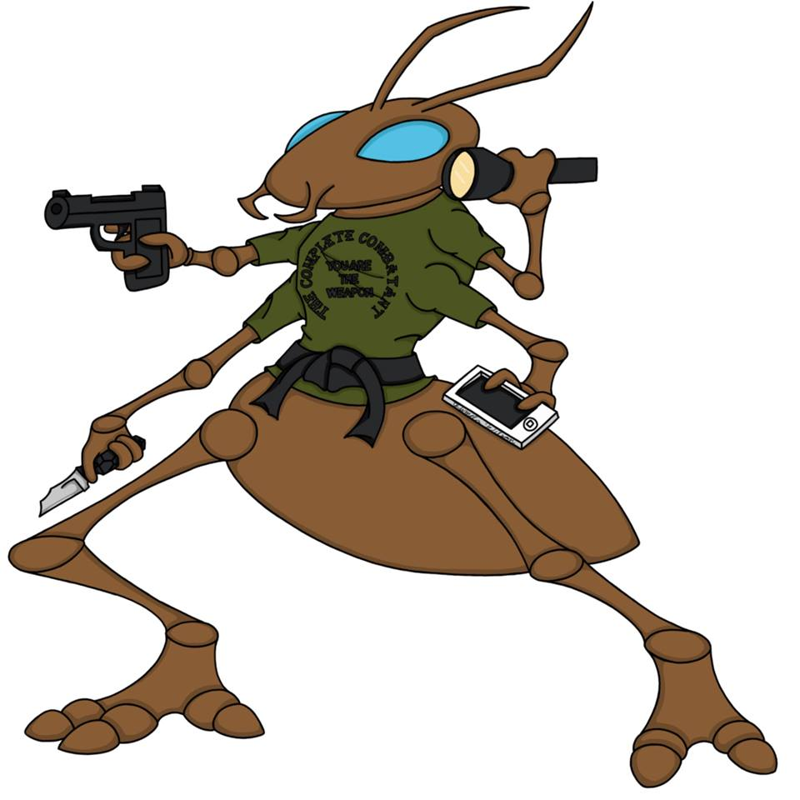

Brian Hill
One of the areas shooters can improve is their approach to practice. Methodology, structure, and feedback are critical elements that are overlooked, but provide the best options for improvement. Strategy, tactics, and techniques need to be practiced until they can be performed with unconscious competence. Equally as important is the shooters mindset, and how they can strengthen their performance under pressure.
Practice is often perceived as drudgery, and therefore is a negative situation.

There are 4 changes to any negative situation:

1-Exit
2-Voice
3-Persistence
4-Neglect

Obviously, in this context, persistence is practice, and the other three, while often used, do not yield the results we are after. We need to find a working solution through deliberate practice. Many believe that only the talented will improve, and of course there are some attributes that make shooting easier for some, like big hands or excellent eyesight, but if look deep enough into high level performance we find persistence is the key factor.
Tell me who you are as a shooter?

Shooters often choose accuracy or speed, as if the two are not interwoven components of shooting. Accuracy is the essential first ingredient, you must hit the target. Speed is the amount of time you have to perform the necessary actions in a fight. Our response time is reaction time plus action time, meaning reacting to the stimulus, making a decision, and the time it takes to perform the action. I see no room for slowness or inaccuracy in this event, both are important, and training must develop the automaticity of the actions, freeing the mind to process the information available, and delivering consistent performance under pressure.

First, we should train the unconscious mind to perform all the administrative actions without effort, that is drawing, clearing malfunctions, movement, reloads, trigger, and muzzle and finger discipline. The unconscious mind has no sense of time when deep into a flow state, and the current level of skill will be automated if practiced regularly.

Second, train the conscious mind to recognize what is important through visualization. Seeing the sights on the target, watching the hands, examining pre-assault indicators, finding the opportunity to interfere with the attack cycle. Staying in the process in the present. This is the act of being the observer of the information from the feedback we are receiving, and having strong visualizations of the process is the key to consistency.

Third, build the self image. Competency, confidence, and calmness are trademarks of a strong self image, and in addition lead to better performance under pressure. Pressure testing, competition, and experience build our self image of what we can do, not what we hope to be able to do. Practice earns skill, skill improves performance, and performance builds our self image.

Practice:

-Failure/feedback
Correct what you are seeing and feeling. Push your limits to find an area of failure. Make the corrections without negativity, and emotion. Modify your effort until you get the desired results. Miyamoto Mushashi said “do nothing which is of no use”; always strive to be both efficient and effortless.

-Define success
You may only practice one thing at a time, such as marksmanship (accuracy and precision) or quickness and efficiency, but not both together. Constant feedback from drilling
will allow you to push past self imposed boundaries. Performance training is processing the feedback in the moment, in other words, calling the shot or visual patience.

-Small skill practice
This leads to small changes, which accumulate into large changes
Pick the most important weakness, and fix it. Stay with it until it is a strength, then move to the next problem. Fix several small issues one at a time, and it will improve your overall performance.

-Interactive
Use targets, dry practice, video analysis, and find a structured program like Mike Seeklander, Ben Stoeger, Claude Werner or Steve Anderson programs, and follow them exactly. Find a coach that connects with you, and can help you grow as a shooter.

-Maximal effort
Train as long as you can with maximal focus and effort. To change requires you to be uncomfortable. Choose quality over quantity.

-Well defined goals
Pick an area, and define success. Avoid perfectionism by understanding what is both possible and probable. Improve your distance shooting, or your draw, for example, with the well defined metrics from the shooting world.
-Full attention
Concentration needs training, stay in the process. Become fully involved with the feedback. Always bring the mind back to the task at hand.

-Mental model
Develop a well defined model in your mind of shooting, a mental representation of skill, which continues building or modifying previous skills on top of existing skills . This is your image of how you shoot, your clearly defined self image
Never stop improving. Do not worry about making mistakes because they are crucial for your development. Build the fundamentals, and your shooting will be consistent. Know exactly what you are capable of doing under stress. Know yourself.

-Coaching
Having someone else observe your training and performance is essential. They will see your blind spots, and help provide the necessary feedback for correction. We should be receptive, and open to improvement, and a simply thank you keeps the mind open and grateful.

Do not meet constructive criticism with anger or denial, but be grateful for the correction. Take a moment to savor success, accept compliments with a grateful acknowledgment instead of dismissing or ignoring them.

5 fundamentals: Stance is context driven, 3 are physical, 2 are visual but all are synergistic

1-Stance is the position of both the body (posture) and feet in which an athlete starts or operates. How does stance help you shoot better?
Balance is essential whether moving or stationary, providing equilibrium and preparedness to shoot accurately with good recoil management. The posture binds us to the target, giving physical parameters to acceptable oscillation during shooting and transitions. Posture engages the mind, allowing us to be ready. Feet forward, knees bent, hips under and pelvic muscles pressing down into the pelvis frees the upper body to be both relax and efficient.

2- Grip is a firm tenacious hold typically giving control, mastery, or understanding. The master fundamental, grip should encircle the gun, be repeatable, and provide constant feedback to the shooter. This is the connection to the gun. Many mistakes are lessened when control of the gun is maintained.
Sights and trigger are synergistic; the sight movie tells the shooter how fast they can press the trigger.

3- Sight is a device that aids the eye in aiming or in finding the direction of an object.
Gabe White refers to a sight movie, accepting the constant motion of the sights, and the inherent wobble zone of the shooter. Three basic sight movies exist, flash, floating, and focused (Max Michel) relative to size and/or distance of the target. Seeing more, and visualizing exactly what is acceptable is the key to performance shooting.

4- Trigger is a lever to release or activate. When manipulating the trigger keep the motion constant. The speed of trigger movement is varied by what the sight movie is showing, but should be constantly moving. Tom Givens suggest 3 trigger speeds, quickly, carefully, and precisely, although most shooters use only one speed no matter the size, difficulty, or distance of the target. The shooter should release the trigger, and prepare for the next shot during recoil, otherwise time is wasted in pinning the trigger instead of processing the information available from the sight movie and target, and making a decision of continuing the process, or stopping to assess the situation.

5- Follow through is to press on in an activity or process especially to a conclusion. At the minimum, we want to see the sights on the target, and ideally we want to see the sight lift on the target, and return to the same spot, or begin our transition to the next target, or process that no further shots are necessary. The mind must focus on the process, and remain in the present. The temptation is to be result oriented, but the process is the only thing we can control through focus. The mind should assess the information available, the shooter should move to a tactical low ready, and check the area for available situational information.

Mixed Six

The armed citizen must have a trustworthy draw, and the ability to hit the target quickly and efficiently. Since our starting position will be different depending on the context of the encounter. The following six positions are the most common in personal protection. The par times relative to the bulls eye ring require visual patience, and strong grasp of the fundamentals of shooting.
- 15 rounds total
- Par times
- 6 yards
- 10 minutes
- All shots to the B-8 or the Q (5 points) except for the 1 (one) head shot

NEED:

- 2 magazines = double stack OR 3 magazines = single stack
- 1 magazine with 1 round
- Phone & Flashlight (props are fine)

DRILL:

- Hands up (fence/frames), draw and fire 2 (3 seconds) on the target
- Primary hand ONLY = Support hand holds flashlight at "eye index" while primary hand draws and fires 2 (5 seconds) on the target
- Support hand on the phone (by the ear), draw and fire 2 (3 seconds) on the target
- “Failure to Neutralize”= draw and fire 2 to the body and 1 to the ocular cavity (4 seconds) on the target
- Low ready, verbal command, on the whistle fire 2 (3 seconds) on the target
- Start with 2 rounds IN THE GUN, draw and fire 2, reload, and fire 2 (9 seconds) on the target
POSSIBLE SCORE OF 150:
- Q = 5 points
- B-8 scored by point value
- Head shot in the ocular box =10 points
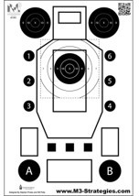
- In the head box = 9 points
- Passing score = 90% (135 points)

NOTES:

© 2020 The Complete Combatant, LLC, Dahlonega, GA USA.
All Rights Reserved
Customer Contact: thecompletecombatant@gmail.com 404-936-6986
www.thecompletecombatant.com

