Literacy Source Superheroes!  Instructional Advisors | 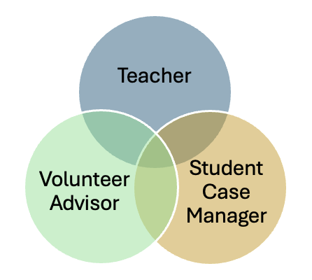

As part of our teacher appreciation week we want to take a moment to focus Literacy Source Instructional Advisors and what makes them unique.

- Firstly, they are Teachers. Did you know that all our instructors are professionals, who bring years of experience and skills in adult basic education and ESOL? Every term the instructors do what teachers do, design 8 – 12 weeks of lesson plans that are crafted for maximum student interaction (you won’t see lecturing in our classrooms!) Their online or in-person lesson plans are centered around student interests and goals, bring in life skills, work skills and the basic skills of reading, writing, conversation, digital literacy, and math. They include reading texts and workbooks to enhance their teaching and are aligned with the College & Career Ready Standards (CCRS) for adult foundational learning and ESOL.
- Secondly, they are Student Case Managers. In addition to their teaching role in the class, they also guide and advise students to help them reach their learning goals. Our small classes and low student/ teacher ratios mean that the instructors are readily available to meet with students and speak to their needs to help them learn. They place students in class and help them move along their learning pathways, at Literacy Source or elsewhere. They also make referrals for barrier mitigation, again sometimes to the Literacy Source case management team and sometimes to community partners.
- Thirdly, they are Volunteer Advisors. Students are offered volunteer tutors to help them 1:1, and it is the responsibility of the instructional advisor to meet with the tutor and student to off to a good start by focusing on the student’s individual needs. From there, in their advising role, they monitor the tutoring offering ongoing guidance, support, and resources to help the tutors provide the best learning experience for the student. Most classes also have volunteer class assistants who may be new to teaching and need support and training as they lead class routines or support small group learning outcomes.

To have a team of robust, experienced teaching staff willing to take on these diverse roles to help students get the learning, support, and resources they need is part of what makes Literacy Source unique.

Literacy Source Instructional Advisors Allie Azersky, Erik Bodlaender, Kaeyoung Park, Leesy Latronica & Megan Allister (AmeriCorps), Megan Dalton.

