Disability Accommodations

A Guide for Students at Literacy Source

2025



Credit to Literacy Minnesota for much of this information and guidance

What’s in this Guide?

What’s in this Guide? 1
Welcome. 2
What is a Disability? 3
What are Accommodations? 5
What are Reasonable Accommodations? 6
Right to Accommodations 7
What is Documentation? 8
How do I ask for Accommodations? 10
Common Accommodations at Literacy Source 15
For more information: 16

Welcome.

This guide talks about:
- What is a disability?
- What are accommodations?
- How do I get accommodations?
- Where can I go for help?

There are different rules for accommodations for the high school equivalency test and US Citizenship interview. To learn about accommodations for these tests, visit GED website or USCIS website. For more information about accommodations for the US Citizenship interview, you can also talk to Cory, the Literacy Source Citizenship Program Manager.

What is a Disability?

“A disability:
- Changes how you do some things, like: seeing, eating, sleeping, learning, reading, working, or breathing.
- Makes it harder to do one or more of these things.
- Or: makes it impossible to do one or more of these things.”

The Americans with Disabilities Act is a law protecting people with disabilities. We call this law the ADA. The ADA protects us at work, in public places, and in adult education.

Quotation: ASAN’s A Self-Advocate’s Guide to the Americans with Disabilities Act

Some examples of people the ADA can protect are:
- People who are deaf or hard of hearing.
- People who are blind or have low vision.
- People who use wheelchairs or canes.
- People who have cancer, diabetes, or HIV.
- People who have dyslexia, dyscalculia, or Attention Deficit Hyperactivity Disorder (ADHD).
- People who have depression, anxiety, or Post Traumatic Stress Disorder (PTSD).

You can learn more about the ADA in A Self-Advocate’s Guide to the Americans with Disabilities Act by the Autistic Self-Advocacy Network.

What are Accommodations?

“Accommodations are changes that make things easier for people with disabilities.” Accommodations help people with disabilities get the same education as everyone else.

Some examples of accommodations are:
- Extra time on assignments or tests.
- Large print
- Amplifiers: a tool that makes speech louder
- Text-to-speech: a tool that reads text out loud.

You can find more examples on this website:
• Common Classroom Accommodations.

Quotation: ASAN’s A Self-Advocate’s Guide to the Americans with Disabilities Act

What are Reasonable Accommodations?

There are many kinds of accommodations. You can’t get every accommodation in every situation. Accommodations must be reasonable.

Reasonable means that the school:
- Has the time and money to do it, and
- Can do it without changing what class is like for the teacher and all the other students too much.

For example, one-on-one lessons with a teacher are not a reasonable accommodation in many adult education classes. One-on-one lessons are too much change. They are too different from what classes are usually like. A one-on-one lesson with a tutor at Literacy Source is a reasonable accommodation. This is a regular program at our school.

Right to Accommodations

The ADA gives people with disabilities a legal right to reasonable accommodations in many places, like:
- At work
- At adult education programs
- At other schools, like technical college and university.

To have a legal right to accommodations in adult education, you need documentation. You can learn about documentation on page 9.

What is Documentation?

Documentation is proof that you have a disability and need accommodations. You usually need documentation to get accommodations.

One kind of documentation is a letter from your doctor, psychiatrist, or therapist. It says:
- What disability you have.
- How your disability affects you.
- What kind of accommodations you need.

To get documentation:
- Tell your doctor about problems at school.
- Talk to your doctor about what accommodations can help.
- Ask your doctor to write a letter to your school.

Another kind of documentation is an IEP or 504 plan. IEPs and 504 plans are from U.S. K-12 schools. You might have one if you got accommodations in a U.S. K-12 School.

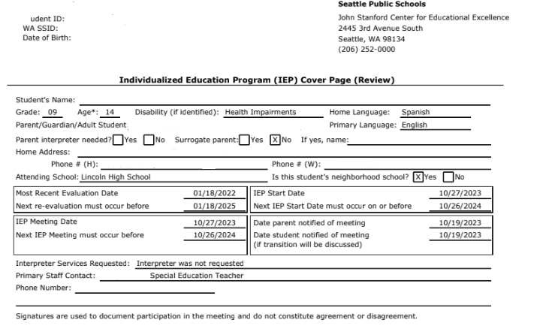

Your school can look at your old IEP and 504 plan to see what accommodations you got before. This might be enough to get accommodations again.

If you can’t get documentation, don’t worry. There is more information about what to do on page 14.

How do I ask for Accommodations?

Tell someone at school that you want to ask for accommodations. You can tell a teacher, tutor, or someone else. Bring your documentation with you.
You might have to give some details about your disability. If you don’t say what your disability is and how it affects you, your school doesn’t have to give you accommodations.

Your school has to keep your disability confidential. Confidential means that your school can’t tell other people who don’t need to know.

After you get accommodations, use them. If you don’t use them, your school doesn’t have to keep giving them.

To ask for accommodations, you can say:
- My disability is….
- My disability makes it hard for me to ….
- I need accommodations to help me ….
- The accommodations I’m asking for are …

For example:
- My disability is ADHD
- My disability makes it hard for me to remember instructions.
- I need accommodations to help me follow instructions.
- The accommodations I’m asking for are written instructions for classroom activities.

If Literacy Source thinks an accommodation isn’t reasonable, it might offer a different one instead.
If you think the accommodation Literacy Source offers won’t work, you can say:
- That won’t work because…
- My documentation says that my disability …
- It’s important that my accommodations help …

For example:
- That won’t work because I would still have to remember spoken instructions for a long time.
- My documentation says that my disability makes it hard for me to remember what I hear.
- It’s important that my accommodations help me remember instructions.

If you can’t get documentation, there are still many things Literacy Source can do to help. You don’t need documentation for small changes if your teacher agrees.

If you can’t get documentation:
- Think about what the problem is. What isn’t working for you?
- Think about what changes can help with the problem. What do you need so you can learn?
- Talk to your teacher. Your teacher will have ideas about how to help

Common Accommodations at Literacy Source
There are common accommodations used all the time at Literacy Source. You can just ask your teacher or tutor for any of these.
Seeing:
- Large print
- Move to front of classroom
- Use reading glasses
Hearing:
- Learn how to change computer volume
- Use headphones with the computer
- Move to front of classroom
- Move to work in quieter space if possible for tutoring or group work
Moving:
- All classrooms and a bathroom are accessible
- Provide a mouse or mousepad
- Use whiteboards to practice writing
Pain:
- Seat cushions
- Take frequent breaks
- Have shorter tutoring sessions

ADHD/Attention/Anxiety
- Teach short instructional units (20 minutes or less)
- Give clear instructions
- Model activities
- Use small group work
- Match with a tutor
- Spend time building trust

For more information:

Disability Rights Washington
https://disabilityrightswa.org/


