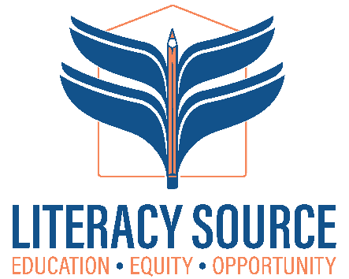
VISTA: Outreach, Systems, & Library Coordinator

Project Needs Statement
​​In Seattle, of the population over the age of 25, 53.8 percent (vs. a national average of 27.4 percent) hold a bachelor's degree or higher; 91.9 percent (vs. 84.5 percent nationally) have a high school diploma or equivalent.¹ This leaves a stigma and unrecognized reality that over 500,000 adults residing in King County do not have basic proficiency in reading, writing, or math. This number continues to increase as more children are not receiving the help they need in the K-12 system, and we see more people immigrate to our area as English language learners. Helping adults improve their literacy skills is key to creating a more robust, stable, and healthy community. Literacy Source helps meet the need for adult learning in King County, and in order to do so, we need to grow our organizational capacity to serve more learners well and recruit volunteers to support their learning.

Project Goal

The Literacy Source VISTA project will serve low-literacy, under-resourced King County, WA community members by 1) Expanding student and volunteer outreach programs to increase enrollment 2) Increasing student engagement in center activities and programs 3) Developing educational programs in student-identified topics 4) Creating student resources that mitigate barriers to learning, track pathways, and support goal-attainment and 5) Developing a program to expand the internal library circulation. As a result of this project, within three years Literacy Source will serve more students and increase literacy rates of the highest-need community members, thereby improving economic outcomes and reducing poverty for county residents.

Location:
This position is based at Literacy Source’s Learning Center at 12360 Lake City Way NE, Ste 301. However, the job requires both in-person and remote work as needed.

About Literacy Source:
As a non-profit community learning center, we work towards an inclusive and equitable society providing education and opportunities for all adults. We provide free basic skills classes and one-on-one tutoring at our Learning Center in Lake City and in locations throughout Seattle. Our students range from 18 to 90, speak 50 languages, and represent 68 nations. 97% of our students are low-income and 88% are immigrants or refugees. All our students share one common element – the desire to learn and achieve their goals.
Our mission: Literacy Source provides accessible, high-quality foundational education for adults to create lasting opportunities for themselves, their families, and their communities. More on our mission, values and organization at www.literacysource.org.

Position Description and Duties:
The VISTA project will focus on developing and/or improving the following 4 areas:
1) Student and volunteer outreach programs to increase enrollment
2) Increase student engagement in center activities and programs and develop educational programs in identified topic areas i.e. Know your Rights (KYR) and other student requested electives
3) Student support and resource materials to help mitigate barriers to learning, track pathways, and reach goals
4) Develop a program to increase and expand internal library circulation.

Scope of work will include the areas of English to Speakers of Other Languages (ESOL), General Education Development (GED) test prep, citizenship, and digital literacy skills.

Required Qualifications:
- Literacy Source works to become a fully inclusive, multicultural, anti-racist organization. Commitment to this work is essential.
- Ability to effectively interact with co-workers, clients, donors, and volunteers with diverse backgrounds and treat everyone with respect.
- Connection with mission of Literacy Source and the diverse communities we serve.

Desired Qualifications:
- Lived experience that reflects our student population. immigrant or refugee; non-traditional educational trajectory
- Proficiency in Spanish, Chinese, Amharic, Oromo, Arabic, Tigrigna;

Compensation and Hours:
- Living allowance - $$1155.14 (every 2 weeks)
- Housing assistance $750 for the year
- Housing Stipend of $300 per month (LS)
- Education Award - $7,395 or Cash Stipend - $1,803
- $150 towards Professional Development
- Healthcare reimbursement allowance
- Month and Orca Transit Card
- 1 year of service. 35 hr. week Mon – Fri. with occasional weekend events. The position is hybrid - required to be in the office at our Lake City location, Mon – Thurs 8:30am – 3pm
- 10 personal days: 10 sick days

Interview process
- Phone screen interview with Literacy Minnesota VISTA recruitment officer
- Online or in-person interview with Literacy Source recruitment panel

How to Apply:
Complete application on VISTA portal: https://my.americorps.gov/mp/listing/viewListing.do?fromSearch=true&id=128078
Send a cover letter and resume to Caroline Socha, Literacy Source, Volunteer Program Manager at carolines@literacysource.org
For more information, visit www.literacysource.org or call 206-782-2050

Start/Closing Date:
Start Date: February 16th, 2026 – February 12^{th,} 2027. Position is open until filled
Literacy Source is an equal opportunity employer working towards a culturally diverse workplace.
We strongly encourage applications from the BIPOC community, immigrants, refugees, women, people with disabilities, members of the LBGTQ community and other underrepresented and historically marginalized groups.

