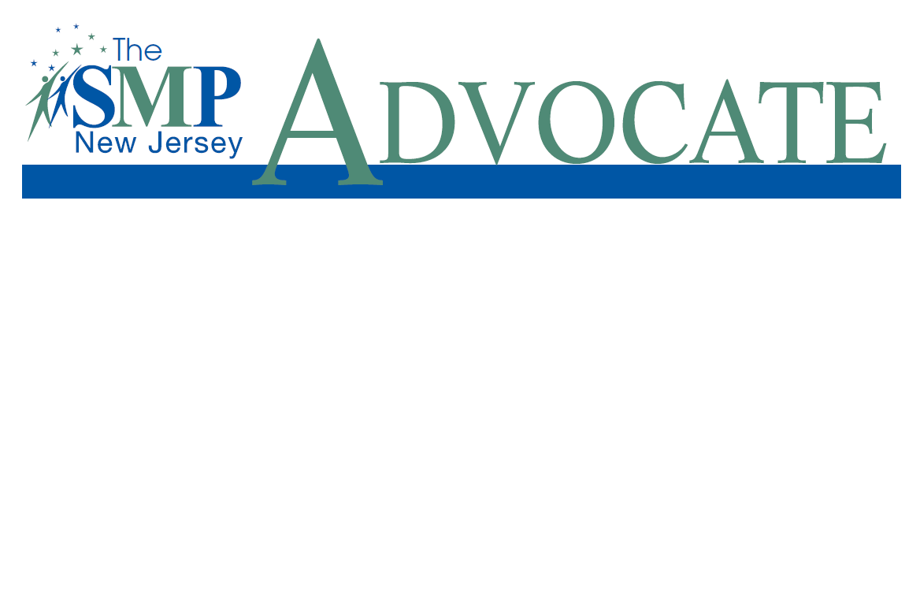
Issue #38, 9/5/2023

SMP of New Jersey Advisory Committee

Charles Clarkson, Esq.
SMP-NJ Project Director

Edward S. Campell, O.D.
SMP-NJ Volunteer
Coordinator of Complex Interactions

Laila Caune
Middlesex County Director of the Office of Aging & Disabled Services

Shirley Force
Executive Director,
County of Passaic
Department of Senior Services/ADRC

John Krayniak
Former Assistant Attorney General, Antitrust Section,
Division of Criminal Justice
State of New Jersey

Julie Marte
Associate State Director-Multicultural Outreach, AARP New Jersey

(continued)
THAT TIME OF YEAR AGAIN: MEDICARE OPEN ENROLLMENT

By Charles Clarkson, Esq.

Project Director, Senior Medicare Patrol of NJ

Every year between October 15 and December 7, a period known as “Open Enrollment,” Medicare beneficiaries can make changes in their Medicare coverage. The Senior Medicare Patrol of New Jersey (SMP), a federally funded program of the U.S. Administration for Aging, believes that if you know your options you can avoid being scammed and make the right choices — giving you the best coverage at the least cost.
Why make a change? Whether you have Original Medicare (Part A and/or B), Part D (prescription drug plan), or a Part C Medicare Advantage plan, your plan can change. Premiums, deductibles, and coverages can all change. Even if they remain the same, your health or finances may have changed. SMP encourages all beneficiaries to re-visit their coverage and decide whether or not to change during Open Enrollment.

Beneficiaries have these choices, which become effective January 1, 2024:

- If you are enrolled in Original Medicare, you can change to a Medicare Advantage plan with or without drug coverage. These plans are private companies approved by Medicare and give you the services of Original Medicare. If you join a Medicare Advantage plan, you do not need (and are not permitted) to have a Medicare supplement insurance plan (also known as a Medigap policy), and if your Medicare Advantage plan has drug coverage, you will not need a Part D plan.

- If you are in a Medicare Advantage Plan, you can switch to another Medicare Advantage plan or drop your Medicare Advantage Plan. If you decide to drop a plan and not switch to another plan, you will be enrolled in Original Medicare. You should then consider enrolling in a Medicare supplement insurance plan to cover the costs that Original Medicare does not pay for and enroll in a Part D plan for drug coverage.

Mary McGeary
NJ State Director,
State Health Insurance Assistance Program (SHIP), NJ Division of Aging Services

Dennis J. McGowan
Manager, Office of AAA Administration, NJ Division
of Aging Services

Lisa Pino, Morris County MIPPA/SHIP Coordinator, Norwescap

Cathy Rowe
Executive Director,
NJ Advocates for Aging Well

Jean Stone
Former Program Integrity Senior Specialist, Division of Stakeholder Engagement & Outreach, CPI Data Sharing & Partnership Group

Ken Wessel
Trustee, National Institute for Homecare Accreditation (NIHCA)

Frank Winter
Partnership Manager
SMP Liaison, CMS

- If you are in Original Medicare with a Part D plan, you can stay in Original Medicare and switch your Part D plan.

If you are in Original Medicare and do not have a Part D plan, you can enroll in a Part D plan. If you join a Part D plan because you did not do so when you were first eligible for Part D and you did not have other coverage that was, on average, at least as good as standard Medicare drug coverage (known as creditable coverage), your premium cost will be penalized 1% for every month that you did not enroll in Part D. You will have to pay this penalty for as long as you have a drug plan. The penalty is based on the national average of monthly premiums multiplied by the number of months you are without coverage, and this amount can increase every year. If you qualify for extra help (low-income subsidy), you will not be charged a penalty.

Why change Part D plans? Beneficiaries may want to change Part D prescription drug plans (PDPs) for a number of reasons: (i) the PDP has notified the beneficiary that it plans to drop one or more of their drugs from their formulary (list of available medications); (ii) the beneficiary is reaching the coverage gap (donut hole) sooner than anticipated and may want to purchase a PDP with coverage through the coverage gap, if one is available; (iii) the PDP has notified the beneficiary that it will no longer participate in the Medicare Part D program; (iv) the PDP will raise its premium or co-pays higher than the beneficiary wants to pay, and a less expensive plan may be available and (v) either a beneficiary is not happy with the PDP’s quality of service, or the plan has received low rankings for a number of years. For 2024 beneficiaries in New Jersey can expect to choose from a number of PDPs. The plans will be announced in late September or early October 2023.

Compare plans each year. Beneficiaries should remember that PDPs change every year and it is recommended that beneficiaries compare plans to insure that they are in the plan that best suits their needs. When comparing plans, keep in mind to look at the “estimated annual drug costs,” i.e., what it will cost you out of pocket for the entire year, from January 1 through December 31 of each year. Plans can be compared at the Medicare web site: www.medicare.gov. If you do not have access to a computer, call Medicare at 1-800-Medicare to assist in researching and enrolling in a new plan. Medicare can enroll a beneficiary over the telephone. When you call, make sure that you have a list of all your medications, including dosages. Another resource for Medicare beneficiaries is the State Health Insurance Assistance Program (known as SHIP), telephone number: 1-800-792-8820. SHIP is federally funded and can provide beneficiaries with unbiased advice. Call SHIP to make an appointment with a counselor. You do not need to use a broker or agent, who may not be looking out for your best interest. Brokers and agents are usually being paid to enroll you in certain plans. Beneficiaries can also call the Senior Medicare Patrol of New Jersey at 732-777-1940 or our help line at 732-SMP-4359.
Medicare Advantage Open Enrollment. From January 1 through March 31 of each year, beneficiaries who are already enrolled in a Medicare Advantage plan have a second chance to change their Medicare Advantage plan or go back to Original Medicare. This period is known as the Medicare Advantage Open Enrollment period. You can change plans only once during this enrollment period. Here are the actions that you can take:
- If you are in a Medicare Advantage Plan (with or without drug coverage), you can switch to another Medicare Advantage Plan (with or without drug coverage).
- You can drop your Medicare Advantage Plan and return to Original Medicare. You will also be able to join a separate Medicare Part D drug plan.

Your coverage will start the first day of the month after you apply to switch plans.
During the Medicare Advantage Open Enrollment period you cannot:
- Switch from Original Medicare to a Medicare Advantage Plan.
- Join a Medicare drug plan if you are in Original Medicare.
- Switch from one Medicare drug plan to another if you are in Original Medicare.
__________________________________________________________________________________________________________________________________

FRAUD ALERT---GOT COVID-19 TESTS YOU DIDN’T ORDER? DON’T PAY

Unordered COVID-19 tests — and bills — are arriving on doorsteps around the country. What is going on? It is another scam targeting people with Medicare. Here is what to do if you get billed for tests you didn’t order.

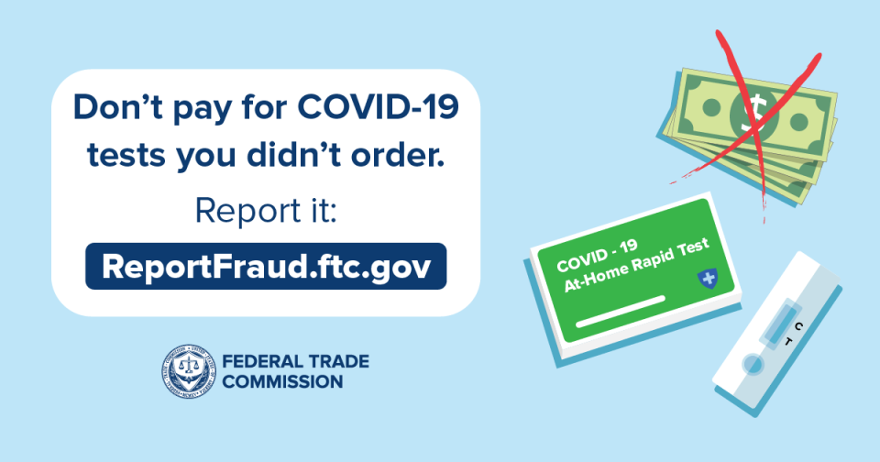
In June, the FTC warned about scammers stealing people’s Medicare numbers and billing Medicare for COVID-19-related services (and other things) that they sometimes got — and sometimes didn’t. The difference now? You might be getting the bill instead of Medicare. That’s because after May 11, when the COVID-19 Health Emergency officially ended, Medicare and other health insurance plans stopped paying for many at-home over-the-counter COVID-19 tests. Once Medicare denies payment, those scammy companies could come back with a bill in your name.
Here is what to do if you get one of these bills for unordered COVID-19 tests:
- Do not pay it. By law, companies cannot send you things you did not order and then demand payment. If you get a bill like this, report it at ReportFraud.ftc.gov.
- Check your Medicare Summary Notices (MSN) and Explanations of Benefits (EOB) to see whether your account was billed. Statements are available by mail or online at Medicare.gov. Look for services, products, or equipment Medicare paid for that you did not get. Do the statements show any double charges, or things you or your doctor did not ask for?
- If you suspect Medicare fraud, call your health care provider or Medicare plan and ask for an explanation. If you are not satisfied with the response, call the Senior Medicare Patrol of NJ at 732-777-1940 or the helpline at 877-SMP-4359.
- Report Medicare fraud to the Health and Human Services Office of Inspector General online or at 1-800-HHS-TIPS (1-800-447-8477). It helps them track down the scammers and try to stop them.
_________________________________________________________________________________

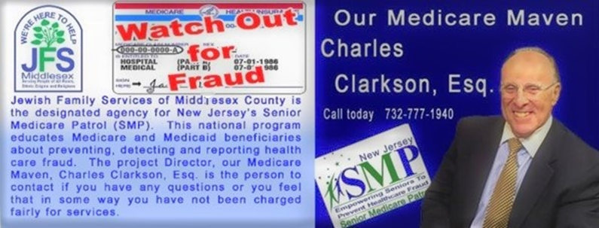

ASK CHARLES
Charles Clarkson is the Project Director of the Senior Medicare Patrol of New Jersey.

How can I get a Replacement Medicare card?
If you lose your card, you can obtain a replacement card by phone at 1-800-772-1213, or online at the Social Security Administration website (ssa.gov). Make sure that you have your Medicare number ready when you call. You should receive your new card in about four weeks.
You can also open a Medicare account online at Medicare.gov. This account will allow you to print your own Medicare card. When you open an account, pick a username and a strong password and do not share it with anyone. If you cannot remember the password, write it down in a book and save it in a safe place. Writing your passwords down is good practice. It allows you to select strong, longer passwords without fear of not remembering them. Caution: Never use the same password twice.
Five years ago, Medicare replaced Medicare cards for all beneficiaries by removing the Social Security number and replacing it with a Medicare Beneficiary Identifier (MBI). The MBI number is a random selection of numbers and letters. Because of the new MBI, Medicare can replace it with a new MBI if your MBI has been compromised. A beneficiary can do this by calling Medicare at 1-800-MEDICARE and requesting a new MBI due to a compromised number.
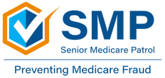

STAY CONNECTED
The Senior Medicare Patrol of New Jersey has a website. You can reach our site at:
http://seniormedicarepatrolnj.org/




Forward this to a friend Friend us on Facebook Follow us on Twitter/X
#MedicareMaven

Serve your community; learn about Medicare by volunteering for the
Senior Medicare Patrol of New Jersey
SMP of New Jersey is currently recruiting Volunteer Community Liaisons to speak to small groups of their peers and help provide Medicare education at community events throughout the State. Bilingual a plus.
The role of the Community Liaison is to share information that can help others PREVENT, DETECT, and REPORT Medicare fraud, waste, and abuse.
Free Training Available
For more information, please contact Michelle Beley-Bianco,
SMP-NJ Coordinator of Volunteers, 732-777-1940 or michelleb@jfsmiddlesex.org

SMP - Empowering Seniors to Prevent Medicare Fraud

Senior Medicare Patrol of New Jersey
Charles Clarkson, Esq.
SMP-NJ Project Director
Ext. 1117
Email: Charlesc@jfsmiddlesex.org
Twitter: #MedicareMaven; @charlessmpnj

Joel Schneider
Outreach Specialist
Ext. 1154
Email: joels@jfsmiddlesex.org

Michelle Beley-Bianco
Coordinator of Volunteers
Ext. 1157
Email: Michelleb@jfsmiddlesex.org

Edward Campell
Coordinator of Complex Interactions
Ext. 1152
Email: Ed@jfsmiddlesex.org

Molly J. Liskow
Editor, SMP New Jersey Advocate
Email: SMP@jfsmiddlesex.org


Senior Medicare Patrol (SMP) New Jersey is a program of:
Jewish Family Services of Middlesex County
219C Blackhorse Lane, North Brunswick, NJ 08902
Tel. 732-777-1940
Fax 732-777-1889
or call our toll-free SMP Hotline at
877-SMP-4359 (877-767-4359)

