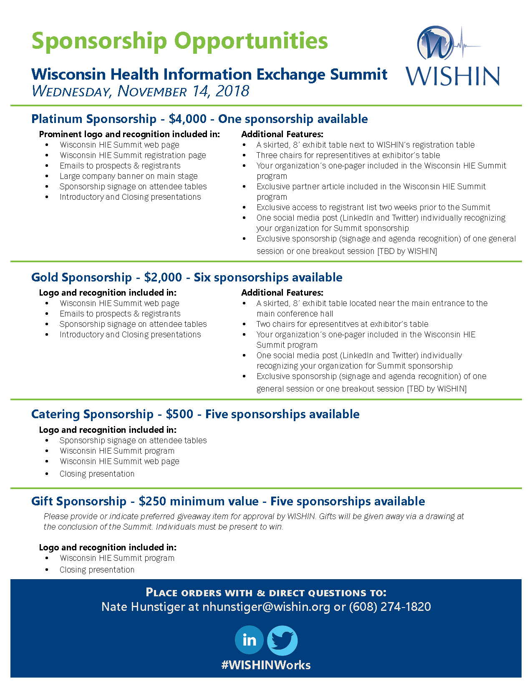

Thank you for your interest in being a sponsor of the Wisconsin Health Information Exchange Summit presented by WISHIN. Please complete this form and return to Nate Hunstiger (nhunstiger@wishin.org).
Name:
Position:
Company:
E-mail:
Phone:

Signature Date:

Sponsorship level:
☐ Platinum Sponsor* - Please provide your materials or PDF of materials for the Summit program no later than Monday, October 1, 2018.
☐ Gold Sponsor* - Please provide your materials or PDF of materials for the Summit program no later than Monday, October 1, 2018.
☐ Catering Sponsor*
☐ Gift Sponsor*
*The deadline for sponsoring this event is Monday, October 1, 2018. Payment and ALL requested materials must be received by this date to secure the full benefits of sponsorship. For all sponsorship levels, please send a high-resolution copy of your logo (preferably a JPEG or PNG file) with your order to Nate Hunstiger at nhunstiger@wishin.org.
Please make checks payable to WISHIN and mail to:
PO Box 259038, Madison, WI 53725-9038
*We will notify you when the check has been received.

