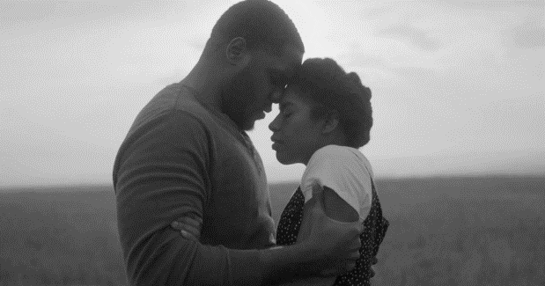
Preserves: A Kansas Story

Please join us for a free, one-day-only staged reading of PRESERVES,
an original feature film by Micah Ariel Watson.
This is a FREE event.

2:30 pm Sunday, July 26
St. James Episcopal Church
3750 E. Douglas, Wichita, KS 67208

We invite you to an exclusive first look at an original film
by Micah Ariel Watson, writer of Canaan.

Set against the quilted backdrop of Kansas's rich African American history, Preserves follows a dancer and an ex-offender whose romance unearths a century-old secret buried within their small town. Inspired by places like Nicodemus and woven with the legacies of the Exoduster Movement, Black faith traditions, and the stories passed down through generations, this sweeping tale is distinctly Kansan.

Presented in partnership with The Kansas African American Museum and the Arts Council of Wichita, this live reading of an original screenplay offers a rare opportunity to experience the script performed live and to engage with a story that honors the people, histories, and landscapes that have shaped generations of Black life on the Great Plains. We invite you to gather in celebration of Kansas history, storytelling, and community memory.

Hosted by
Wichita Native Micah Ariel Watson,
The Kansas African American Museum, and the Arts Council

